Housing and Regeneration Contributory Outcomes – Commentary

A Well Functioning Housing System

[Table 1 – Summary Table on Indicator Measures for a Well Functioning Housing System]

Indicator | Previous Value | Latest Value | Performance | Previous Update | Latest Update
Number of occupied dwellings in Scotland | 2,538,755 | 2,562,668 | Improving | Sep'20 | Sep'21
Gap in % Satisfied with house between lowest 3 deprivation deciles and the Average | 5.6% | 5.1% | Maintaining | 2018 | 2019
Number of Loans for House Purchase | 55,774 | 69,779 | Improving | 2020 | 2021
Ratio of housing costs to Income | 7.8% | 7.5% | Maintaining | 2018/19 | 2019/20
Increase the number of new homes  (*) excluding conversions in 2021/22 | 15,360 | 20,852(*) | Improving | 2020/21 | 2021/22
Effective Housing Land Supply - Number of Housing Units | N/A | N/A | N/A | N/A | N/A
Strength of Construction (GVA) | 75.3 | 86.9 | Improving | 2020 | 2021

Availability and Choice
[Chart 1 – Number of Occupied Dwellings in Scotland (Source: National Records for Scotland - Household Estimates)]
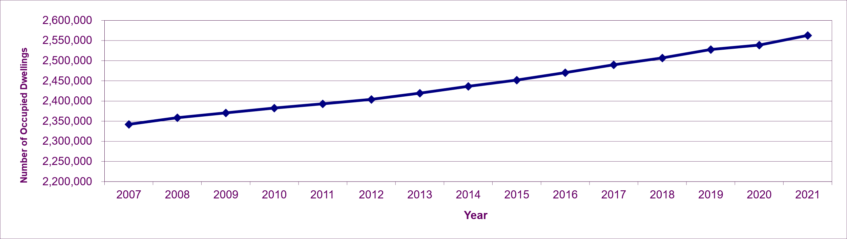
Over the past 14 years the number of occupied dwellings has increased by 220,677 (9.4%) from 2.342 to 2.563 million.
This represents an annual average increase of 15,763, with the largest increase occurring in the latest year between 2020 and 2021 (23,913), following a small increase of 10,994 between 2019 and 2020, during which supply of new housing which was affected by the Covid-19 pandemic. The smallest increase over the period was between 2010 and 2011 (10,204).
This indicator incorporates population and household growth, in that an annual increase of between 10,000 and 15,000 is considered to be a ‘maintaining’ position. An annual increase of more than 15,000 is required to show this indicator as ‘improving’ and any decrease or increase less than 10,000 will show it as ‘worsening’.
The increase of 23,913 between 2020 and 2021 represents an ‘improving’ position.

[Chart 2 – Dwellings by Tenure (Source: Scottish Government - Housing Statistics for Scotland - 'Stock by Tenure' Table)]
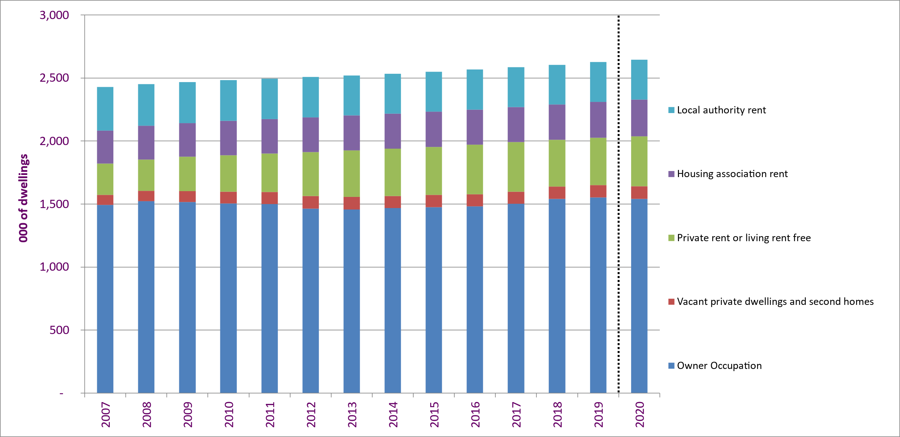

Between 2007 and 2020, the biggest change in dwelling tenure has been in the Private Rented Sector:

Private Rented Sector (or living free): +148,000 (+60%) to 395,000 (although note that the latest estimate for 2020 isn’t directly comparable to results for previous years due to impacts from Covid on the survey estimates used)
Local Authority Rent : -29,000 (-8%) to 317,000
Housing Association Rent: +30,000 (+11%) to 291,000
Vacant private dwellings or 2nd homes: +22,000 (+27%) to 101,000
Owner-Occupation: +46,000 (+3%) to 1.54 million (although note that the latest estimate for 2020 isn’t directly comparable to results for previous years due to impacts from Covid on the survey estimates used)
Key factors contributing to all these changes include:

Growth in Private Rented Sector, due to financial constraints in the housing market, following the financial crisis in 2007/08, making it more challenging for some households to enter into home ownership. These constraints eased by 2018, which may have contributed to a fall of 22,000 (6%) in the size of private rented sector in 2018. The survey data shows an increase of 25,000 since 2018, but the 2020 data is not directly comparable with previous years.
At least 31,050 sales of Local Authority and Housing Association Stock (from 2007/08 to 2019/20), with the majority under Right to Buy, alongside other stock losses such as demolitions. These were mostly countered by almost 62,000 new build local authority and housing association homes during the same period.
Dominance of Private Sector led new building, accounting for 74% of the 236,338 new homes built over this period (2007/08 to 2019/20).
[Chart 3 – Percentage of People Satisfied with Their Home by Deprivation (Source: Scottish Government - Scottish Household Survey)]
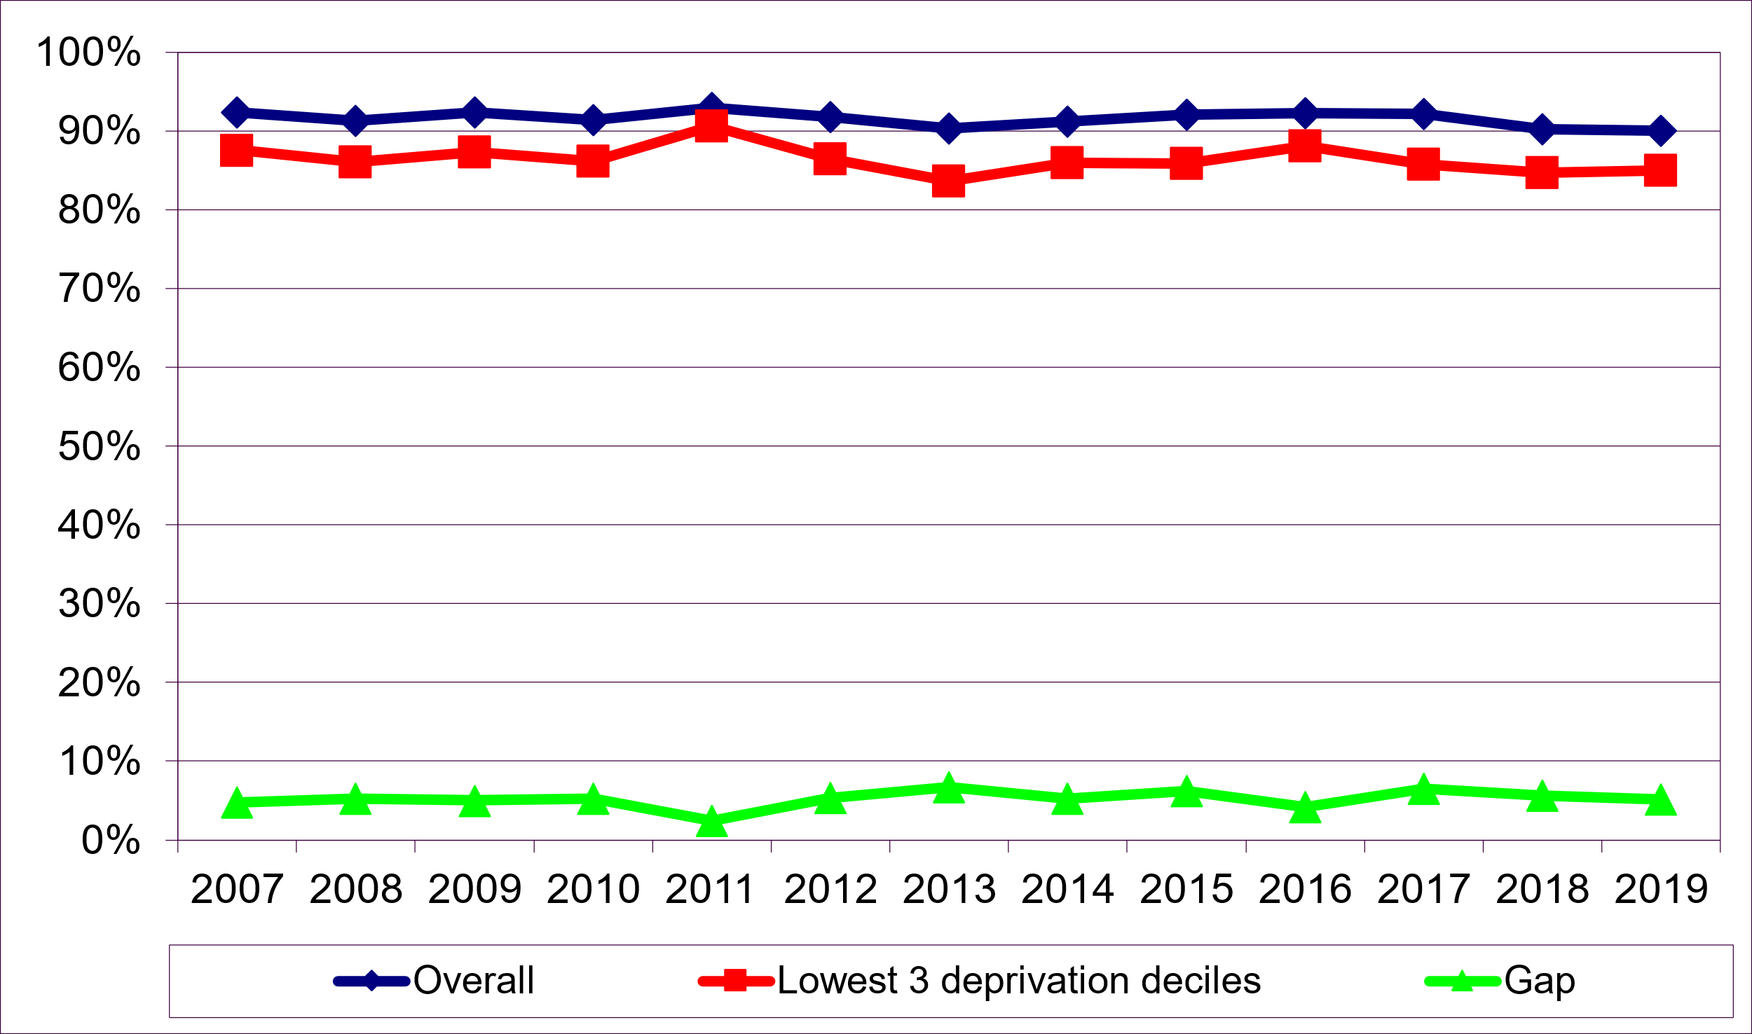
In 2019, 85.0% of households in the 30% most deprived areas were satisfied with their home which was similar to 2018 (84.7%). For Scotland as a whole, 90.1% of households were satisfied with their home, similar to 2018 (90.3%).
Therefore, the gap in satisfaction between Scotland as a whole and the 30% most deprived areas was 5.1 percentage points, similar to the previous year when the gap was 5.6 percentage points. The change in the gap was within 3 percentage points which means that the assessment for this indicator is ‘Performance Maintaining’

Homes that People can Afford
[Chart 4 – Number of Loans for House Purchases (Source: Financial Conduct Authority)]
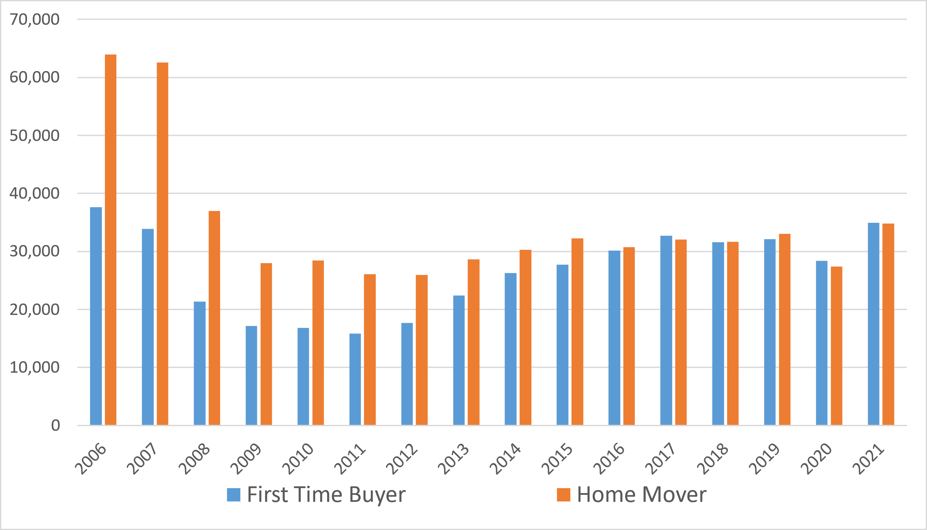
Following the 2008 financial crisis and ensuing recession, the total number of loans advanced for home purchase fell by more than half (53%) between 2007 and 2009, from 96,489 to 45,134. Lending for home purchase then steadily recovered, with the total number of loans reaching 65,138 in 2019, an annualised growth rate of 3.7% over the period from 2009 to 2019.
The Covid-19 pandemic and associated restrictions on home moves led to a sharp reduction in housing market activity in Q2 2020. However, following the lifting of restrictions on home moves in June 2020, there has been a strong recovery, which limited the annual decrease in 2020 to 14%, and resulted in the total number of loans for home purchase in 2021 (69,779) being 7% above the 2019 (pre-covid) level.
During the housing-market boom years of the early 2000s, home movers constituted a signficant majority of housing market activity, with their share of loans for house purchase standing at 65% in 2007. However, following the 2008 financial crisis, housing-market activity became increasingly balanced between home movers and first-time buyers, and since 2016 the share of loans for home purchase of home movers and first-time buyers has been approximately equal.
Please note the split between first-time buyers and home movers was erroneous in the June 2020 publication and has been corrected.

[Chart 5 – Ratio of Housing Costs to Income (median) (Source: Department of Work and Pensions (DWP) – Family Resouces Survey)]
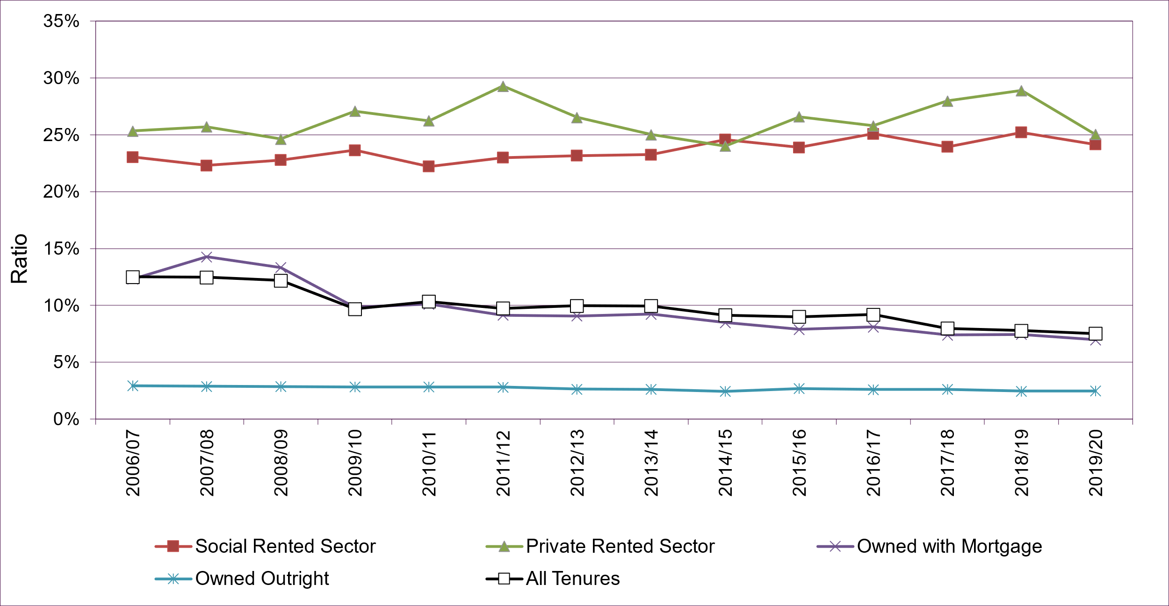
This measure of housing affordability shows the median ratio of housing costs to net (unequivalised) household income. The main indicator is on the ‘All Tenures’ aggregate.
Housing costs include rent (gross of housing benefit); council water charges; mortgage interest payments (net of tax relief); structural insurance premiums (for owner occupiers); and service charges.
Over the past 13 years, the ‘All Tenures’ ratio was at its highest between 2006/07 and 2008/09, averaging at 12.4% over this period. Following the drop in 2009/10, the ratio remained very flat, averaging at 9.9% between 2009/10 and 2013/14, after which it dropped to an average of 9.1% between 2014/15 and 2016/17, after which it has fallen further to an average of 7.8% between 2017/18 and 2019/20.
Trends for ‘Owned with a Mortgage’ also follow this general pattern, with a greater reduction from 14.3% in 2007/08 to 9.8% in 2009/10, reflecting falls in mortgage interest rates and reaching 7.0% by 2019/20.
The ratio for ‘Owned Outright’ households has been fairly constant over the past 13 years, within the range of 2.4% and 2.9%
In 2019/20, the ratio for the Private Rented Sector (25.0%) was slightly higher to that for the Social Rented Sector (24.2%). For the Private Rented Sector this ratio was 0.3 percentage points lower than 25.4% in 2006/07, whilst for the Social Rented Sector the ratio is 1.1 percentage points higher than in 2006/07 (23.1%).

Growth of Supply
[Chart 6 – Supply of New Housing in Scotland (Source: Scottish Government - Housing Statistics for Scotland Supply of new housing annual tables & Housing statistics quarterly update) ]
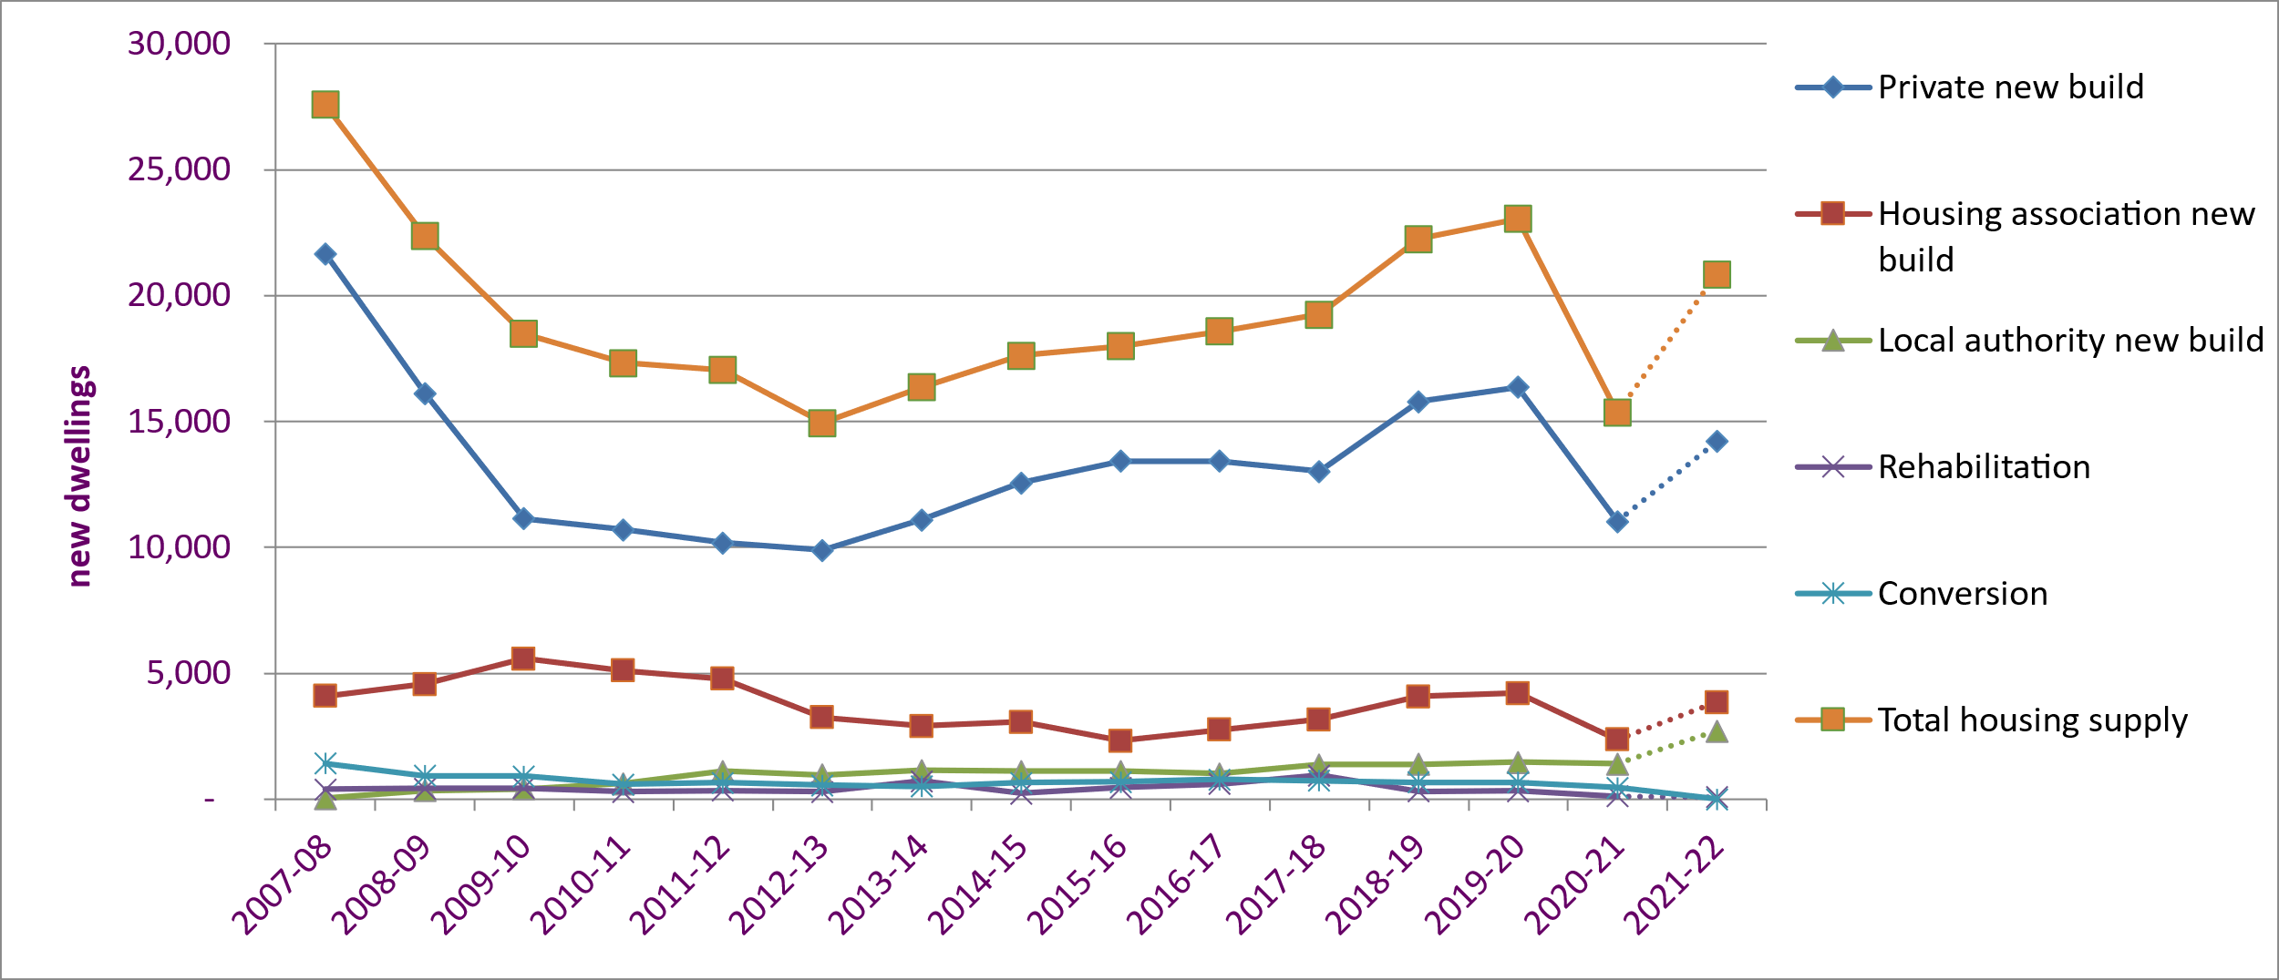
The total supply of new housing fell dramatically after the start of the recession and decreased for 5 years by 12,654 (46%) from 27,594 in 2007-08 to 14,940 in 2012-13.
Total supply then increased in every year until 2019/20, peaking at 23,047. The coronavirus pandemic then led to a sharp fall of 33% to 15,360 in 2020/21. There has been a srong recovery since the pandemic, with total housing supply, excluding conversations, already up to 20,852 in 2021/22, representing an improving performnce for this indicator.
The private led new build sector was most affected by the recession, with a decrease of 11,771 (54%) between 2007-08 and 2012-13. After growing by 6,475 (65%) over 7 years, private housebuilding then fell by 5,344 (33%) in 2020/21, before recovering by 3,188 (29%) in 2021/22..
Over this period, new builds by Housing Associations peaked at 5,576 in 2009-10, then fell 58% to a low of 2,320 in 2015-16, before rising again to 4,204 in 2019/20. In 2020/21, housing association new builds fell 44% to 2,364, before recovering by 1,488 (63%) to reach 3,852 in 2021/22..
New build by Local Authorities generally increased from 28 in 2007-08 to 1,468 in 2019-20, followed by a much smaller decrease of 4% (57) to 2020/21 compared to Private-led and Housing Association completions. There was a large increase in 2021/22 of 92% (1,294), with new build by Local Authorities reaching a 14 year high of 2,705.
The combined number of rehabilitations and conversions averaged 1,149 over the past 14 years, with the numbers in 2016-17 (1,390) and 2017-18 (1,685) well above this average, but the numbers since being below this average, with 562 in 2020/21.
Note: New build and rehabilitation figures for 2021-22 are taken from the latest published Housing statistics quarterly update. The conversions figure for 2021-22 is sourced from separate annual statistics and isn't yet available.
[Chart 7 – Effective Housing Land Supply (Source: Local Authority Planning Performance Framework - Annual Reports)]
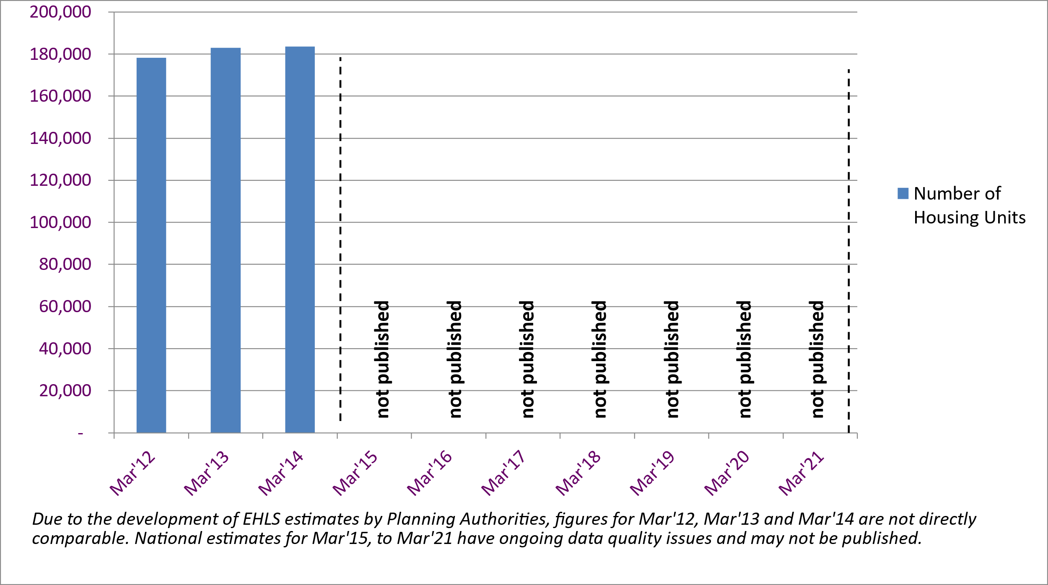
National estimates of Effective Housing Land Supply (EHLS) have been derived from the Planning Performance Framework (PPF) Annual Reports, published by Local Authorities between 2012 and 2014.
Caution: These estimate should be considered as developmental, as they may not be 100% robust, accurate and consistent in initial years of reporting.
EHLS is one of the PPF National Headline Indicators (NHIs), defined as:
Realistic picture of available effective land supply which can contribute to the housing requirement and which can be developed within a 5-year period beyond the date of the Housing Land Audit. This land is in the ownership or control of a party which can be expected to develop it or release it for development. It is also free from, or there is a solid commitment to resolve any issues around physical constraints, contamination, deficit public funding, marketability and infrastructure. Housing is the sole preferred use of the land in planning terms or factors such as ownership and marketability point to housing as being a realistic option.
These estimates are based on Housing Land Audits conducted by Local Authorities available at that point in time and may have been completed in previous years. This means EHLS estimates for some Local Authorities may be the same across different years.
Latest published national estimates of EHLS show 183,500 housing units as at March’14.
National estimates of EHLS for March’15 to March’21 have on-going data quality issues and may not be published.

[Chart 8 – Major Housing Developments, Average Decision Time (weeks) (Source: Scottish Government - Planning Performance Statistics)]
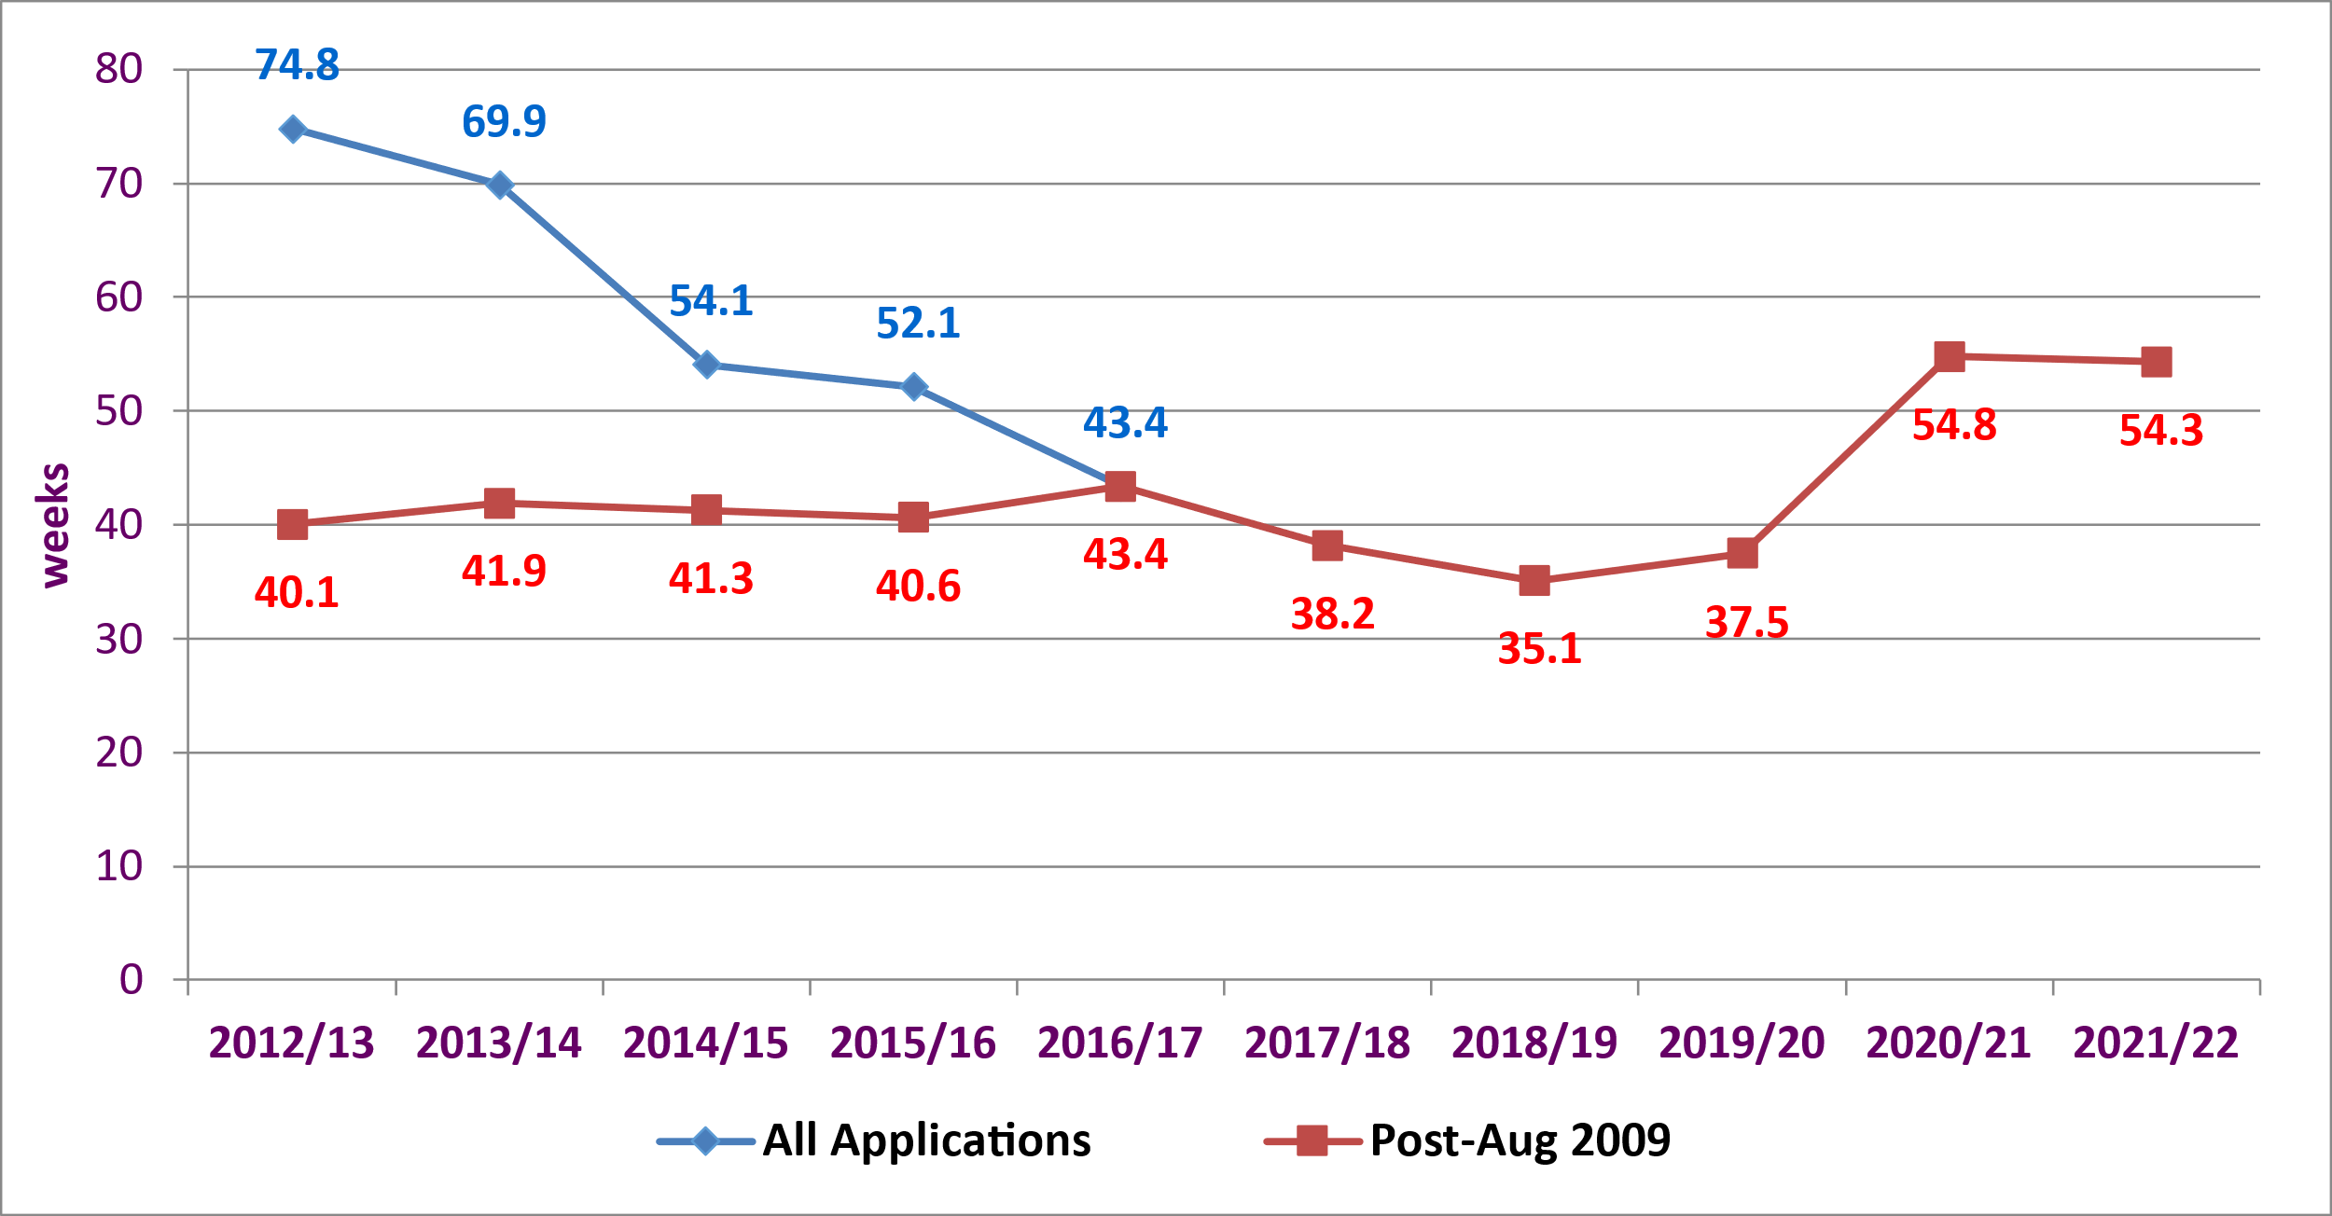
[Chart 9 - Local Housing Developments, Average Decision Time (weeks) (Source: Scottish Government - Planning Performance Statistics)]]
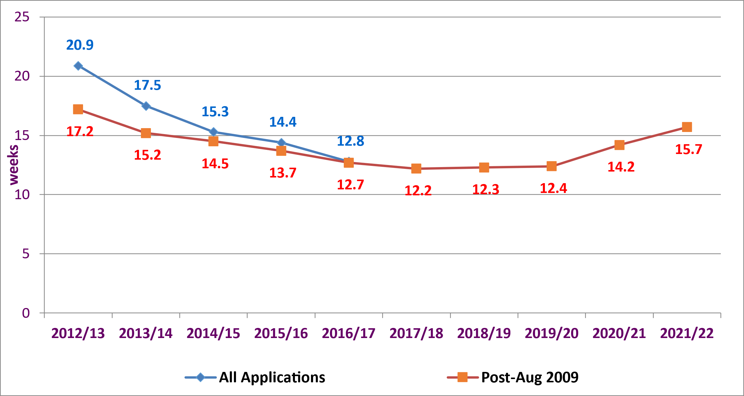
Major housing developments relate to those where a planning application is for 50 or more dwellings, or for a site that exceeds 2 hectares in size.
These statistics relate to the average decision time of planning applications or the average life-span of the applications, where external factors affect the overall decision time.
Results are shown for all applications decided in a particular year and for those which were submitted post August 2009, when substantial changes were made to the planning system. These results provide a better reflection of the performance of the current planning system, by excluding a small number of old legacy cases.
The average decision time for major housing developments (post-Aug 2009) remained fairly stable between 2012/13 and 2015/16, ranging between 40.1 and 41.9 weeks. This was followed by an increase to 43.4 weeks in 2016/17 and a sharp decrease to 38.2 weeks in 2017/18 then 35.1 in 2018/19. This then rose to 54.8 weeks in 2020/21, and then falling slightly to 54.3 weeks in 2021/22.
From mid-March 2020, planning application processing was impacted by the COVID-19 Pandemic. Some applications have longer decision times due to this. These impacts should be considered when making comparisons with earlier years. Also, there are typically only a small number of decisions made for major developments each quarter, therefore average decision times are likely to vary greatly.
Local Housing developments are those that have less than 50 dwellings and with a site area that is less than 2 hectares.
For (post-Aug 2009) local housing developments, average decision times decreased from 17.2 weeks in 2012/13 to 12.2 weeks in 2017/18, and then remained similar to stand at 12.4 weeks in 2019/20, before rising each year to 15.7 weeks in 2021/22. These were also impacted by the COVID-19 pandemic from March 2020

[Chart 10 – Construction GVA (Source: Scottish Government - Economy GDP Publication, Second Estimate of GDP)]
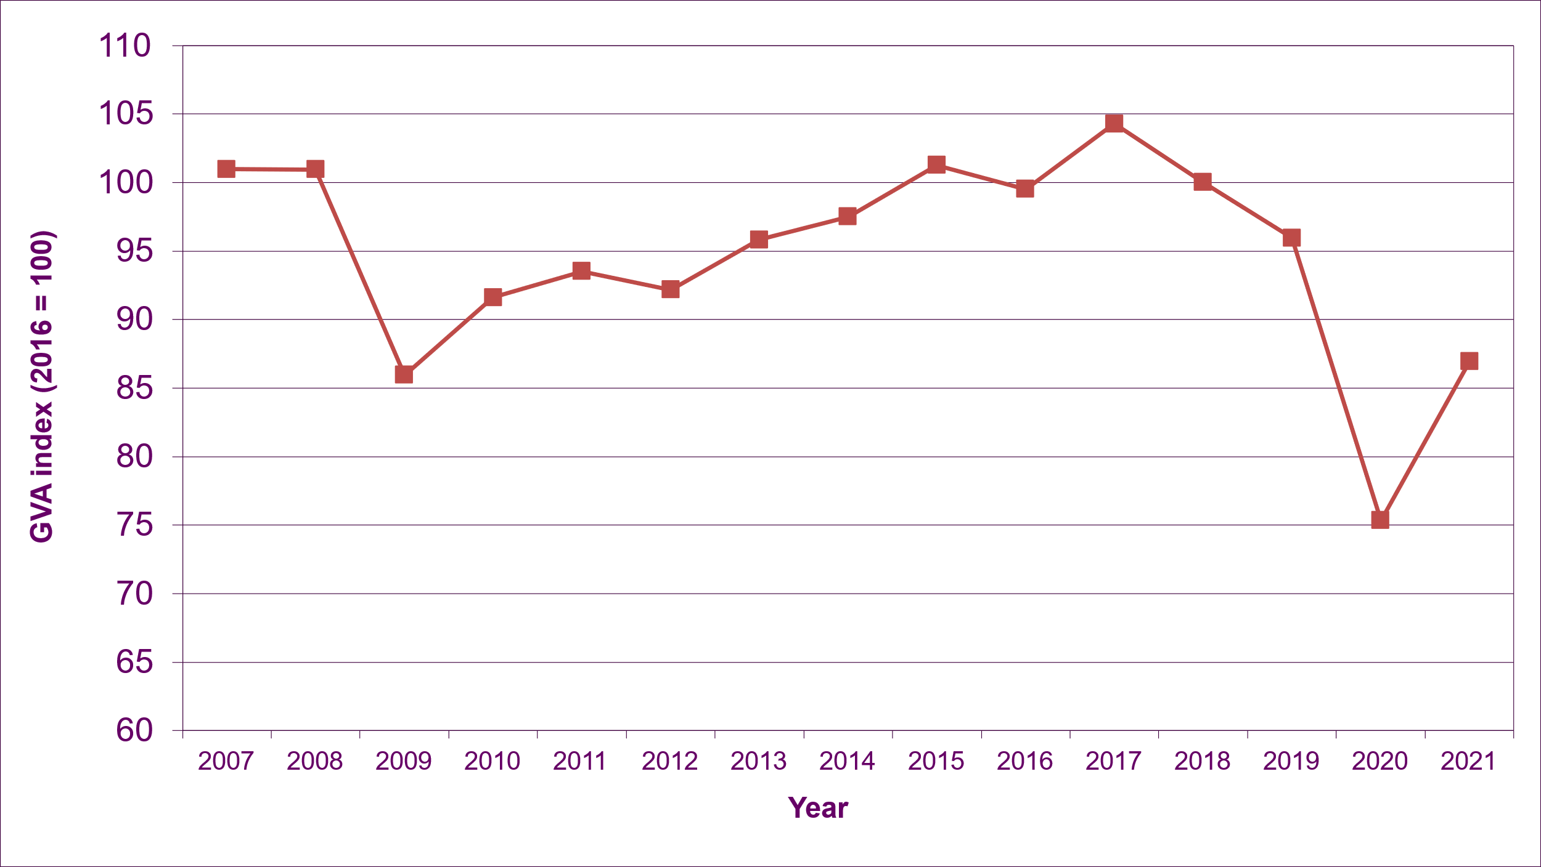
Construction GVA is made up of the following sectors: housing, infrastructure and other public, private industrial and private commercial sectors. The GVA measure includes both new construction as well as repair and maintenance.
The trends show that that Construction Output was fairly stable between 2007 and 2008, before falling by 14.9% in 2009, as the impact of the recession was felt.
However, unlike new house building trends, construction output then partially recovered, increasing by 8.8% between 2009 and 2011. The Scottish Government Economic Recovery Plan, which accelerated £346 million of Capital Funding contributed to the increase during this period.
Since 2009, construction output has broadly been increasing gradually, up 21.3% by 2017, reflecting a large programme of investment taking place across Scotland. Projects included the Forth Replacement Crossing, two hospitals in Glasgow (Queen Elizabeth University Hospital and the Royal Hospital for Children), the Borders Railway construction and the Schools for the Future building programme. Construction output then fell consistently until 2019, before a dramatic fall of 21.5% in 2020, due to the impacts of the coronavirus pandemic. Output then rose by 15.1% in 2021, and is at level similar to 2009.

High Quality, Sustainable Homes
[Table 2 – Summary Table on Indicator Measures for High Quality, Sustainable Homes]

Indicator | Previous Value | Latest Value | Performance | Previous Update | Latest Update
SHQS section on Healthy, Safe and Secure (% of homes passing) | 86.5% | 86.3% | Maintaining | 2018 | 2019
Fuel Poverty (rate) | 27.0% | 35.0% | Worsening | October 2021 | October 2022
Energy Efficiency - Median SAP 2012 rating | 67 | 67 | Maintaining | 2018 | 2019
Disrepair to Critical Elements (% of homes) | 56.9% | 51.9% | Improving | 2018 | 2019
Satisfaction with condition of the home (SHCS) (% of households) | 82.4% | 81.8% | Maintaining | 2018 | 2019
% of people with access to green or blue space (5 min walk or less) - (NPF National Indicator) | 65.3% | 65.5% | Maintaining | 2018 | 2019

Safe
[Chart 11 – Percentage of Houses Passing the Healthy, Safe and Secure Section of the SHQS (Source: Scottish Government - Scottish House Conditions Survey)]
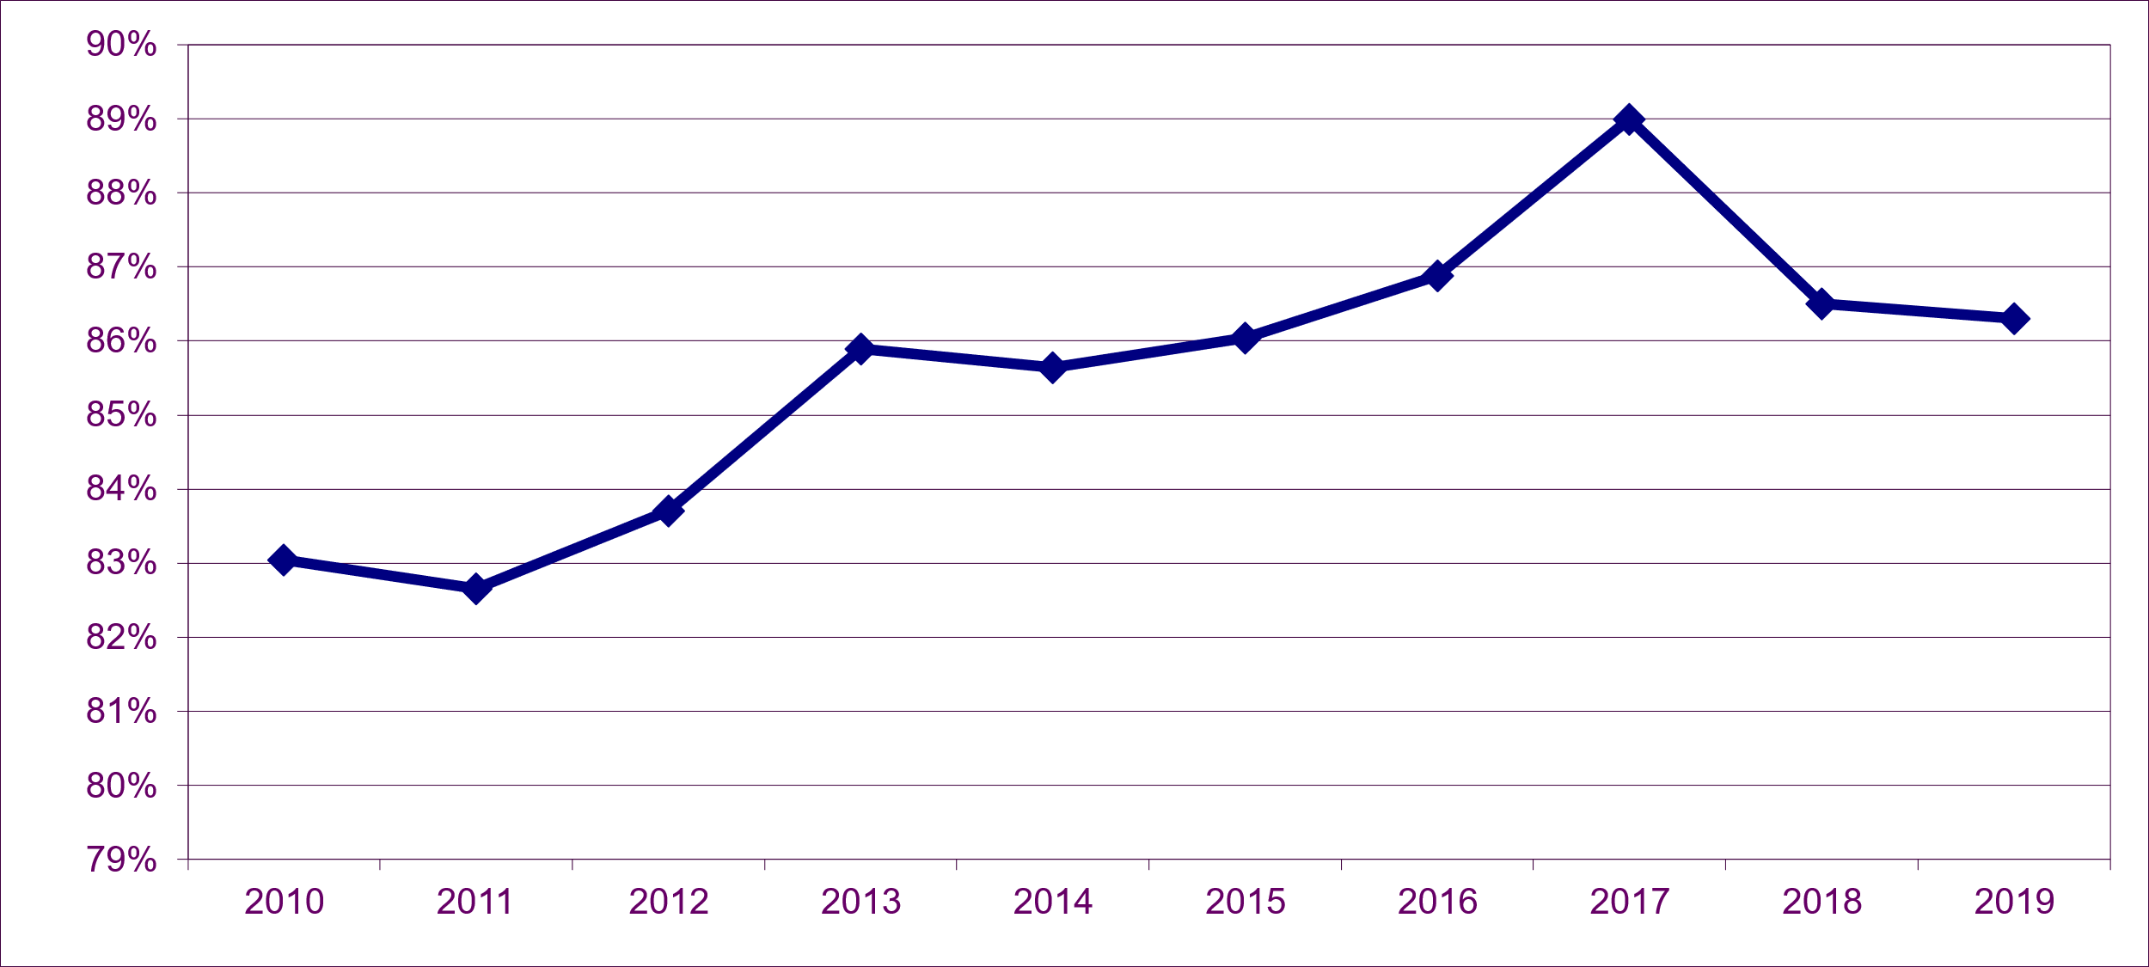
The percentage of houses passing the Scottish Housing Quality Standard (SHQS) on health, safety and security increased by 3.2 percentage points between 2011 and 2013, reaching 85.9% in 2013. Following this increase, the rate remained fairly similar until 2015. After this there was a 3% point increase from 86% in 2015 to 89% in 2017, but then a decrease of 2.5 percentage points to 2018, and remaining around this level at 86.3% in 2019, leading to a "maintaining” performance for this indicator.
This standard covers a range of safety and security measures including :
Safe: smoke alarms; energy supply systems/appliances; common lifts, internal/external areas, refuse chutes and bin stores.
Adequate: common/public lighting
Secure: dwelling door locks & common entry systems; with common front and rear doors in a good state of repair.
Note that due to the impacts from the Covid pandemic there was no physical survey SHQS data collected in 2020. Results from the 2021 physical survey are due to be published in 2023.

Warm
[Chart 12 – Fuel Poverty and Extreme Fuel Poverty Rates (Source: Scottish Government - Scottish House Conditions Survey & Scenario Modelling)]

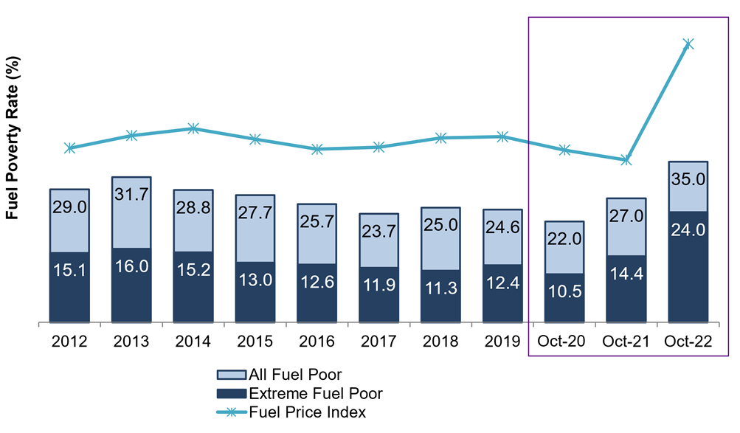
Note: The figures for October 2020, 2021, and 2022 are based on scenario modelling and are therefore not directly comparable to the figures from 2012 to 2019, which are based on Official Statistics from the Scottish House Condition Survey (SHCS)
Please note that the 2020 Scottish House Condition Survey was suspended due to the Covid-19 pandemic restrictions on in-house surveying. The 2021 survey was conducted using a hybrid ‘external+’ approach, with results scheduled for publication in 2023.
Fuel poverty rates decreased for 4 consecutive years from 31.7% in 2013 to 23.7% in 2017, after which they stabilised, reaching 24.6% in 2019. Subsequent scenario modelling suggests that fuel poverty rates increased sharply from 22.0% in October 2020 to 35.0% in October 2022, reflecting the increases in energy prices and corresponding increases in the Ofgem energy price caps. The estimate for October 2022 reflects the £2,500 Energy Price Guarantee, as well as a range of UK and Scottish Government mitigations:
- £400 to account for the Energy Bills Support Scheme
- £650 Cost of Living payment for those on means-tested benefits,
- £300 Pensioner Cost of Living Payment for pensioner households who receive the Winter Fuel Payment,
- £150 Disability Cost of Living Payment
- and £150 Council Tax rebate for households in council tax bands A-D or that receive council tax reduction.
The scenario modelling utilised the latest available data from the 2019 Scottish House Condition Survey and applied increases in energy prices to the underlying modelled energy bills and also assigned the mitigations above to eligible households. Modelled fuel bills were not adjusted to account for the £100 Alternative Fuels Payment (which will be added to future versions of the scenario modelling).
Trends in extreme fuel poverty followed a similar patter, reducing for 5 consecutive years from 16.0% in 2013 to 11.3% in 2018. The scenario modelling estimates that rates of extreme fuel poverty more than doubled from 10.0% in october 2020 to 24.0% in October 2022.
The definitions of fuel poverty and extreme fuel poverty are set out in the Fuel Poverty (Targets, Definition and Strategy) (Scotland) Act 2019, where a household is in fuel poverty if:
- in order to maintain a satisfactory heating regime, total fuel costs necessary for the home are more than 10% of the household's adjusted (i.e. after housing costs) net income (and more than 20% in the case of extreme fuel poverty); and
- if, after deducting those fuel costs, benefits received for a care need or disability and childcare costs, the household's remaining adjusted net income is insufficient to maintain an acceptable standard of living.
Under this definition, a household’s adjusted after housing costs net income is net of income tax, national insurance contributions, mortgage or rent payments, childcare costs, council tax, water and sewerage charges.
The remaining adjusted net income must be at least 90% of the UK Minimum Income Standard to be considered an acceptable standard of living, with an additional amount added for households in remote rural, remote small town and island areas.

Resource Efficient
[Chart 13 – Energy Efficiency – Median SAP 2009 & SAP 2012 Scores (Source: Scottish Government - Scottish House Conditions Survey)]
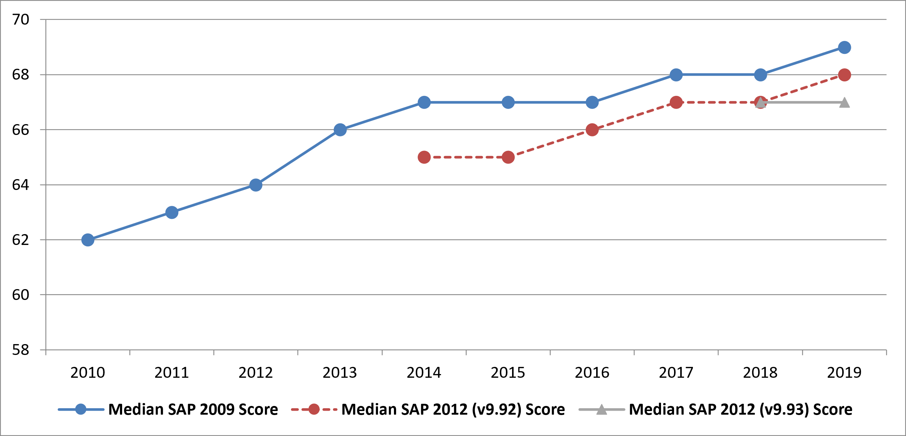
There was a substantial improvement in the energy efficiency of the housing stock, as measured by the 2009 Standard Assessment Procedure (SAP), between 2010 and 2014. The median SAP 2009 score increased by 8% from 62 in 2010 to 67 in 2014, although it remained at this level in 2015 and 2016, before increasing to 68 in 2017 and 2018 and 69 in 2019.
SAP 2009 has now been replaced by the latest, improved, industry standard of SAP 2012. The median SAP 2012 (v9.92) score was 2 points below SAP 2009 in 2014 and 2015, but it has shown an improvement of 2 points from 65 in 2015 to 67 in 2017 and 2018, after which it has improved to 68 in the latest year 2019. However, in the latest version of SAP (v.9.93), 2018 and 2019 both had a score of 67, leading to a “maintaining” performance ranking.
The historic distribution of SAP 2009 scores shows that the biggest increase since 2010 has occurred in the 71-80 band, rising from 16% to 37% of the stock. The biggest decreases have occurred in the 51-60 and 41-50 bands, falling by 11 and 7 percentage points respectively.

[Chart 14 – Energy Efficiency – SAP 2009 Banded Profile (Source: Scottish Government - Scottish House Conditions Survey)]
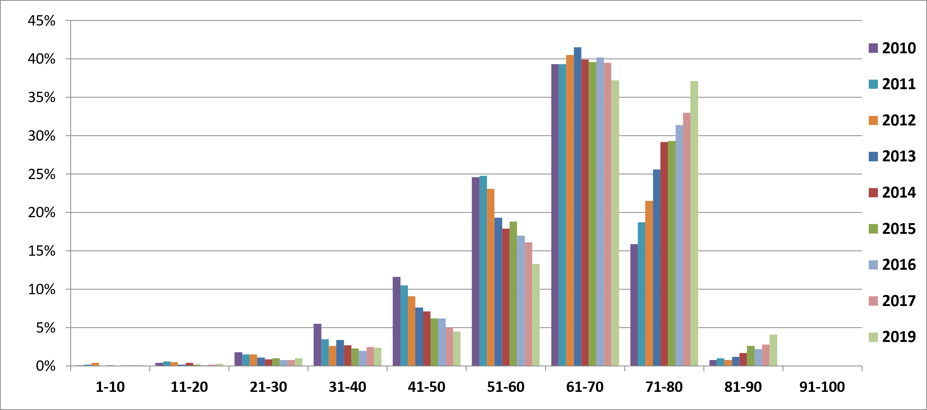
The uptake of energy efficiency schemes in Scotland since 2010/11 have made a substantial contribution to improvements in the energy efficiency of the housing stock. Full tables are available in the HAR outcome indicators master spreadsheet.
Note that due to the impacts from the Covid pandemic there was no physical survey SHQS data collected in 2020. Results from the 2021 physical survey are due to be published in 2023.

[Chart 15 – Disrepair to Critical Elements (Source: Scottish Government - Scottish House Conditions Survey)]

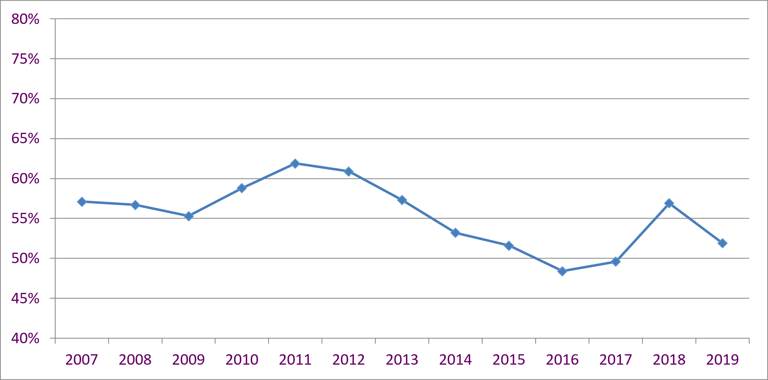

[Chart 16 – Disrepair to Critical Elements – by tenure (Source: Scottish Government (SG) Scottish House Conditions Survey (SHCS))]
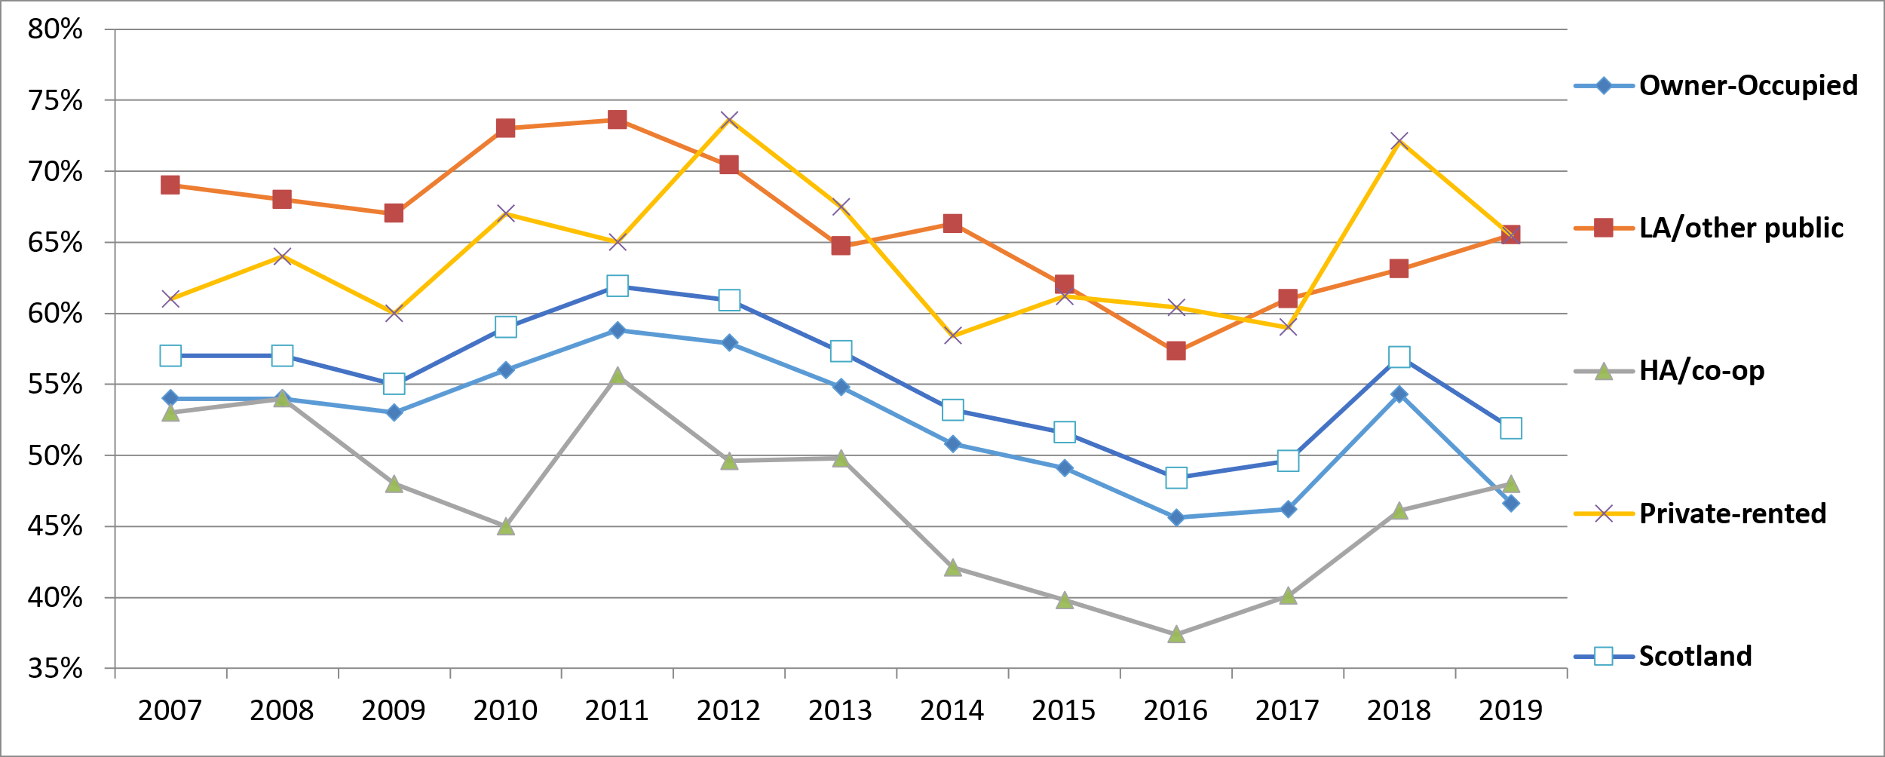

[Chart 17- Disrepair to Critical Elements – by age of dwelling (Source: Scottish Government (SG) Scottish House Conditions Survey (SHCS))]
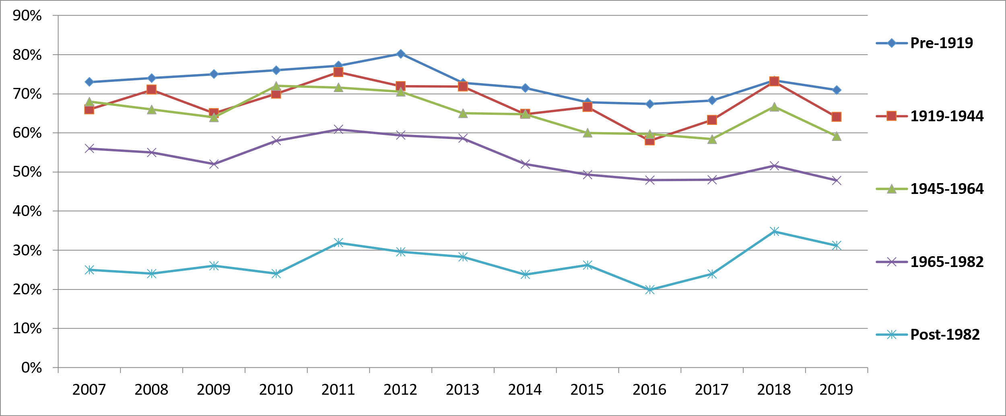

Critical elements are defined as those whose condition is central to a dwelling being wind and weather proof, structurally stable and safeguarded against rapid deterioration.
This indicator measures any level of disrepair to critical elements, no matter how small.
Between 2009 and 2011, there was an increase in the percentage of homes with disrepair to critical elements across all tenure types, with the Scotland level increasing by 6.6 percentage points from 55.3% in 2009 to 61.9% in 2011. Since then the rate decreased for 5 consecutive years, falling by 13.5 percentage points to 48.4% in 2016, after which rose to 56.9% in 2018, before falling 5 percentage points to 51.9% in 2019.
Since 2011, there has been a statistically significant decrease in disrepair to critical elements for owner occupied and LA/other public sector tenures, with a decrease of 12.2 percentage points for Owner Occupied stock, and a decrease of 8.1 percentage points for Local Authority Stock.
In 2019, Private Rented Stock and Local Authority Stock had the highest level of disrepair to critical elements at 65.5% each. There is also a clear pattern of older dwellings having a higher level of disrepair than newer dwellings, particularly compared to those built post-1982.

Promote Wellbeing
[Chart 18 – Percentage of People Who are Satisfied With the Condition of Their Home (Source: Scottish Government - Scottish House Conditions Survey)]
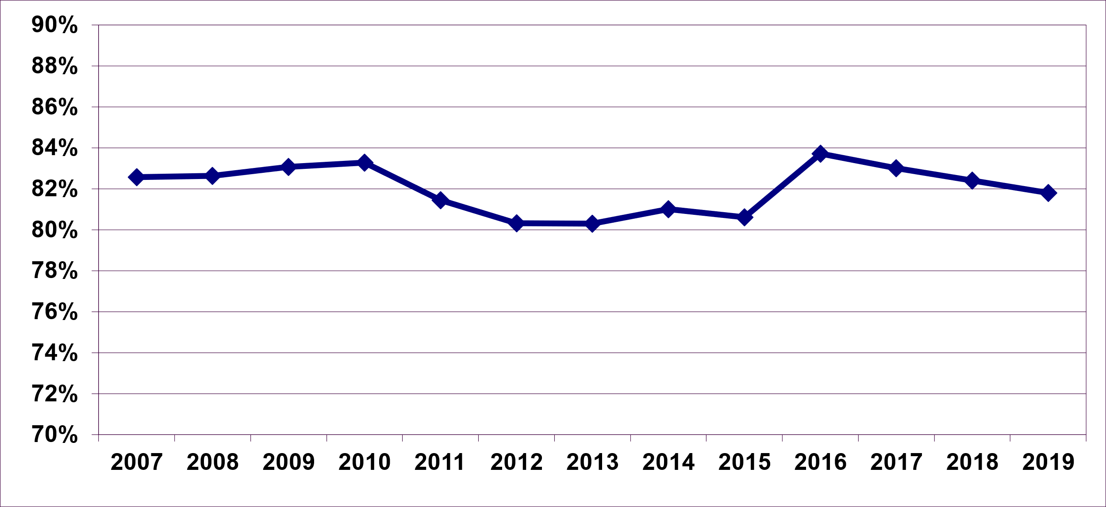
There was a significant increase in the percentage of people who were satisfied with the condition of their home between 2015 and 2016, rising 3.1 percentage points to 83.7%.
Over the past 3 years the percentage has dropped slightly to 81.8% in 2019, which is not a significant decrease.
Note that due to the impacts from the Covid pandemic period, the results of the SHS 2020 telephone survey are not directly comparable to SHS results for previous years, and are not considered suitable for the purposes of indicator reporting.

[Chart 19 – Walking Distance to Nearest Useable Green or Blue Space (Source: Scottish Government - Scottish Household Survey)]
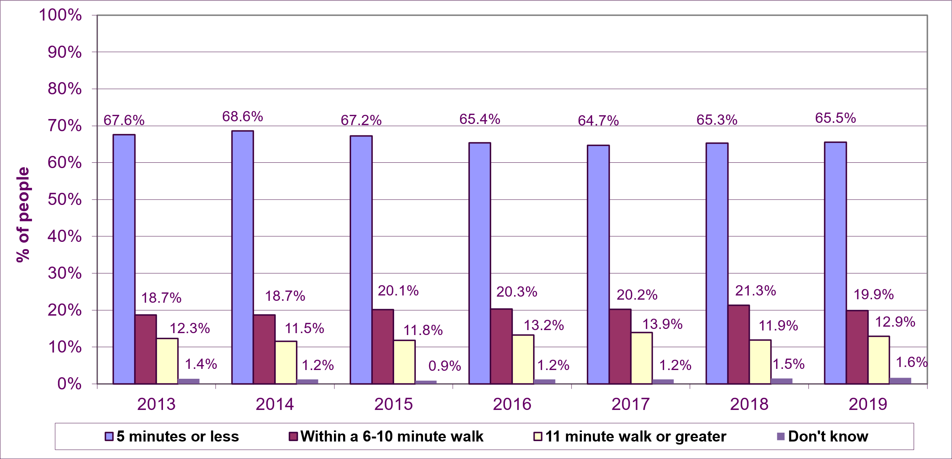
The results show that in 2019: 65.5% of people can access useable green or blue space areas within 5 minutes walk or less, 19.9% need to walk 6-10 minutes, 12.9% are 11 or more minutes walk away and 1.6% did not know.
The results show a small (not statistically significant) increase of 0.2 percentage points in the latest year, in the percentage of people within 5 minutes walk from useable green or blue space. However, at 65.5%, this is lower than 68.6% in 2014, with more people now needing to walk longer to access useable greenspace. This is reflected in the figures that indicate that more people need to walk 6-10 minutes for useable green or blue space with the 2019 rate (19.9%).

Homes that Meet Peoples Needs
[Table 3 – Summary Table on Indicator Measures for Homes that Meet Peoples Needs]

Indicator | Previous Value | Latest Value | Performance | Previous Update | Latest Update
Housing Lists - LA & CHR Gross (counts every list that each applicant is on) | 164,946 | 178,260 | Worsening | March'20 | March'21
Improve access to suitable housing options for those in housing need (Homelessness 2012 Target) | 91.0% | 95.7% | N/A | 2011/12 | 2012/13
Over-Crowded Homes | 53,000 | 51,000 | Maintaining | 2018 | 2019
How convenient services are | 81.4% | 80.8% | Maintaining | 2014 | 2016
Repossessions (UK) | 1,459 | 1,310 | Improving | 2020 | 2021
Evictions & Abandonments in the Social Sector | 1,915 | 118 | Improving | 2019/20 | 2020/21
Percentage of households in need, requiring one or more adaptations (based on self-assessed need) | 42.1% | 53.6% | Worsening | 2018 | 2019

Accessing a Home
[Chart 20 – Housing Lists (Source: Scottish Government)]
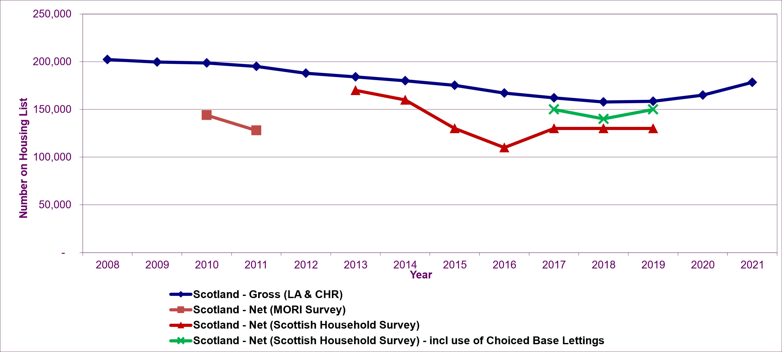
The Scotland - Gross (LA & CHR) estimates are based a compilation of Local Authority (LA) and Common Housing Register (CHR) Lists and includes applicants on Transfer Lists. These estimates include double counting of applicants on more than one list but also exclude applicants on lists in the 6 LAs (including Glasgow), which have transferred all of their housing stock to Registered Social Landlords (RSLs).
The Scotland – Net (MORI) estimates are derived from the MORI Omnibus Surveys carried out in Aug’10 and Feb’11. They cover the whole of Scotland and specifically ask about and exclude double-counting of applicants. (Please note the small sample size of this survey means the results should be treated with caution and only used as a broad indication).
The Scotland – Net (Scottish Household Survey) estimates are derived from questions included in the survey from 2013. They cover the whole of Scotland and also exclude double-counting of applicants on more than one list. (These estimates are based on responses from at least 9,400 households per year and can be considered to be reliable).
Recent trends show a decrease in gross (LA & CHR) housing lists, falling by 44,429 (22%), from 202,235 in 2008 to 157,806 in 2018, after which there have been increases in the years since, with 178,260 on a housing list in 2021, an increase of 8% (13,314) on the previous year. This represents a worsening performance for this indicator. These longer term trends need to be considered with some caution as there have been administrative changes to housing lists, including greater use of Common Housing Registers. With the increase in the most recent year to March 2021, likely to be due to impacts from the Coronavirus pandemic.
The Net - MORI and Net - Scottish Household Survey results both point to a national total below that of the Gross (LA & CHR) figures. The Scottish Household Survey also showed a reduction of 60,000 (35%) in the number of households on housing lists, from 170,000 in 2013 to 110,000 in 2016. However there was an increase of 20,000 (18%) to 130,000 in 2017 which remained at this level to 2019. In addition, in 2017 a further 20,000 households reported that they were not on a housing list, but have applied for social rented housing using choice based lettings, with an equivalent figure of 10,000 being seen in 2018 and 20,000 in 2019. Note that due to the impacts from the Covid pandemic period, the results of the SHS 2020 telephone survey are not directly comparable to SHS results for previous years, and are not considered suitable for the purposes of indicator reporting
(Note. Some of the decrease in Scottish Household Survey results between 2013 and 2016 may be due to some social landlords moving to a choice based letting system, as opposed to a more traditional points based housing list system. This may have resulted in some households not considering themselves to be on a housing list even though they are actively seeking social housing. The new questions added to the 2017 survey now provide estimates of these households.)
[Chart 21 – Percentage of Homeless Households Entitled to Settled Accommodation (Source: Scottish Government - Homelessness Statistics)]
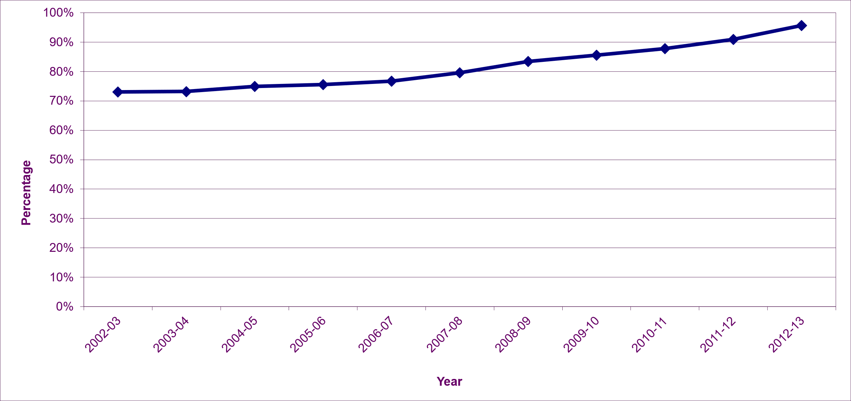
This indicator measured progress towards the December 2012 Homelessness Target, since when all unintentionally homeless households are assessed as priority need and entitled to settled accommodation.

[Chart 22 – Number of Over-Crowded Homes by Tenure (Source: Scottish Government - Scottish House Conditions Survey)]
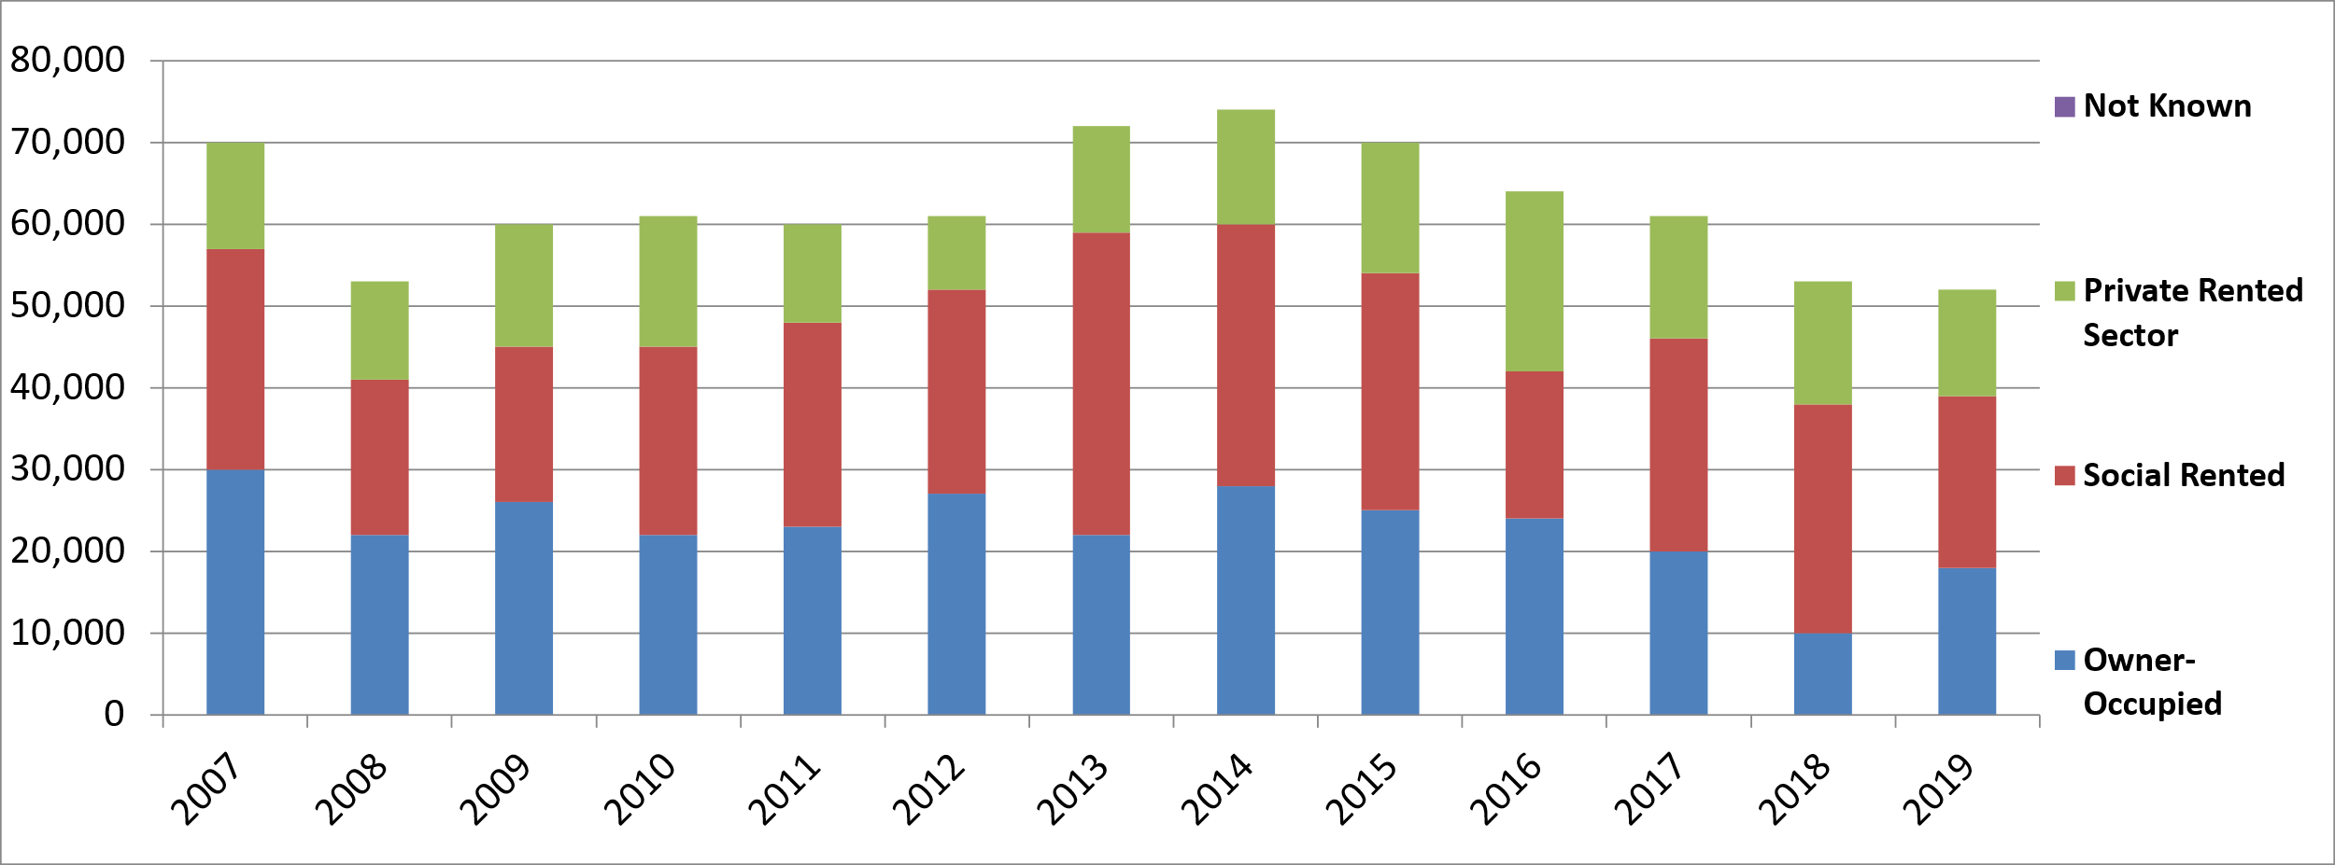
[Chart 23 – Number of Under-Occupied Homes by Tenure (Source: Scottish Government - Scottish House Conditions Survey)]
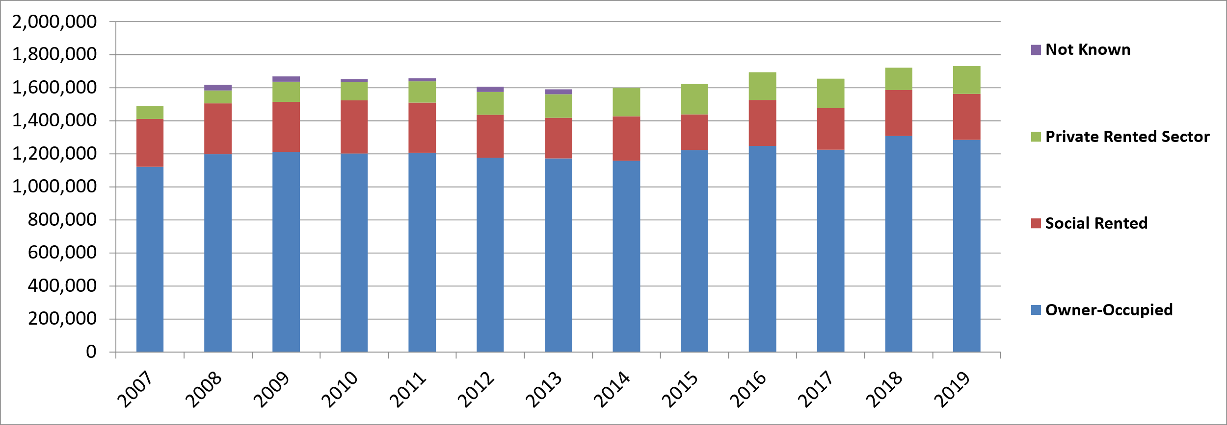
The total number of over-crowded homes in Scotland, defined by the Bedroom Standard, fell from an estimated 53,000 in 2018 to 51,000 in 2019. In the longer term, this represents a fall of 23,000 (or 31%) from a peak of 74,000 in 2014.
In 2019, 2.1% of homes in Scotland were over-crowded. This rate was highest in Private Rented Sector (4.2% or 13,000 homes) and the Social Rented Sector (3.3% or 21,000 homes) and lowest in the owner-occupied homes (1.1% or 18,000 homes).
In 2019, there was an increase of 9,000 (0.5%) in the estimated number of under-occupied homes in Scotland from 1.721m in 2018 to 1.730m in 2019.
Overall, 69.3% of homes were under-occupied, with the rate highest in owner-occupied (82.9%) homes and lower for the Private Rented Sector (53.2%) and Social Rented Sector (44.0%).
Note that due to the impacts from the Covid pandemic there was no Scottish House Condition Survey physical data collected in 2020. Results from the 2021 physical survey are due to be published in 2023.

[Chart 24 – Percentage of People Who Consider Services Convenient (Source: Scottish Government - Scottish Household Survey)]
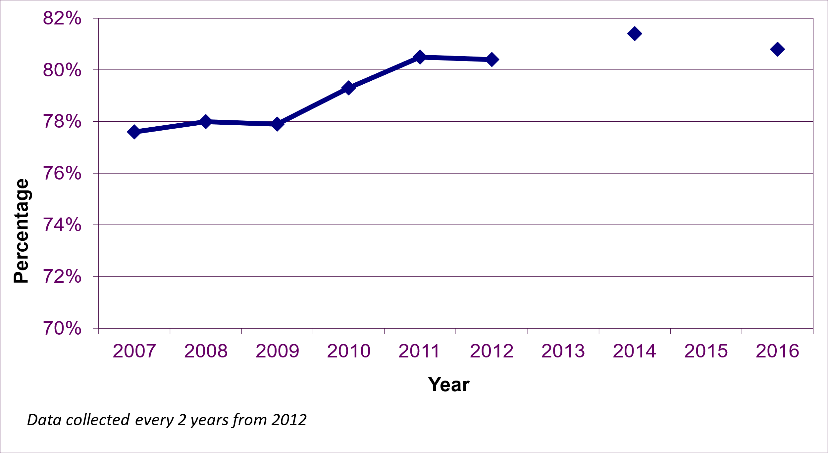
In 2018 the SHS question on the percentage of people who consider services convenient has been removed from the survey. Therefore data is only available up to 2016.
The percentage of people who considered local services convenient was around 78% between 2007 and 2009. This was followed by 2 years of increase to 80.5% in 2011, with a similar level in 2012 of 80.4%. The level in 2014 was 1% higher at 81.4%, before dropping slightly to 80.8% in 2016.
The list of services covered includes: a small amount of food shopping; chemist; post office; cash machine and banking services; dentist and doctor surgery and hospital outpatient services; public transport; petrol station.

Keeping a Home
[Chart 25 – Number of Reposessions of Regulated Mortgages (Securitised and Unsecuritised) in UK (Source: Financial Conduct Authority)]
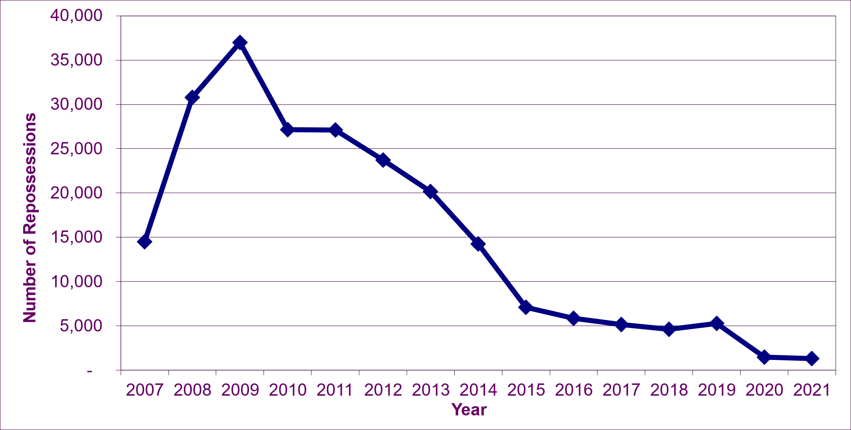
UK data on mortgage repossessions is used as a proxy for the likely pattern in Scotland.
There was a steep 155% rise in the number of repossessions between 2007 and 2009, the period of the financial crisis and economic recession, which led to a sharp increase in unemployment. As the economy began to recover, and unemployment fell, repossessions also fell, from 36,978 in 2009 to 5,874 in 2016, further supported by low mortgage rates. From 2016 to 2019, repossessons were at a relatively stable level.
Despite the impact of the Covid-19 pandemic, repossessions fell to 1,459 in 2020 and 1,310 in 2021. A key contributor to this fall was FCA guidance which recommended that lenders provide tailored support to those affected and that evictions should not be enforced. Further reductions in interest rates during this period would also have helped keep repossessions low.

[Chart 26 – Evictions or Abandomnents in the Social Rented Sector (Source: Scottish Government, Scottish Housing Regulator)]
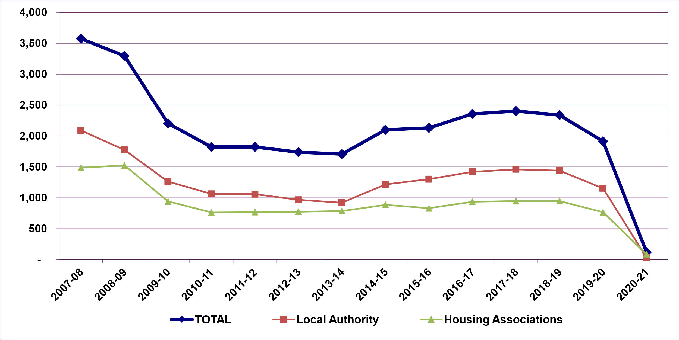
There was a large decrease in the total number of evictions and abandonments from 3,573 in 2007/08 to 2,204 in 2009/10, followed by a further fall to 1,708 by 2013/14. Between 2013/14 and 2017/18 was an increase of 697 (41%), reaching 2,405 in 2017/18. In 2019/20, there was an overall decrease of 18% to 1,915 from 2018/19.
In 2020/21, the total number of evictions and abandonments fell to 118, due to legislation brought in to prevent evictions during the coronavirus pandemic.

Supporting Independent Living
[Chart 27 – Percentage of Households in Need, Requiring One or More Adaptations (Source: Scottish Government - Scottish House Conditions Survey)]
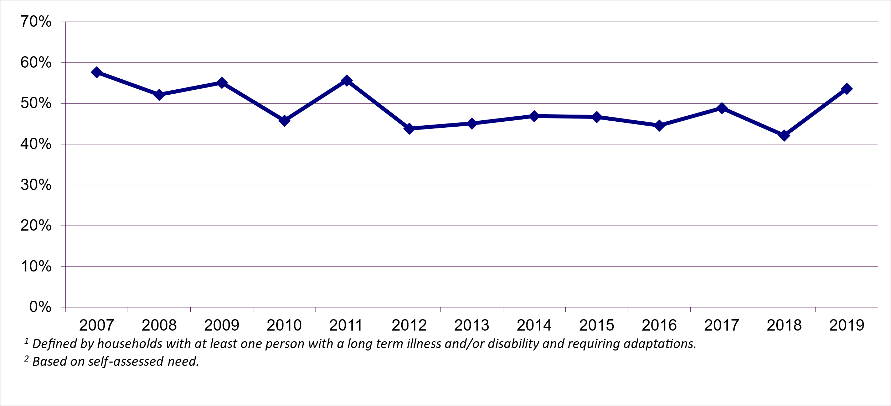
The source of data for this indicator is the Scottish House Condition Survey. However it is based on about 230 households in the sample annually, which have (i) at least one person with a long term illness and/or disability and (ii) a self-assessed need for adaptations in the home. It is not based on needs assessed by an occupational therapist, the access route to adaptations for most people.
As such, this data can only be used to provide an indicative estimate of the percentage of such households in need requiring one or more adaptations, which averaged around 45.4% over the 8 years 2012 to 2018. Results for 2019 showed an increase of 11.5% points to 53.6%. Due to the small sample sizes, a threshold of +/-10 percentage points has been set to determine whether this indicator is showing an ‘improving’ or ‘worsening’ position from year to year. Most annual changes have been within this threshold, although the latest year performance is seen to be “worsening”.
Note that due to the impacts from the Covid pandemic there was no physical survey SHQS data collected in 2020. Results from the 2021 physical survey are due to be published in 2023.

People Live in Sustainable Communities
[Table 4 – Summary Table - Measures for People Live in Sustainable Communities]

Indicator | Previous Value | Latest Value | Performance | Previous Update | Latest Update
Percentage of workless households | 18.1% | 18.6% | Maintaining | 2020 | 2021
Employment rate (gap between deprived areas and other areas) | 15.1pp | 13.8pp | Improving | 2020 | 2021
%age of people with post school qualifications (Gap between deprived areas and other areas) | 22.9pp | 16.4pp | Improving | 2020 | 2021
Healthy Life Expectancy (Males) (gap between deprived areas and Scotland average in years) | 8.6 | 10.1 | Maintaining | 2017-19 | 2018-20
Percentage of people rating their neighbourhood as a very good place to live (NPF National Indicator) | 57.4% | 57.0% | Maintaining | 2018 | 2019
Amount of vacant and derelict land | 10,926 | 9,750 | Improving | 2019 | 2021
%age of people who agree their council provides a high quality service | 46.0% | 44.3% | Worsening | 2018 | 2019
%age of people satisfied with community centres and facilities | 30.7% | 28.9% | Worsening | 2018 | 2019
%age of people who feel they can influence decisions affecting their local area | 20.1% | 17.8% | Worsening | 2018 | 2019
% of people who feel safe walking alone in their neighbourhood at night | 82.1% | 82.9% | Maintaining | 2017 | 2019

Economically Sustainable Communities
[Chart 28 – Percentage of Workless Households (Source: Office for National Statistics - Annual Population Survey)]
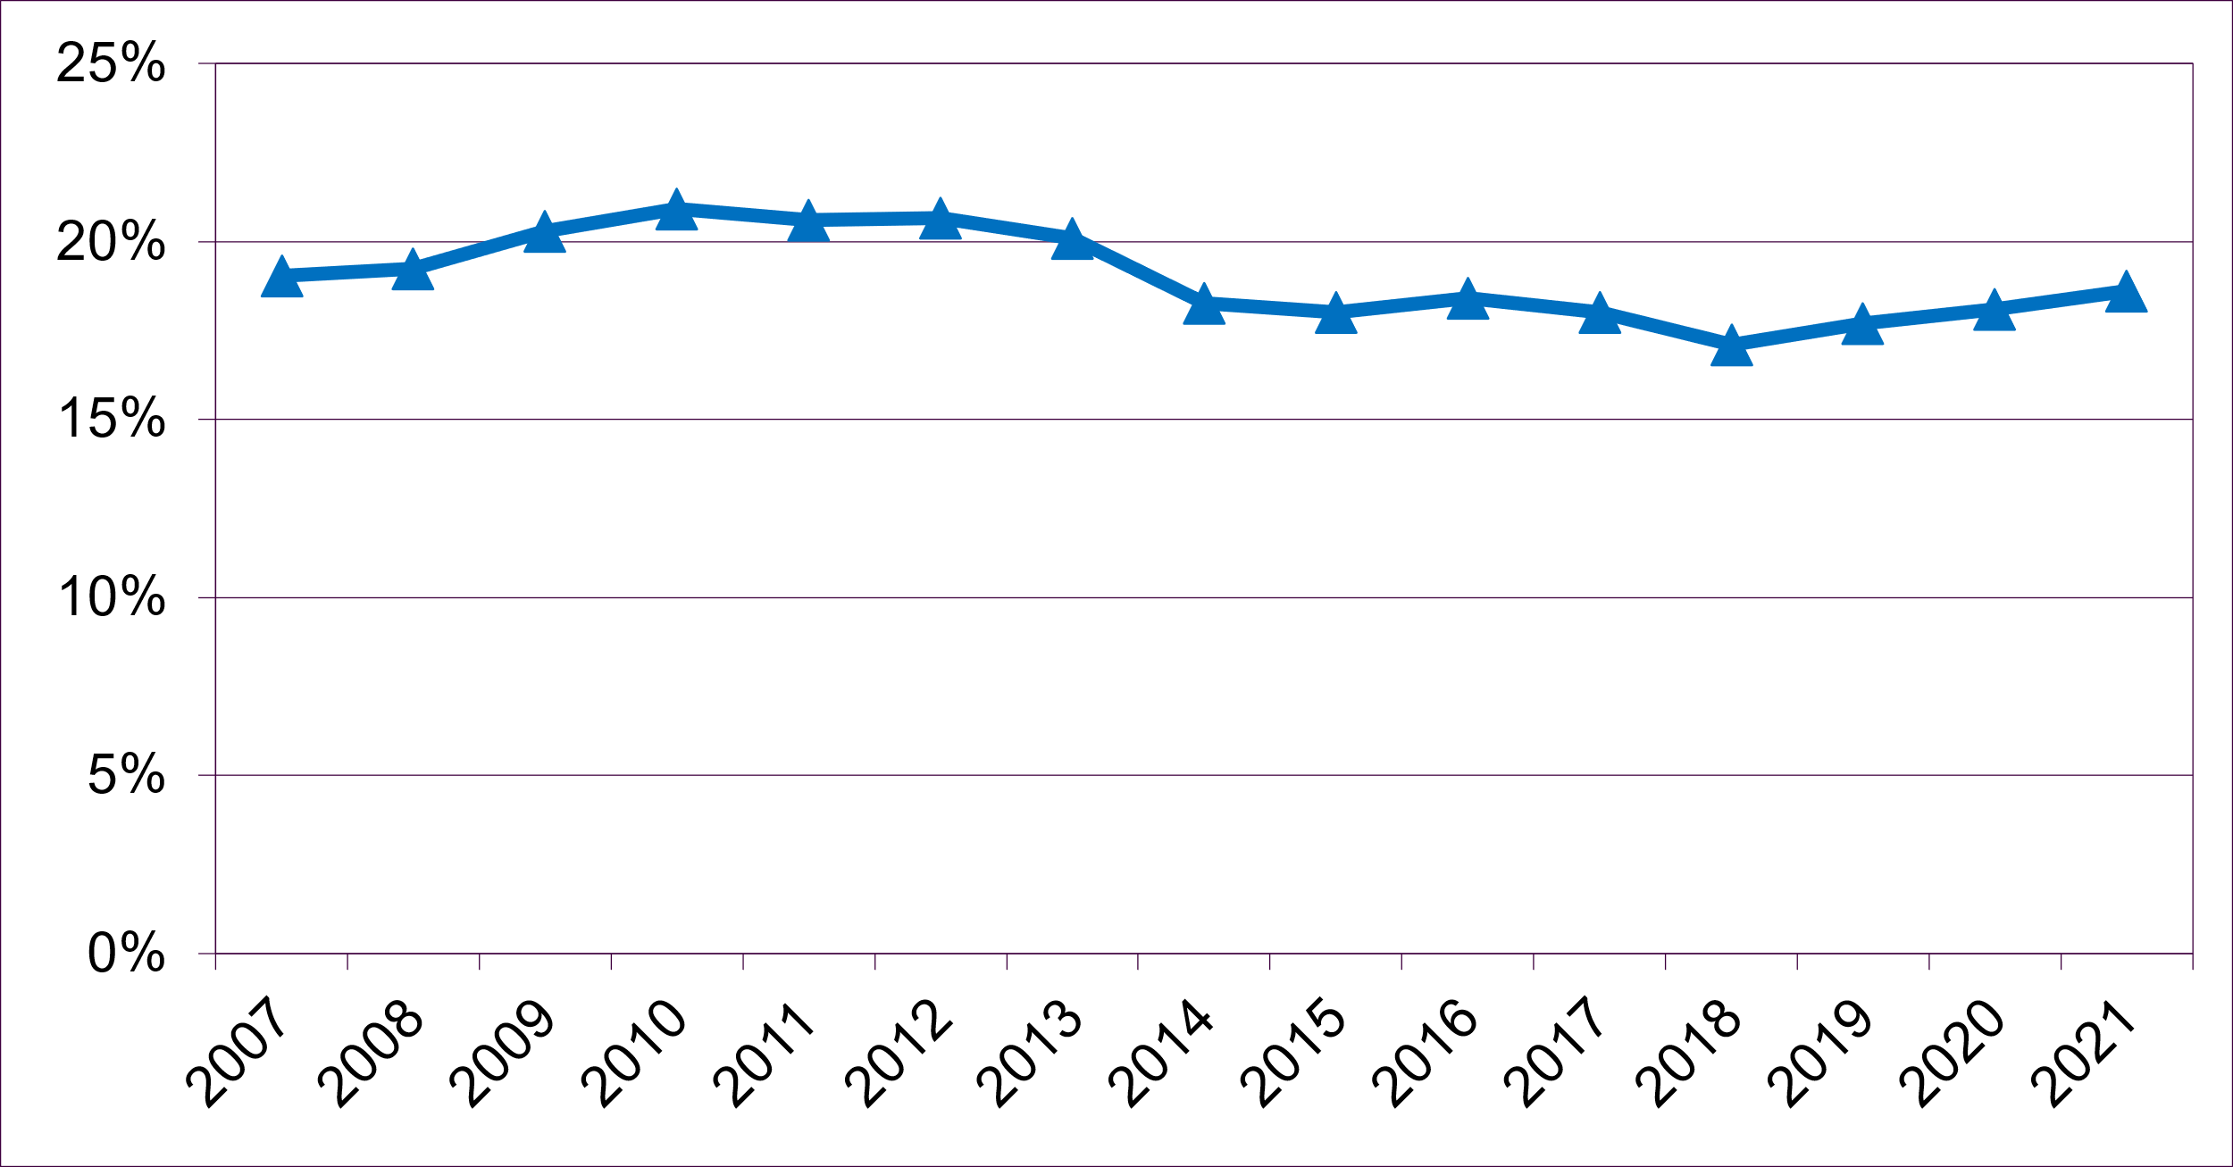
[Chart 29 – Employment Rate (including gap between the most deprived and rest of Scotland) (Source: Office for National Statistics - Annual Population Survey)]
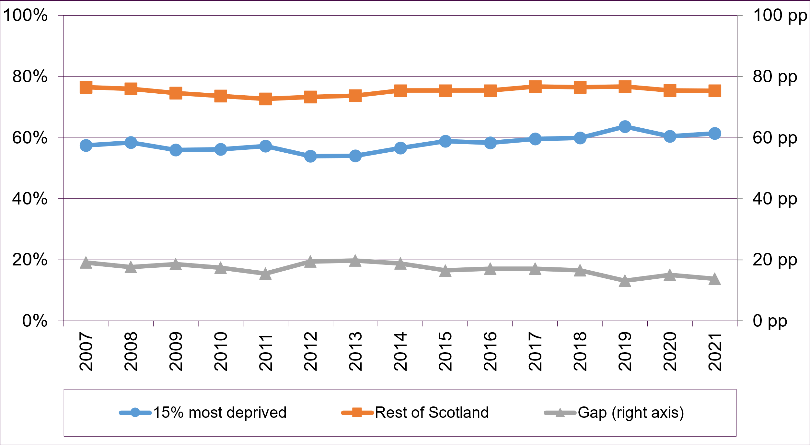
2014 saw the biggest annual drop in workless households over the past 14 years, from 20.1% in 2013 to 18.3% in 2014. After that, the rate remained fairly stable over the next 3 years, fluctuating between 18.0% and 18.4%. In 2018, the rate dropped to its lowest since 2007 at 17.1%. This then rose to 18.1% in 2020 and 18.6% in 2021.
The employment rate for the 15% most deprived areas rose by 7.4 percentage points from 54.0% in 2013 to 61.4% in 2021.
Over the same period, the employment rate for the Rest of Scotland increased from 73.8% to 75.3% in 2021, a smaller increase of 1.5 percentage points
This has resulted in a fall in the employment gap between the 15% most deprived areas and the Rest of Scotland from 19.8 percentage points in 2013 to 13.8 percentage points in 2021, a fall of 6.0 percentage points. This includes a fall of 1.3 percentage points in the last year, resulting in an improving performance for this indicator.

[Chart 30 – Percentage of People with HNC/HND or Above (Source: Office for National Statistics - Annual Population Survey)]]
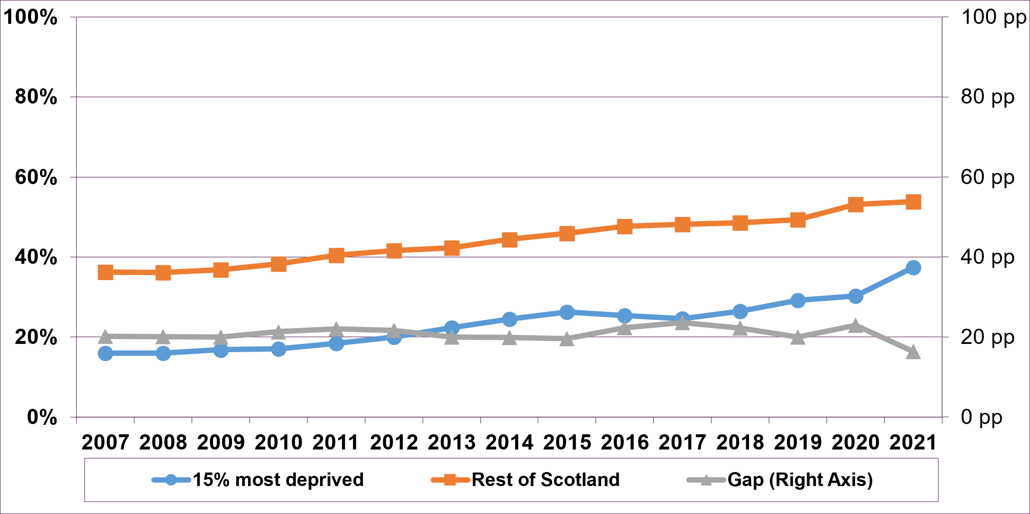
The percentage of people with post school qualifications in the 15% most deprived areas increased from 16.0% in 2007 to 26.2% in 2015, after which it fell slightly to 24.6% in 2017 before increasing again year on year to 37.4% in the latest year 2021. For the rest of Scotland there has been a gradual increase across the whole period from 36.2% in 2007 to 53.8% in 2021.
Between 2007 and 2021 the percentage in deprived areas has increased by 21.4 percentage points, which is a higher rate of increase to the rest of Scotland at 17.6 percentage points.
The gap between the 15% most deprived and the rest of Scotland reached its lowest point since 2007, at 16.4 percentage points in the latest year 2021. Over the last year, the gap decreased by 6.5 percentage points, mainly due to the increase in the percentage of people with post school qualifications from 30.3% in 2020 to 37.4% in 2021, resulting in an improving performance for this indicator.

[Chart 31 – Healthy Life Expectancy – Males (Source: National Records of Scotland - Healthy Life Expectancy in Scotland)]
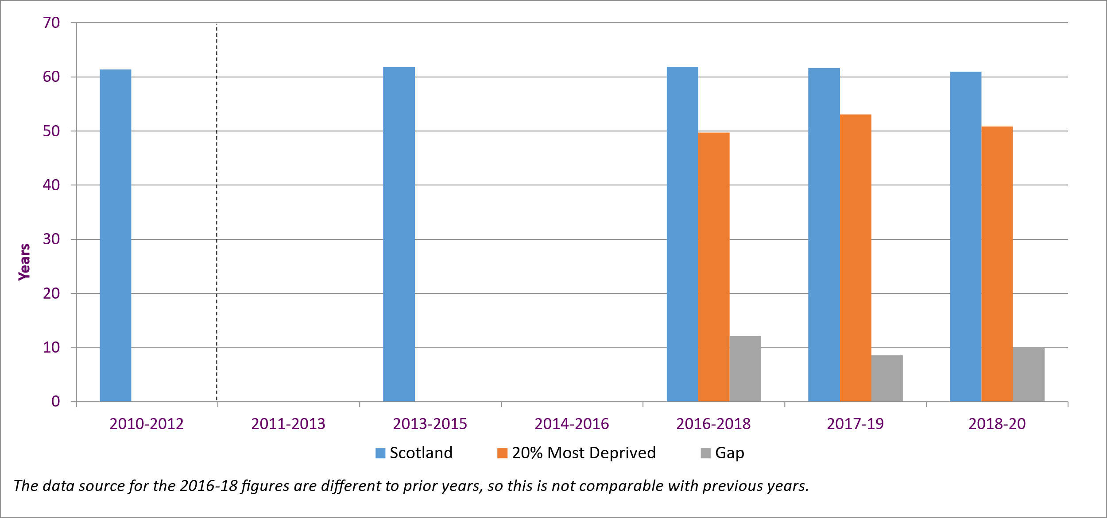
[Chart 32 – Healthy Life Expectancy – Females (Source: National Records of Scotland - Healthy Life Expectancy in Scotland)]
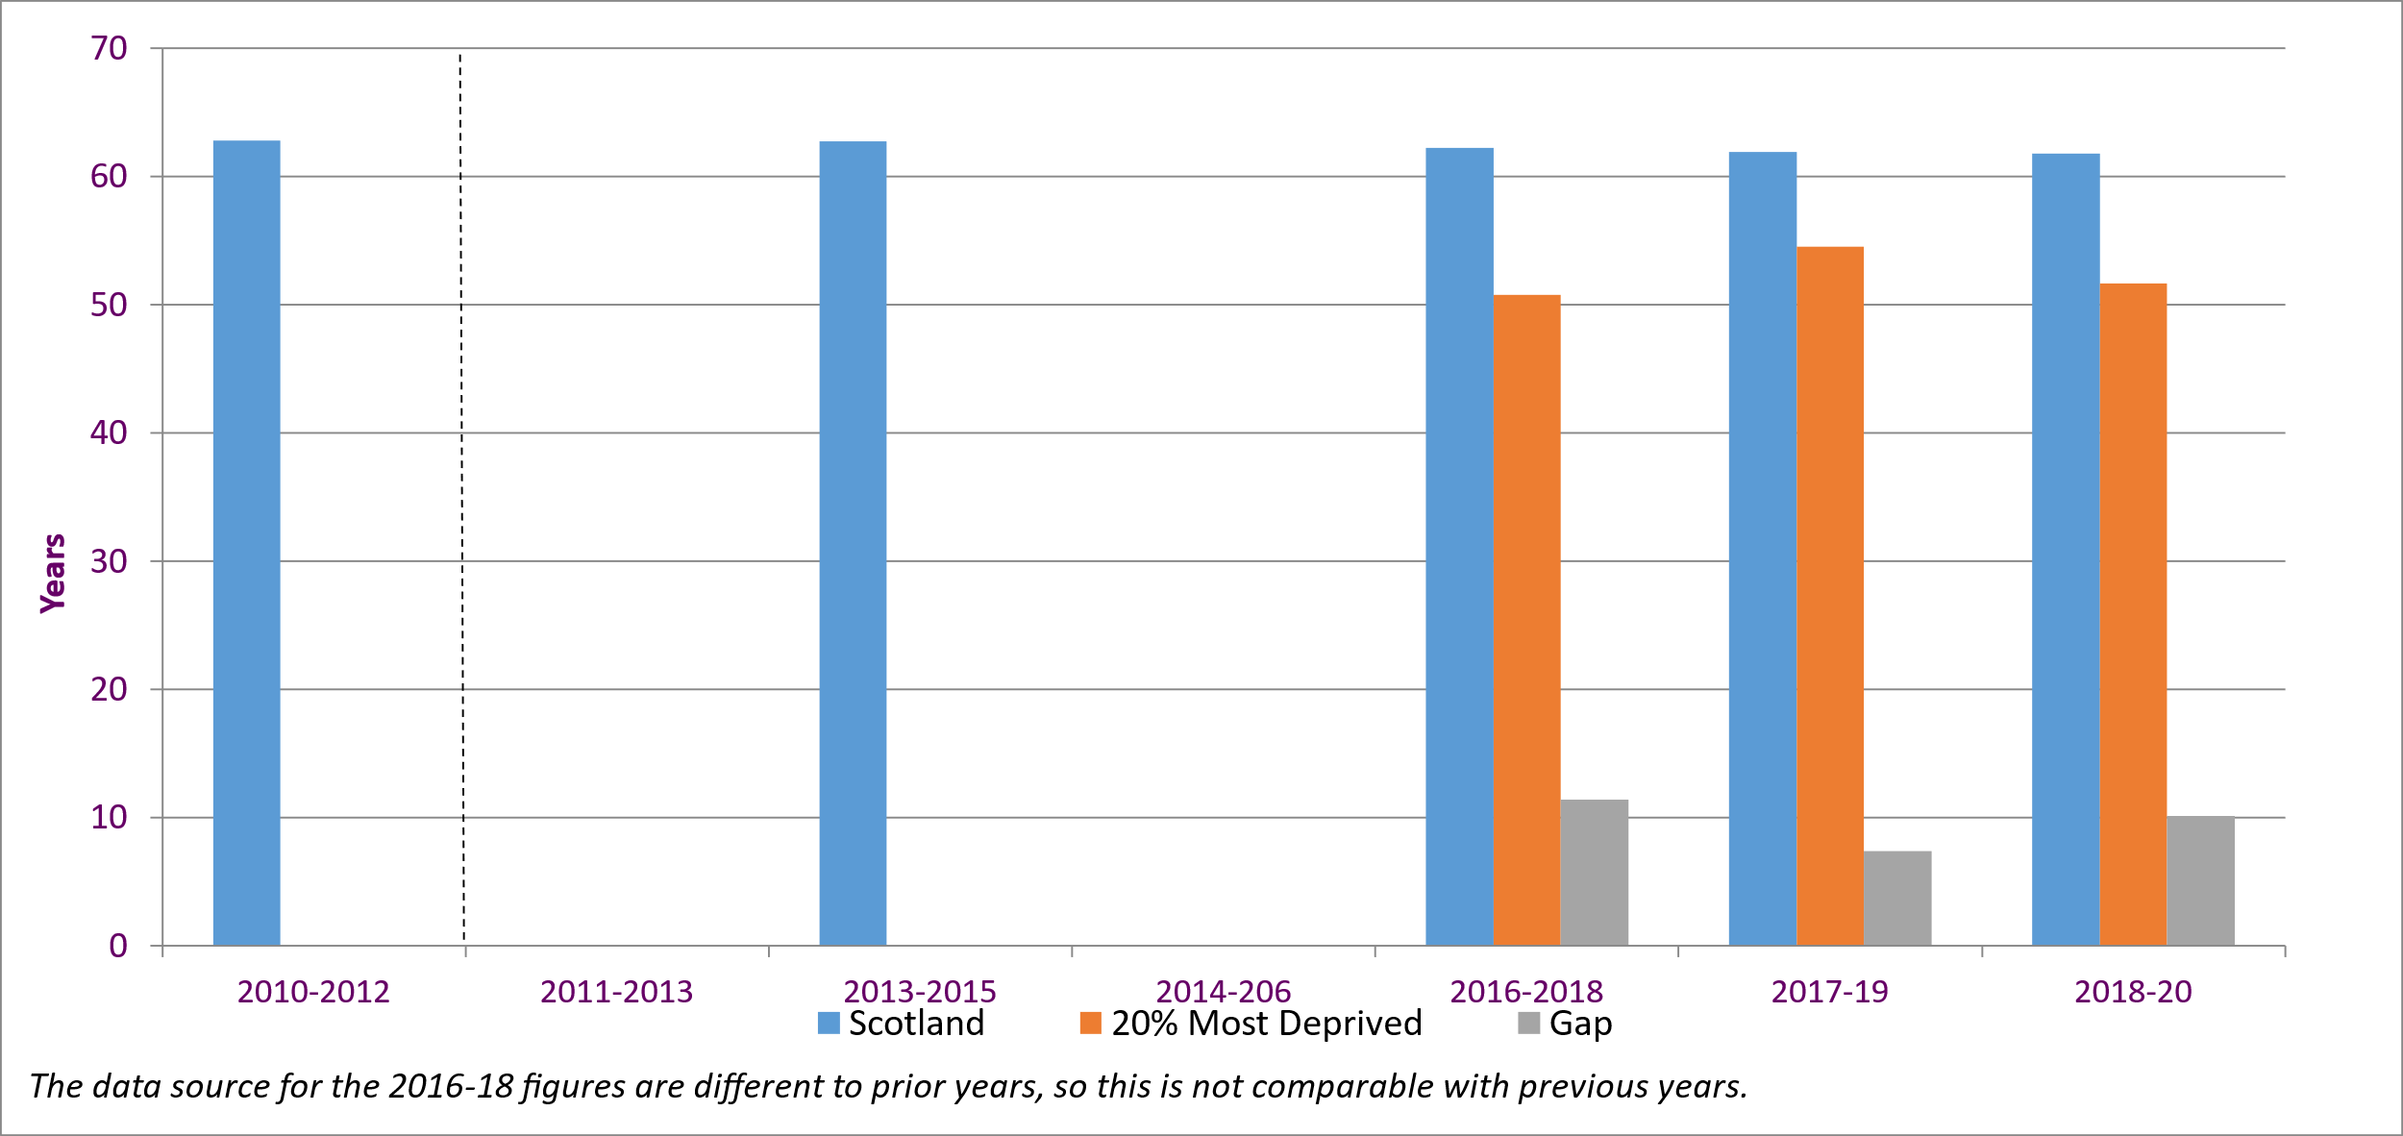
These charts show the Healthy Life Expectancy (HLE) of males and females over the past 10 years, for Scotland overall and for the 20% most deprived areas, along with the inequality gap.
Using the latest methodology, the Healthy Life Expectancy of males in 2016-18 was 61.9 years in Scotland with the most deprived being 49.7 years, a gap of over 12.2 years. The gap reduced to 8.6 years in 2017-19, before increasing again to 10.1 in 2018-20, with healthy life expectancy at 60.9 for all males, but only 50.8 for the 20% most deprived. As the increase in the gap in the latest period was below the 2.0 percentage points thresholds, the performance for this indicator is considered to be ‘maintaining’.
For females, the Healthy Life Expectancy in 2016-18 was 62.2 years in Scotland compared to 50.8 years in the most deprived areas, a gap of 11.4 years, falling to 7.4 in 2017-19 before rising again to 10.1 in 2018-20, with healthy life expectancy at 61.8 for all females, but only 51.7 for the 20% most deprived.
[Chart 33 – Healthy Life Expectancy Gap (Source: National Records of Scotland - Healthy Life Expectancy in Scotland)]
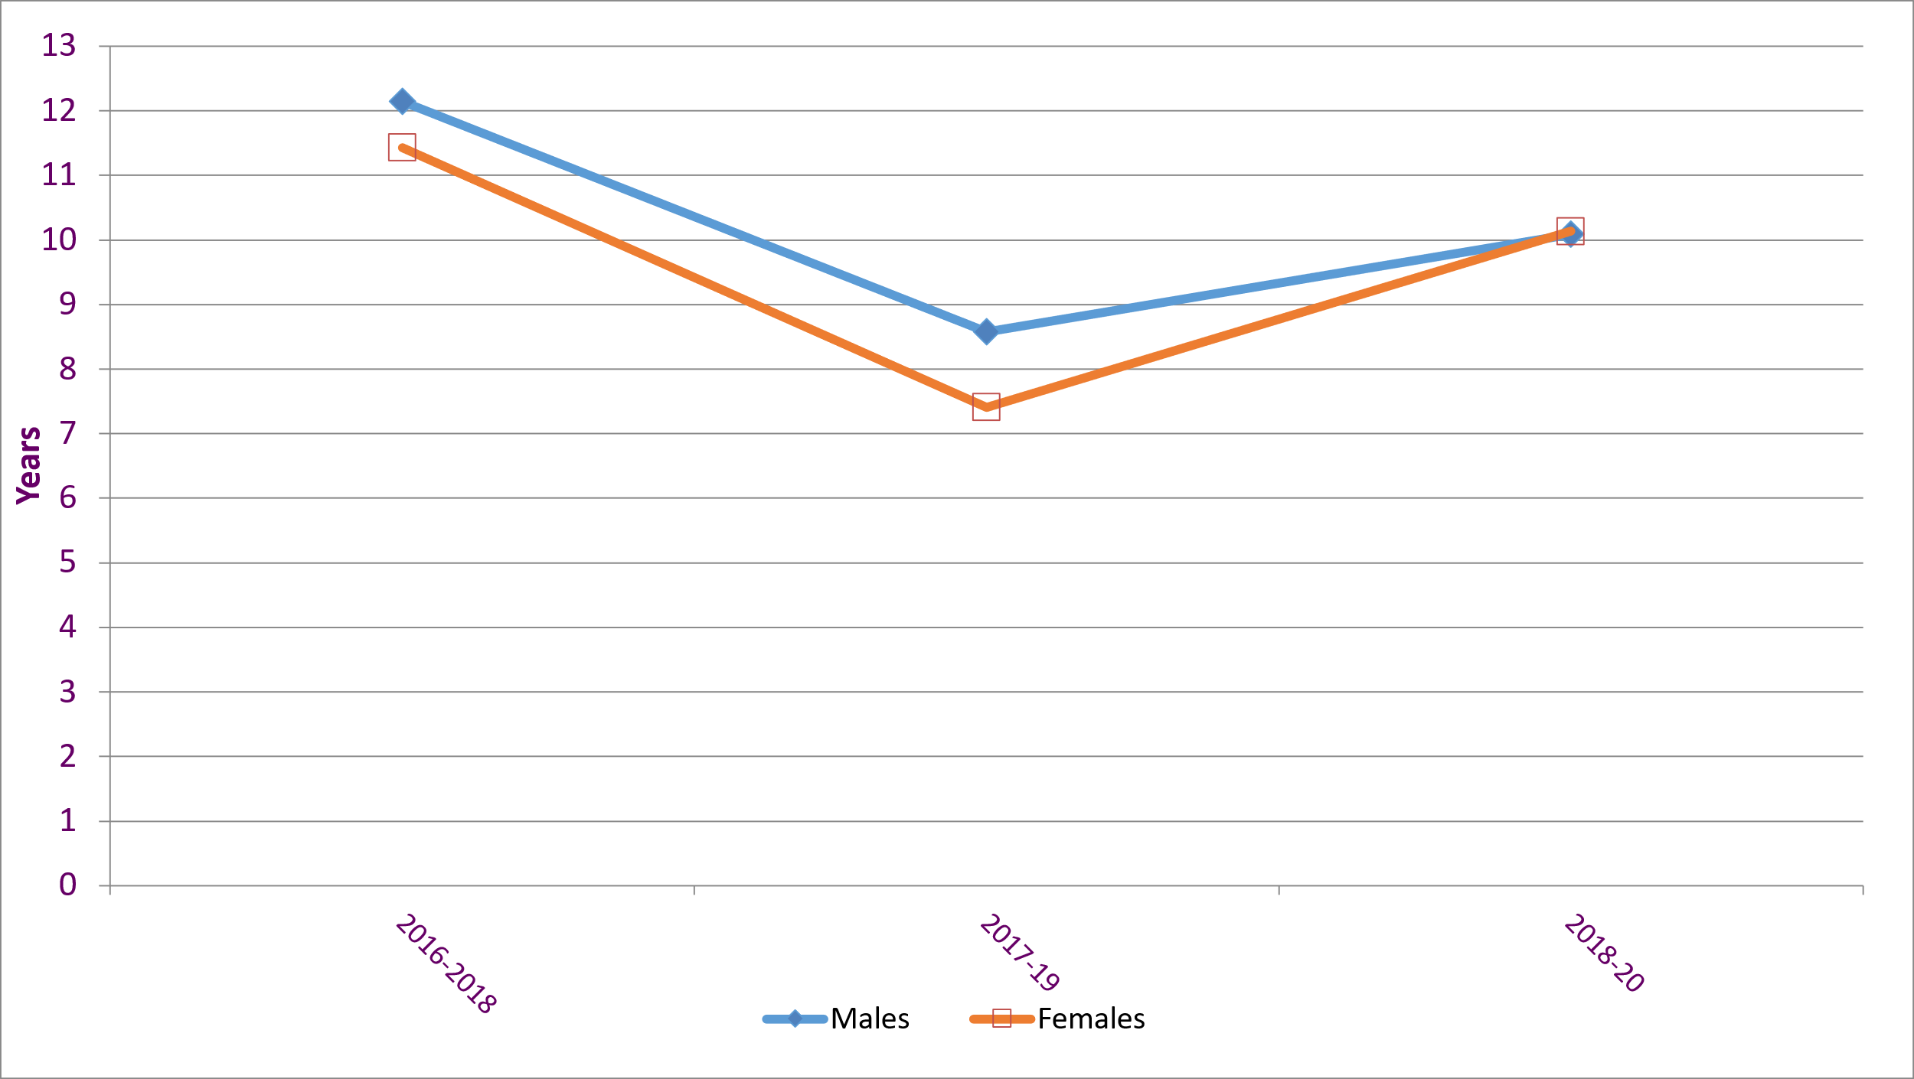

Physically Sustainable Communities
[Chart 34 – Percentage of People Rating their Neighbourhood as a Very Good Place to Live (Source: Scottish Government - Scottish Household Survey)]
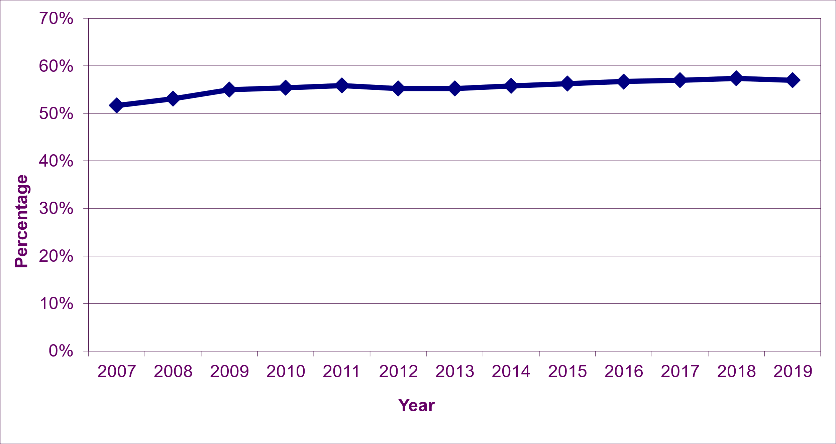
The percentage of people rating their neighbourhood as a very good place to live, has increased gradually from 51.7% in 2007 to 57.4% in 2018, though fell slightly to 57.0% in 2019, resulting in a ‘maintaining’ performance for this indicator in the latest period.

Note that due to the impacts from the Covid pandemic period, the results of the SHS 2020 telephone survey are not directly comparable to SHS results for previous years, and are not considered suitable for the purposes of indicator reporting.

[Chart 35 – Amount of Derelict and (Urban) Vacant Land (Source: Scottish Government - Scottish Vacant and Derelict Land Survey)]
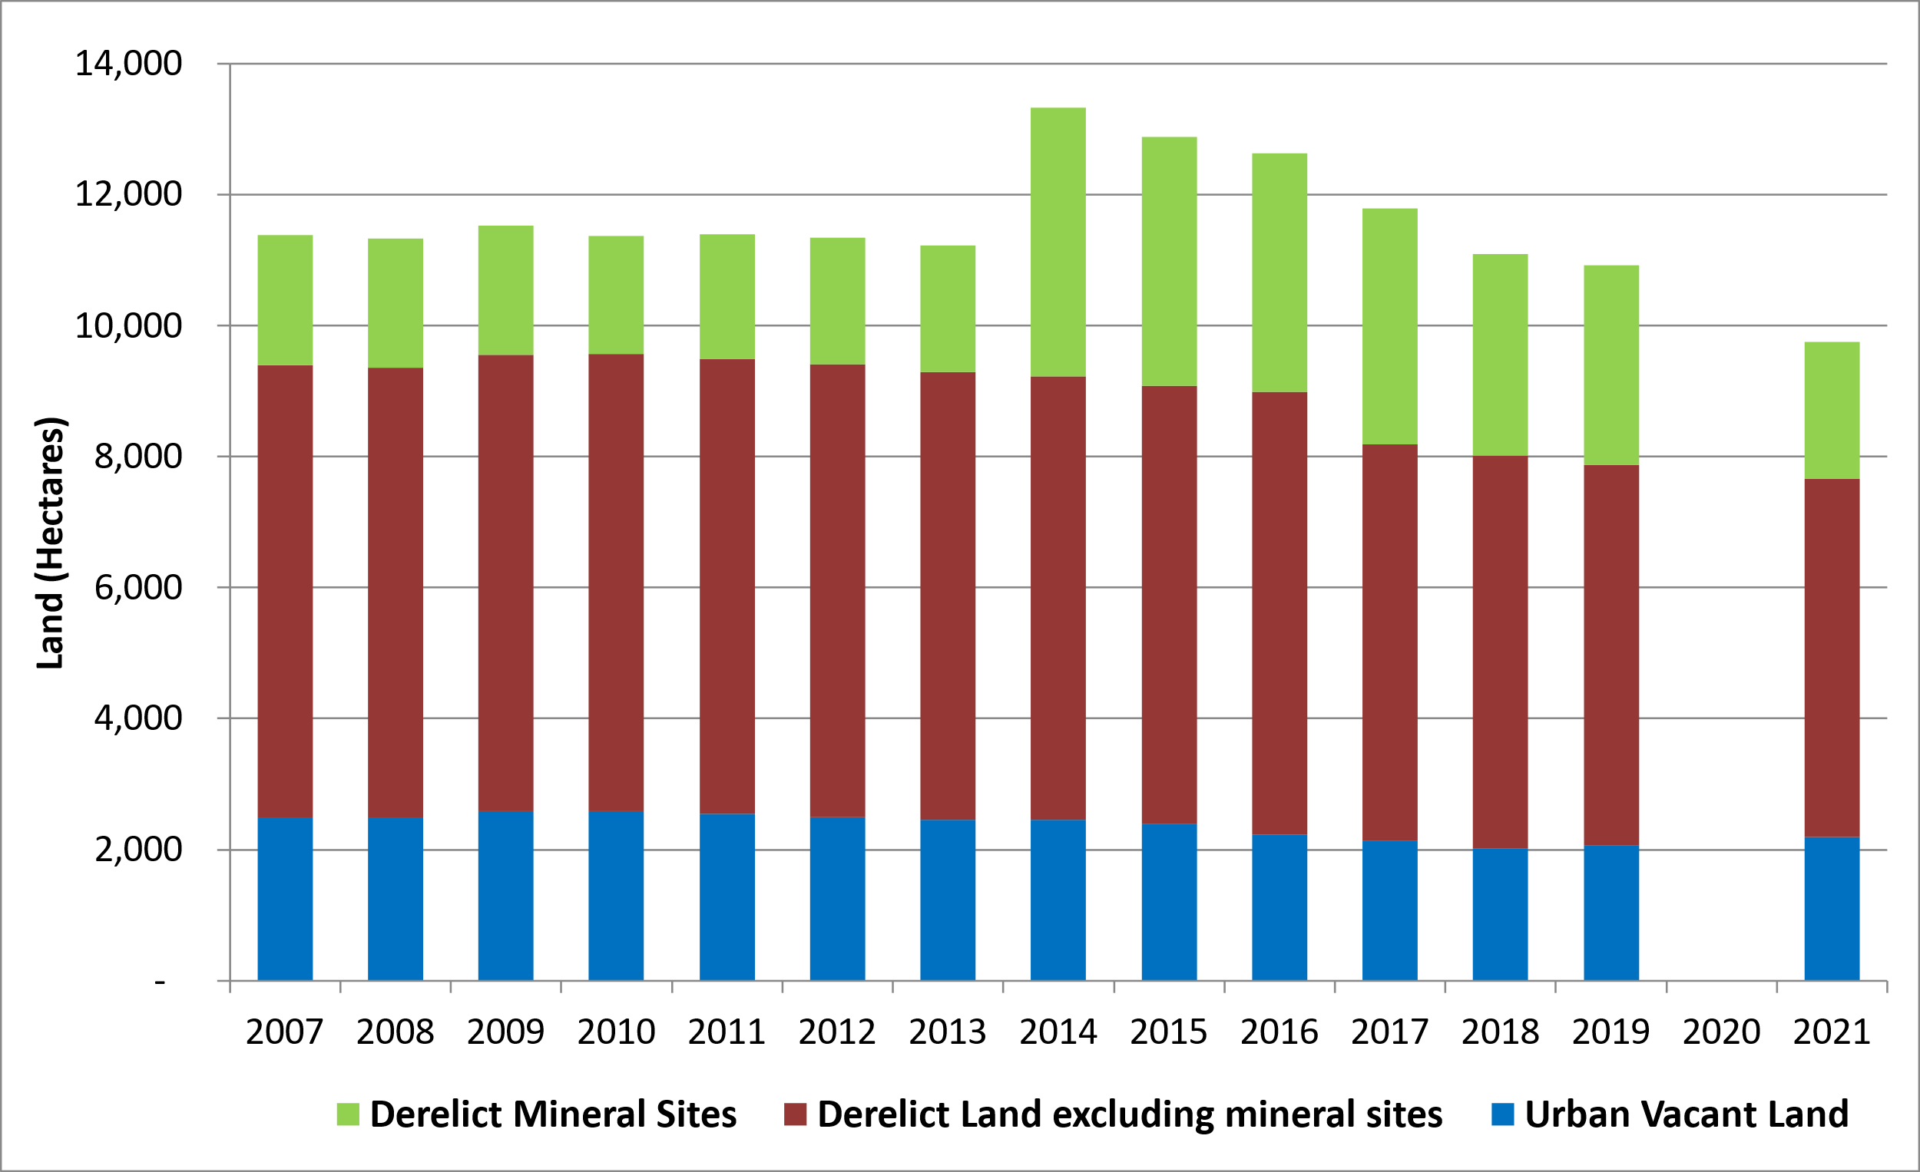
In 2014, there was a large increase in derelict mineral sites of 2,175 to 4,110 hectares (ha), mostly due to former surface coal mining sites that became derelict in East Ayrshire.
Since 2014, there has been a decrease of 2,016 (ha) (49%) in derelict mineral sites; a decrease of 1,300 (ha) (19%) in other derelict land (mostly between 2016 and 2017) and a decrease in urban vacant land of 262 (ha) (11%).
The total amount of derelict and urban vacant land decreased by 1,176 (ha) (11%) between 2019 and 2021, to 9,750 (ha). As data is missing for 2020, performance has been evaluated using twice the normal threshold (400 hectares rather than 200 hectares). This means the indicator is “improving”.

Note that Scottish Vacant and Derelict Land statistics were not published for the 2020 survey. The statistics publication was suspended for that year because of limitations to survey returns due to COVID-19 pandemic related restrictions. It was not possible to produce a robust set of Scotland figures or ensure the quality of the returns is consistent with previous years, particularly in relation to any potential new sites.

Socially Sustainable Communities
[Chart 36 – The Percentage of People Who Agree that Their Council Provides a High Quality Service (Source: Scottish Government - Scottish Household Survey)]
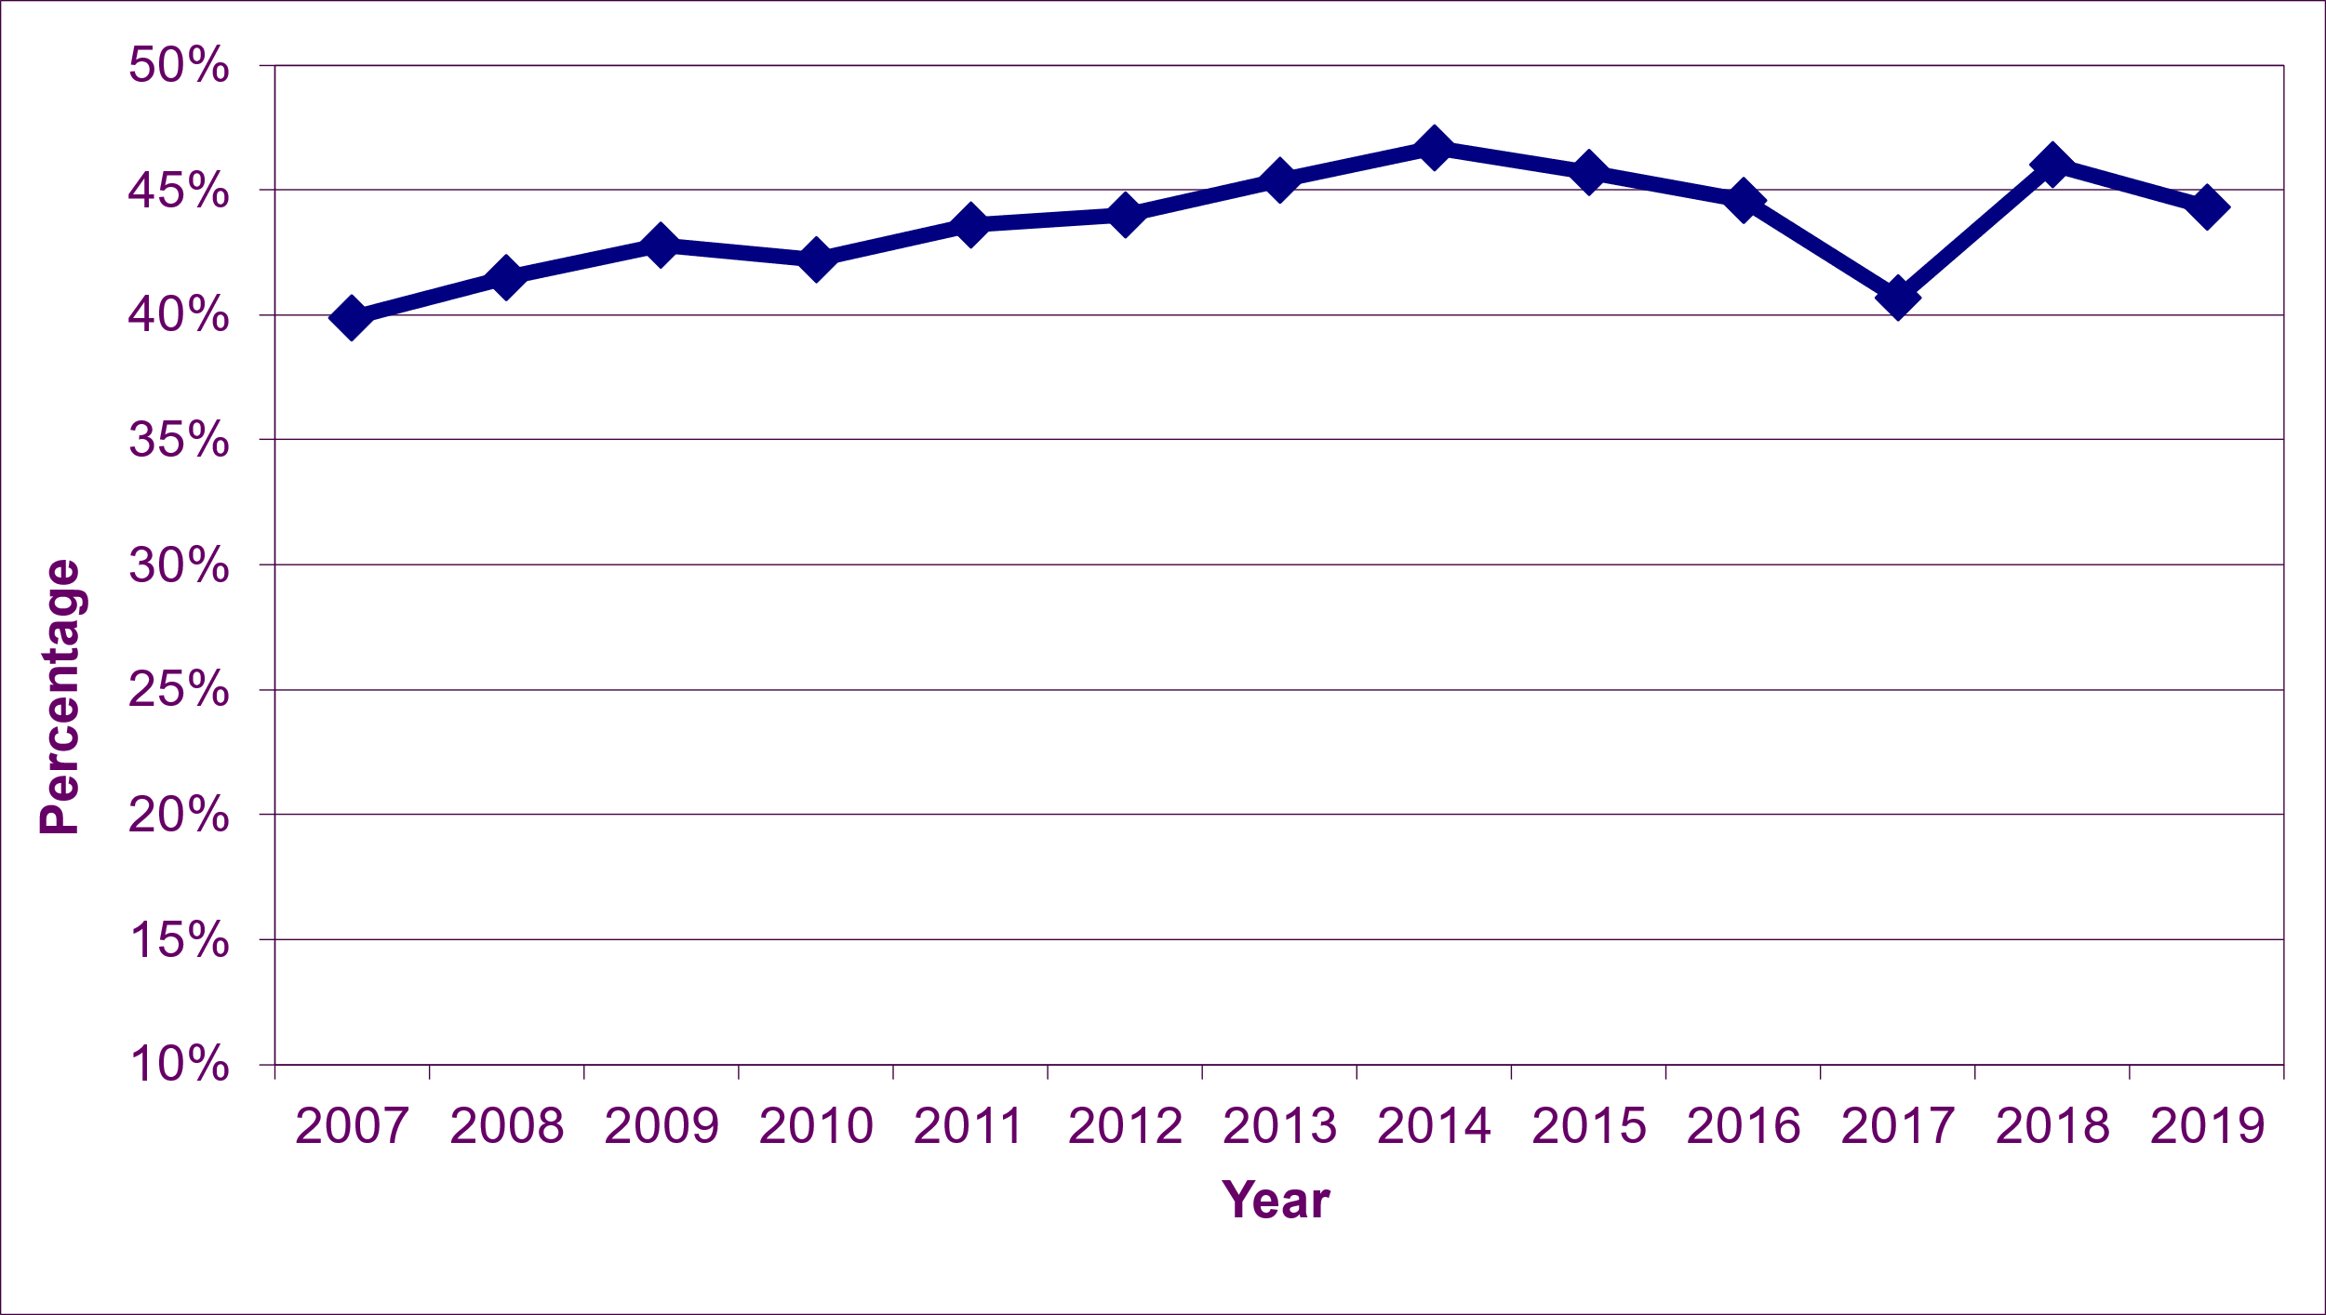
The percentage of people who agree that their Council provides a high quality service generally increased by 6.8 percentage points from 39.9% in 2007 to 46.7% in 2014.
This was followed by a 6.0% point decrease in the following 3 years to 2017, including a large decrease of 3.9 percentage points from 44.6% in 2016 to 40.7% in 2017. In 2018, the percentage increased by 5.3 percentage points to 46.0%, falling again in 2019 to 44.3%, a 1.7 percentage point drop, resulting in a ‘worsening’ performnce for this indicator.
Note that due to the impacts from the Covid pandemic period, the results of the SHS 2020 telephone survey are not directly comparable to SHS results for previous years, and are not considered suitable for the purposes of indicator reporting.

[Chart 37 – Percentage of People Satisfied with Community Centres and Facilities (Source: Scottish Government - Scottish Household Survey)]
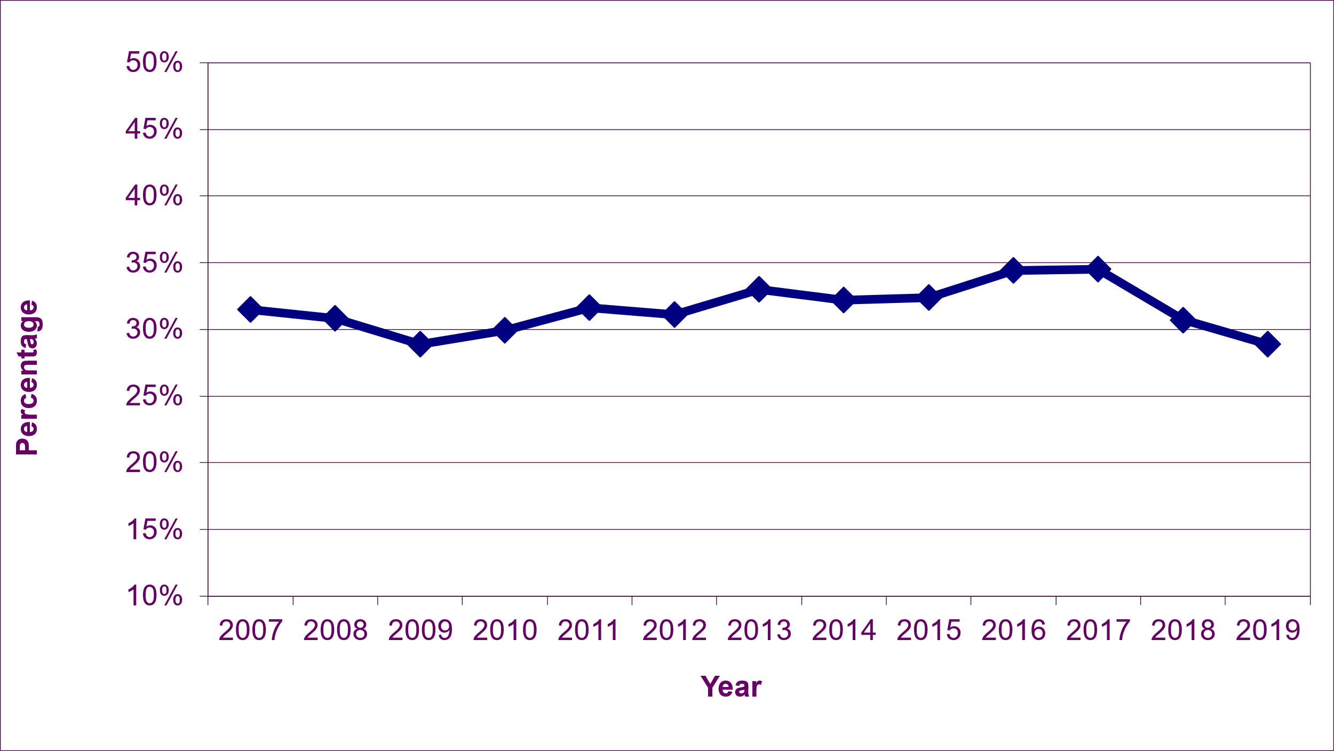
The percentage of people satisfied with Community Centres and Facilities increased by 5.5 percentage points from 28.9% in 2009 to 34.4% in 2016.
There was virtually no change in 2017, with the percentage remaining at 34.5%, falling to 30.7% in 2018 and then another 1.8 percentage points to 28.9% in 2019, resulting in a ‘worsening’ performance for this indicator..
Note that due to the impacts from the Covid pandemic period, the results of the SHS 2020 telephone survey are not directly comparable to SHS results for previous years, and are not considered suitable for the purposes of indicator reporting.

[Chart 38 – Percentage of People who Believe they Can Influence Decisions in Their Area (Source: Scottish Government - Scottish Household Survey)]
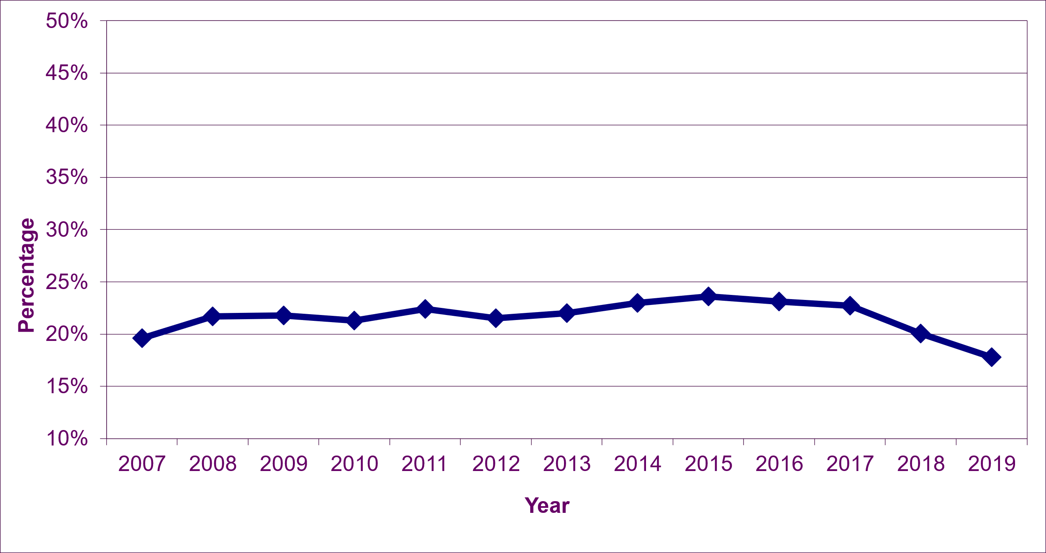
The percentage of people who believe they can influence decisions in their area increased by 4.0 percentage points from 19.6% in 2007 to 23.6% in 2015.
This has since fallen each year since, reaching 17.8% in 2019, a fall of 5.8 percentage points since 2015. The fall of 2.3 percentage points in the last year results in a ‘worsening’ performance for this indiocator.
Note that due to the impacts from the Covid pandemic period, the results of the SHS 2020 telephone survey are not directly comparable to SHS results for previous years, and are not considered suitable for the purposes of indicator reporting.

[Chart 39 – Percentage of People Who Feel Safe Whilst Walking Alone in Their Neighbourhood at Night (Source: Scottish Government - Scottish Household Survey)]
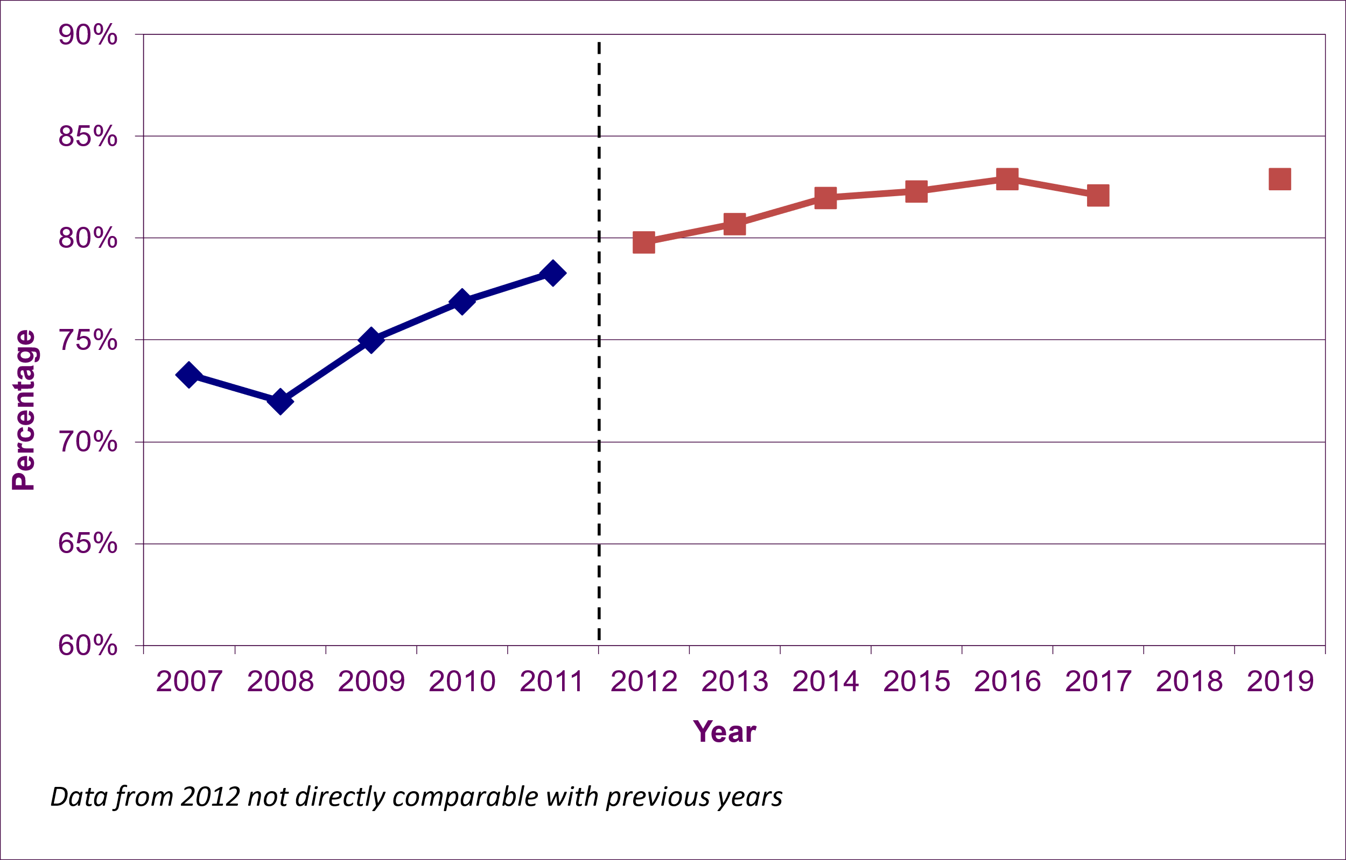
Note: There has been a downward revision to previous figures for 2012 to 2016, in the range of 2.5% to 2.9%. This reflects the inclusion of people who answered ‘Don’t Know’ to this question, who were previously excluded from the results.
There was a marked increase in the percentage of people who feel safe walking alone in their neighbourhood at night, from 72.0% in 2008 to 78.3% in 2011.
There was a change in the Scottish Household Survey questions, which mean that results from 2012 are not directly comparable with the past.
There was continued improvement in this indicator, with an increase of 3.1 percentage points from 79.8% in 2012 to 82.9% in 2016. Since then, it has remained roughly level, at 82.9% in 2019..
As data is missing for 2018, performance has been evaluated using twice the normal threshold (a change of more than 2.0 percentage points rather than 1.0). This means the indicator is “maintaining”.
Note this question was removed from the 2018 SHS questionnaire. Therefore, no data is available for 2018. Due to the impacts from the Covid pandemic period, the results of the SHS 2020 telephone survey are not directly comparable to SHS results for previous years, and are not considered suitable for the purposes of indicator reporting.

