Growth Sector Briefing - Sustainable Tourism
Office of the Chief Economic Adviser
14 March 2024

Growth Sector Definition
Sustainable Tourism sector was identified in Scotland’s Economic Strategy (2015) as one of the growth sectors in which Scotland can build on existing comparative advantage and increase productivity and growth. Scotland’s tourism sector is a diverse industry, with a range of sub-sectors such as hotels, camping sites and other provision of short stay accommodation, restaurants, bars, travel agents, museums and other recreational and cultural activities. In addition, other sectors in the Scottish economy, for example retail and transport, benefit directly and/or indirectly from the tourism industry. Economic activity generated by tourism expenditure cannot be precisely captured using SIC Codes, as tourism is a characteristic of demand rather than specific products or services. However, a number of industries within the service sector can be used to capture economic activity in a set of tourism-related industries outlined below. Data based on this classification do not represent a direct measure of economic activity from tourism, as part of the demand in these industries will be generated by non-tourists as well as tourists.
The Sustainable Tourism growth sector is defined by the Standard Industrial Classification (SIC) 2007 codes:
SIC 55.1: Hotels and similar accommodation
SIC 55.2: Holiday and other short-stay accommodation
SIC 55.3: Camping grounds, recreational vehicle parks and trailer parks
SIC 56.1: Restaurants and mobile food service activities
SIC 56.3: Beverage serving activities
SIC 79.12: Tour operator activities
SIC 79.9: Other reservation service and related activities
SIC 91.02: Museum activities
SIC 91.03: Operation of historical sites and buildings and similar visitor attractions
SIC 91.04: Botanical and zoological gardens and nature reserve activities
SIC 93.11: Operation of sports facilities
SIC 93.199: Other sports activities (not including activities of racehorse owners) nec
SIC 93.21 Activities of amusement parks and theme parks
SIC 93.29: Other amusement and recreation activities

Key Statistics

Recent trends in GDP (2023 Q4)
Updated March 2024, next update June 2024
The latest GDP data show that output in the Sustainable Tourism growth sector increased by 1.0% in the most recent quarter, whereas output across the economy as a whole decreased by 0.6%. Compared with the same quarter in the previous year, output in this sector increased by 3.2%, whereas output across the economy as a whole decreased 0.3%, comparing Q4 2023 to Q4 2022.

Employment (2022)
Updated November 2023, next update November 2024
Employment in the Sustainable Tourism growth sector stood at 229,000 in 2022, accounting for 8.7% of employment in Scotland and 8.6% of employment in Sustainable Tourism across Great Britain. Employment in this sector increased by 9.6% over the latest year in Scotland.

Employment across Scotland (2022)
Updated November 2023, next update November 2024
In 2022, employment in the Sustainable Tourism growth sector was highest in City of Edinburgh (37,000) and Glasgow City (33,000), which comprised 16.2% and 14.4% of employment in this sector respectively.

Exports (2021)
Updated March 2024, next update tbc
Total exports from the Sustainable Tourism growth sector stood at £600 million in 2021, accounting for 0.8% of Scotland’s total exports. Exports from this sector increased by 23.7% over the year.
Exports to the rest of the UK stood at £415 million in 2021 and accounted for 69.2% of total Sustainable Tourism exports. International exports to the EU stood at £85 million (14.2%) and international exports to non-EU countries stood at £100 million (16.7%).

Turnover/Gross Value Added (2021)
Updated August 2023, next update August 2024
In 2021, total turnover in the Sustainable Tourism growth sector was £6,535.1 million. Between 2020 and 2021, total turnover in this growth sector increased by 29.1% in nominal terms.
Gross Value Added for the Sustainable Tourism growth sector was estimated at £3,365.8 million in 2021, an increase of 31.3% compared to 2020 (£2,564.4 million).

Enterprises (2023)
Updated December 2023, next update December 2024
In March 2023, there were 15,830 registered enterprises operating in the Sustainable Tourism growth sector, representing 9.1% of all registered business in Scotland. In 2023, 96.9% of Scottish Sustainable Tourism registered enterprises were small (0-49 employees), accounting for 52.3% of employment in this sector, whilst large enterprises (250+ employees) accounted for 1.0% of registered enterprises but 32.9% of employment.
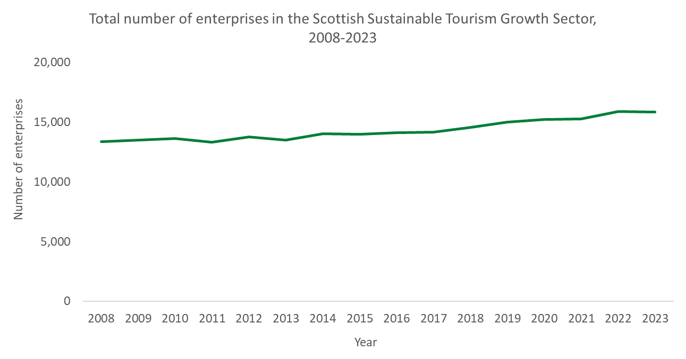
The majority of enterprises in the Sustainable Tourism sector were UK owned with their registered office address in Scotland (98.1%), accounting for 77.9% of sector employment in 2023. 0.9% of businesses were registered abroad, but they accounted for 11.9% of employment in this sector.

Earnings (2023)
Updated December 2023, next update December 2024
Median weekly full time earnings across the Scottish Sustainable Tourism growth sector stood at £498.3 in 2023, which was lower than the Scottish average at £702.8.

Business Demography (2022)
Updated March 2024, next update March 2025
The number of registered business births (VAT/PAYE registrations) in the Sustainable Tourism growth sector in Scotland decreased by 1.3%, from 2,295 in 2021 to 2,265 in 2022. The business birth rate, which is the number of births as a percentage of active businesses, was 12.5%. In comparison, business births in Sustainable Tourism across the UK decreased by 3.9% between 2021 and 2022, with a birth rate of 12.6%.
The number of business deaths (VAT/PAYE de-registrations) in the Sustainable Tourism growth sector in Scotland increased by 32.4%, from 1,605 in 2021 to 2,125 in 2022. The business death rate, which is the number of deaths as a percentage of active businesses, was 11.7%. In comparison, business deaths in Sustainable Tourism across the UK increased by 37.5% between 2021 and 2022, with a death rate of 11.6%.

Sources of information
GDP – Scottish Government Quarterly GDP Index.
Employment – Business Register and Employment Survey.
Exports – Export Statistics Scotland.
Turnover & GVA - Scottish Annual Business Statistics.
Enterprises – Inter Departmental Business Register.
Earnings – Annual Survey of Hours & Earnings.
Business Demography - Inter Departmental Business Register and ONS Business Demography.
All data are available from the Growth Sector Statistics Database: https://www.gov.scot/publications/growth-sector-statistics/
All percentages and percentage changes over time are calculated based on the rounded figures shown in the Growth Sector Statistics Database.
For more information about the methodology behind the Growth Sector Statistics Database, please see the Methodology Note: https://www.gov.scot/binaries/content/documents/govscot/publications/statistics/2019/07/growth-sector-statistics/documents/growth-sector-method-note/growth-sector-method-note/govscot%3Adocument/Growth%2BSectors%2BMethodology%2Bdocument.docx

The index represents the volume of GVA created compared to the ‘base’ year (currently 2019). Figures are deflated to remove the effect of price changes over time to produce an estimate of real terms (or constant price) growth. The figures are seasonally adjusted to remove the effects of regular, calendar based cycles in certain industries.
The figures for the growth sectors are derived by aggregating estimates based at a low Standard Industrial Classification (SIC) level. Export Statistics Scotland is not designed to collect data at this level of accuracy, therefore these results should be treated as indicative.
Employment statistics referred to here are not directly comparable with Business Register and Employment Survey (BRES) employment data.

