Growth Sector Briefing - Creative Industries
Office of the Chief Economic Adviser
14 March 2024

Growth Sector Definition
Scotland’s Creative Industries were identified in Scotland’s Economic Strategy (2015) as one of the growth sectors in which Scotland can build on existing comparative advantage and increase productivity and growth. For more information on the details of the SIC codes used to define this Growth Sector, please see the Creative Industries SIC 2007 definition in the Growth Sector Statistics Database and the Growth Sector Statistics Methodology Note.

Key Statistics

Recent trends in GDP (2023 Q4)
Updated March 2024, next update June 2024
The latest GDP data show that output in the Creative Industries growth sector decreased by 0.3% in the most recent quarter, with output across the economy as a whole decreasing by 0.6%. Compared with the same quarter in the previous year, output in this sector decreased by 2.0%, with output across the economy as a whole decreasing by 0.3%, comparing Q4 2023 to Q4 2022.

Employment (2022)
Updated November 2023, next update November 2024
Employment in the Creative Industries growth sector stood at 88,000 in 2022, accounting for 3.4% of employment in Scotland and 5.4% of employment in Creative Industries across Great Britain. Employment in this sector increased by 11.4% over the latest year in Scotland.

Employment across Scotland (2022)
Updated November 2023, next update November 2024
In 2022, employment in the Creative Industries growth sector was highest in Glasgow City (25,060) and City of Edinburgh (21,065), which comprised 28.5% and 23.9% of employment in this sector respectively.

Exports (2021)
Updated March 2024, next update tbc
Total exports from the Creative Industries growth sector stood at £3.8 billion in 2021, accounting for 4.7% of Scotland’s total exports. Exports from this sector increased by 14.2% over the year.
Exports to the rest of the UK stood at £2.0 billion in 2021 and accounted for 53.8% of total Creative Industries exports. International exports to the EU stood at £680 million (18.0%) and international exports to non-EU countries stood at £1.1 billion (28.3%).

Turnover/Gross Value Added (2021)
Updated August 2023, next update August 2024
In 2021, total turnover in the Creative Industries growth sector was £8,969.8 million. Between 2020 and 2021, total turnover in this growth sector increased by 12.9% in nominal terms.
Gross Value Added for the Creative Industries growth sector was estimated at £4,440.2 million in 2021, an increase of 1.7% compared to 2020 (£4,366.4 million).

Enterprises (2023)
Updated December 2023, next update December 2024
In March 2023, there were 13,030 registered enterprises operating in the Creative Industries growth sector, representing 7.5% of all registered business in Scotland. In 2023, 97.3% of Scottish Creative Industries registered enterprises were small (0-49 employees), accounting for 51.0% of employment in this sector, whilst large enterprises (250+ employees) accounted for 0.9% of registered enterprises but 29.9% of employment.
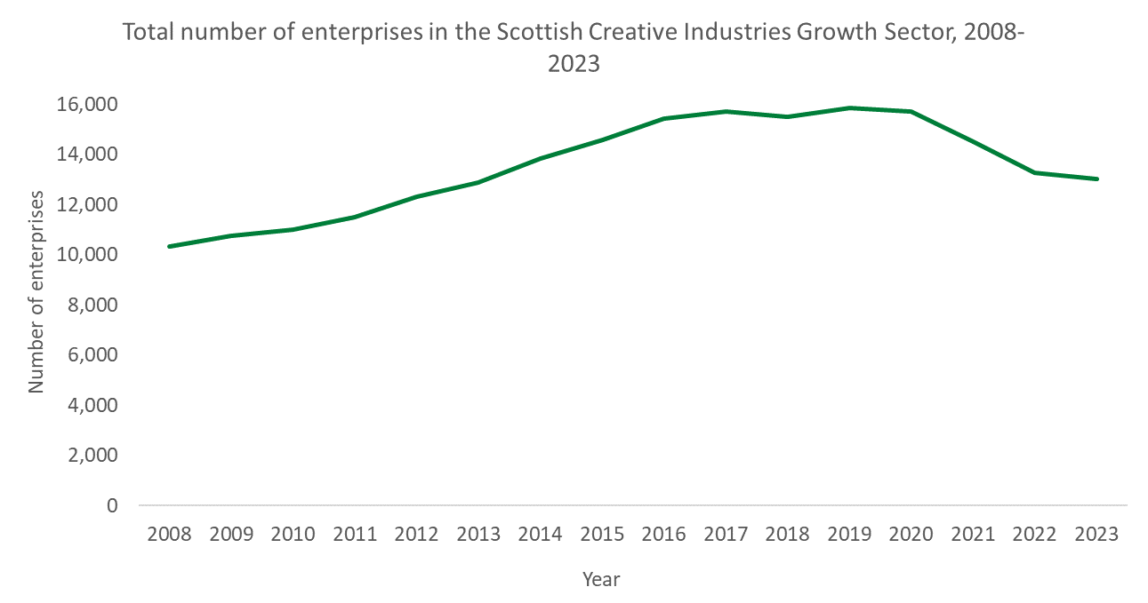
The majority of enterprises in the Creative Industries sector were UK owned with their registered office address in Scotland (96.7%), accounting for 66.1% of sector employment in 2023. 1.9% of businesses were registered abroad, but they accounted for 27.1% of employment in this sector.

Earnings (2023)
December 2023, next update December 2024
Median weekly full time earnings across the Scottish Creative Industries growth sector stood at £689.9 in 2023, which was lower than the Scottish average at £702.8.

Business Demography (2022)
Updated March 2024, next update March 2025
The number of registered business births (VAT/PAYE registrations) in the Creative Industries growth sector in Scotland increased by 2.8%, from 1,405 in 2021 to 1,445 in 2022. The business birth rate, which is the number of births as a percentage of active businesses, was 9.8%. In comparison, business births in Creative Industries across the UK decreased by 0.7% between 2021 and 2022, with a birth rate of 9.8%.
The number of business deaths (VAT/PAYE de-registrations) in the Creative Industries growth sector in Scotland decreased by 22.9%, from 2,490 in 2021 to 1,920 in 2022. The business death rate, which is the number of deaths as a percentage of active businesses, was 13.0%. In comparison, business deaths in Creative Industries across the UK decreased by 9.5% between 2021 and 2022, with a death rate of 12.1%.

Sources of information
GDP – Scottish Government Quarterly GDP Index.
Employment – Business Register and Employment Survey.
Exports – Export Statistics Scotland.
Turnover & GVA - Scottish Annual Business Statistics.
Enterprises – Inter Departmental Business Register.
Earnings – Annual Survey of Hours & Earnings.
Business Demography - Inter Departmental Business Register and ONS Business Demography.
All data are available from the Growth Sector Statistics Database: https://www.gov.scot/publications/growth-sector-statistics/
All percentages and percentage changes over time are calculated based on the rounded figures shown in the Growth Sector Statistics Database.
For more information about the methodology behind the Growth Sector Statistics Database, please see the Methodology Note: https://www.gov.scot/binaries/content/documents/govscot/publications/statistics/2019/07/growth-sector-statistics/documents/growth-sector-method-note/growth-sector-method-note/govscot%3Adocument/Growth%2BSectors%2BMethodology%2Bdocument.docx

The index represents the volume of GVA created compared to the ‘base’ year (currently 2019). Figures are deflated to remove the effect of price changes over time to produce an estimate of real terms (or constant price) growth. The figures are seasonally adjusted to remove the effects of regular, calendar based cycles in certain industries.
The figures for the growth sectors are derived by aggregating estimates based at a low Standard Industrial Classification (SIC) level. Export Statistics Scotland is not designed to collect data at this level of accuracy, therefore these results should be treated as indicative.
Employment statistics referred to here are not directly comparable with Business Register and Employment Survey (BRES) employment data.

