Accompanying Commentary for the 2016 Facts and Figures

The 2016 Agriculture Facts and Figures for Scotland, available at www.gov.scot/agrifactsfigs2016 gives a selection of key statistics for agriculture in Scotland, often alongside some comparative data from elsewhere in the UK. More detailed information on agriculture in Scotland is available in the Economic Report on Scottish Agriculture (ERSA) and other Scottish Government statistical publications.

Chart 1 Income and Expenditure 2015

Chart 1 shows estimates of the outputs (light red on the left) and costs (dark red on the right) in Scottish agriculture in 2015, with gross outputs worth £2.94 billion, input costs of £2.72 billion and subsidies worth £0.45 billion (plus £38m of coupled support included in the outputs figure). The chart provides detail on the elements that make up these totals. Although many of the costs are very provisional, the fact that the light red comes further round the circle than the dark red, even without adding the subsidies, suggest that agriculture was “in the black” before subsidies were added.

Agriculture in the Economy (Table 1)
Gross Value Added (GVA) is a measure of the size or importance of agriculture to the Scottish economy. Table 1 shows that agricultural accounts for just over half a per cent of total Scottish GVA. However, this small percentage masks the fact that agriculture can be the first stage in producing output for additional processing in downstream sectors, such as the food and drinks industry, which in 2013 had a GVA over six times that of agriculture. More details about the food and drink sector can be found in table 10.

Results from the June agricultural census indicate an agricultural workforce in Scotland of 65,000, two and a half per cent of the total Scottish workforce. While England has the largest agricultural workforce within the UK, it has the lowest proportion of its overall workforce working in the agricultural industry (1.1 per cent). Of the four nations, Northern Ireland has the highest proportion of its workforce working in agriculture, with Wales second.

Farm Holdings in 2015 (Table 2)
This table provides data on the number of holdings on the various farm types in Scotland, along with the area that they cover.

Scottish Agriculture in 2015 (Table 3)
The table shows the extent to which rough grazing dominates land usage, with grass and then barley the major crops. Eighty-four per cent of land is Less Favoured Area. Livestock numbers have seen small increases since last year, with the exception of poultry.

Sector Share of Output 2015 (Table 4)
In terms of total agricultural output values, the UK as a whole has a fairly even split between crops and finished livestock - in contrast, in EU28 countries crop output is worth more than double the output value of finished livestock. Within the UK, there is a particularly high reliance on livestock and livestock products: in Northern Ireland (milk 28 per cent, cattle 23 per cent, poultry 14 per cent) and Wales (milk 31 per cent, cattle 25 per cent, sheep 17 per cent). While a large proportion of Scottish output also comes from livestock (cattle 23 per cent, milk 12 per cent, sheep six per cent), Scotland also has significant cereal (11 per cent), horticulture (nine per cent) and potato (six per cent) sectors.

Importance of the LFA (Table 5)
There is a wide range of suitability of land used for agriculture in the UK. While Scotland contains around one third of UK agricultural land area, it has over half of the UK’s “less favoured” land. In fact 84 per cent of Scotland’s land is designated “less favoured”, compared to 80 per cent in Wales, 69 per cent in Northern Ireland and only 16 per cent in England.

Arable Sector (Table 6)
Short term trends in cereal production tend to be influenced by a number of factors; very often weather. Outputs in 2015 showed little change from last year, with wheat and oilseeds up three per cent and one per cent respectively. Barley and oats were down by seven per cent and one per cent respectively; the number of holdings were reduced in 2015 for barley, oilseeds and potatoes, while numbers for wheat and oats increased. Average area per holding decreased in all categories.

Dairy Sector (Table 7)
In 2015 there was a very small decrease in the number of holdings in Scotland with more than 25 dairy cows, from 1,006 in 2014 to 1,000 in 2015. The average number of dairy cows on these holdings has risen, from 166 to 173; the total number of dairy cows has gone up from 170,000 to 176,000. Milk production increased by four per cent in 2015.

Beef Sector (Table 8)
The total number of beef cows remained broadly the same in 2015, at 437,000. There was a decrease in the number of holdings with beef cows, from 9,348 to 9,265 (one per cent); the average number of beef cows per holding saw no change from last year, remaining at 47. There was a one per cent drop in cattle output in 2015.

Sheep Sector (Table 9)
The sheep sector saw a small increase in 2015, but there was a less than one per cent decrease in the number of breeding ewes between 2014 and 2015, and a very slight decrease in the number of holdings with breeding ewes. Total sheep output numbers (i.e. sheep available for production) also decreased slightly in 2015.

Food & Drink Manufacturing Sector (Table 10)
Results from the Exports Statistics Scotland 2014 Publication Tables indicate that, in terms of international exports, food & beverage manufacturing was Scotland’s largest exporting industry by value (£5.0 billion, making up 32 per cent of total international exports). The export value of food & beverages has remained steady in recent years, at around £5.0 billion.

Scottish Annual Business Statistics show turnover of £10.5 billion for food & beverage manufacturing in 2013, with a GVA of £3.9 billion. Almost two thirds of this GVA comes from beverages (61 per cent), with bakery and farinaceous products (10 per cent) and meat and fish processing (6 and 10 per cent respectively) also contributing.

Chart 2 Scottish Food and Drink Manufacturing GVA by Main Sub-Sector, £million, 2013
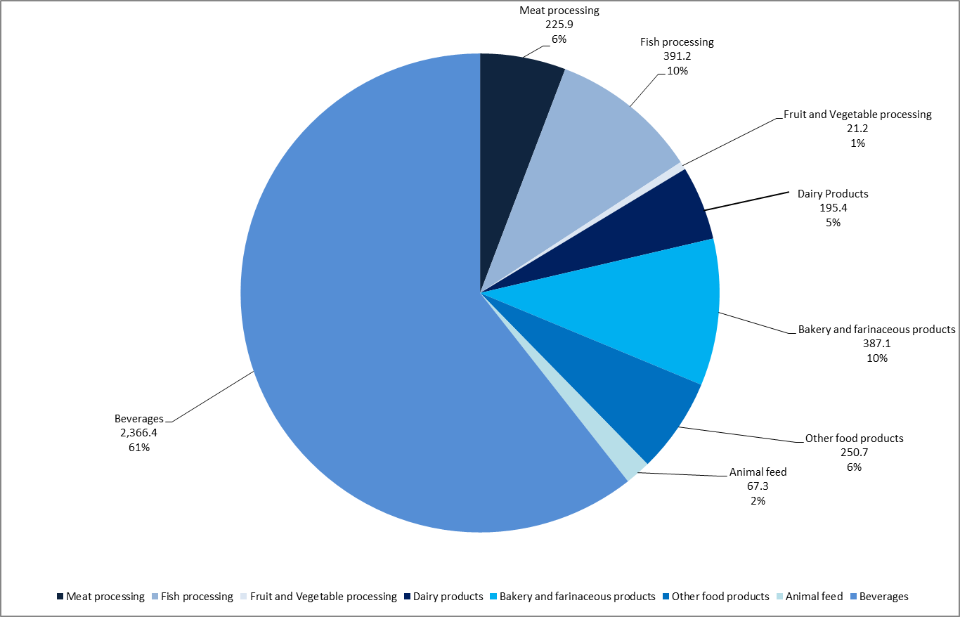

Total Expenditure Under Main Payment Schemes (Table 11)
Basic Payment Scheme, combined with Greening and Young Farmer Payment, accounted for 69 per cent of support in 2015.

Farm Business Income & Direct Subsidies Per Farm By Type of Farming (Table 12)
Dairy farms were the most profitable farm type in 2014-15, as they were the previous year, with mixed farms seeing a large drop in average farm income. LFA livestock farms had the highest level of subsidy as a ratio of output, with mixed farms and LFA sheep farms having the highest as a ratio of income.

Total income from farming (Table 13 and chart 1)
Table 13 shows that while the value of outputs has risen by 65 per cent in the last ten years, costs have risen by 47 per cent. It also shows that in only two of the last ten years costs were estimated to have outstripped outputs; the profitability of the sector is becoming increasingly less reliant on subsidies.

Average Net Worth (Table 14)
Results from the Farm Accounts Survey indicate that a typical farm in Scotland has an Average Net Worth of £1.26 million. Tenanted farms have an average net worth of about £292,000, while owner-occupied farms have an average net worth over five times higher, at £1.54 million.

Total Indebtedness & Investment (Table 15)
Total borrowing continued to increase in 2015, with the cost of borrowing remaining low. The amount of interest being paid was one sixth of the value of total income from farming, following on from the figure of an eighth in 2014.

Hired Regular Full-Time Workers (Table 16)
Average weekly earnings for full-time workers rose by one per cent in 2015; with the average weekly hours worked falling from 42.9 hrs to 42.5 hrs.

