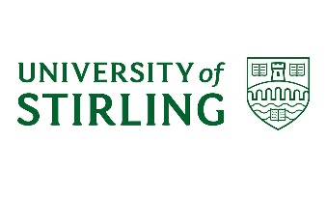

Aberdeen Problem Solving Approach Review
Consent (in principle) to participate in a research interview
The Scottish Government has asked researchers from Ipsos MORI and the University of Stirling, to undertake a review of the Aberdeen Problem Solving Approach. They will be looking at how the Approach is working, and want to gather your opinions by conducting an interview with you. Everything you tell them will remain anonymous.
PLEASE NOTE: You can still decide to opt out of the research at any point after signing this form.

CONSENT TO PARTICIPATE: I agree I am willing to take part in an interview, and for my name and telephone number to be passed to Ipsos MORI so that they can contact me to discuss the interview. |  | Yes |  | No
CONSENT FOR RESEARCHERS TO SPEAK TO SOCIAL WORKERS ABOUT CASE: The researchers might need to ask a social worker for some basic details about your case, including the types of offences you have committed. Everything they tell us would be confidential and would not be passed to anyone outside the research team. Are you happy for them to do this? |  | Yes |  | No

YOUR NAME (PLEASE PRINT BELOW)
……………………………………………………………………………………………………………………………………………….
YOUR SIGNATURE (PLEASE SIGN BELOW)
……………………………………………………………………………………………………………………………………………….

