Sublittoral biotope survey

- Habitat 2 - Lower Infralittoral

Salinity | Fully marine |  | Substratum | Small angular boulders, cobbles, pebbles and gravel
Wave exposure | Sheltered |  | Depth (below chart datum) | 3.2 – 9.2m bcd
Survey quality | Thorough |  | Zone | Lower infralittoral
Tidal streams | Weak |  | MNCR classification | IR.LIR.K.Lsac.Pk
Other features |  | Highly silted

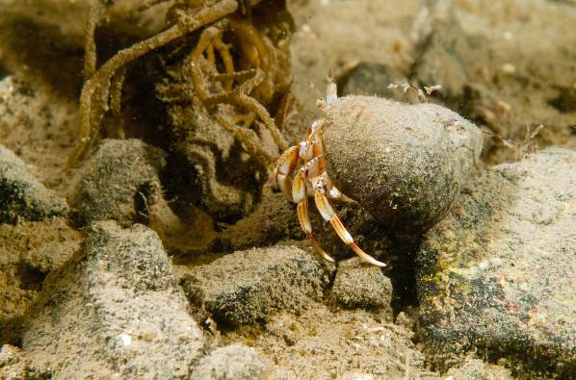
The site consisted of a Laminaria saccharina kelp park (in the cape form) on very heavily silted small angular boulders, cobbles, pebbles and gravel, extending to over 9m bcd.
Heavily silted cobbles with kelp holdfasts
Silted cobbles and Pagurus bernhardus
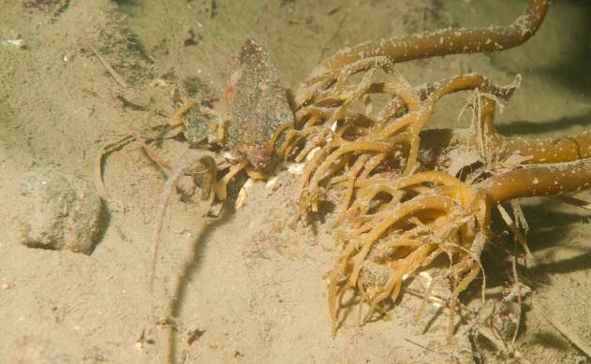
Two spot dives (dive 3 and 4), starting at 58° 00’.342N, 006° 32’.617W and 58° 00’.354N, 006° 32’.656W (the proposed positions for the concrete piles), and heading in a southwest direction, showed a modified hard substrate of lower infralittoral small boulders, cobbles, pebbles and gravel, with occasional encrusting red coralline algae. Laminaria saccharina, growing in its sheltered waters cape form was the characterising species. Beneath the kelp canopy were a limited number of associated red seaweeds, Phycodrys rubens and Delesseria sanguinea. The high quantities of silt and the reduced light intensity beneath the kelp presumably contributed to the sparse epiflora.
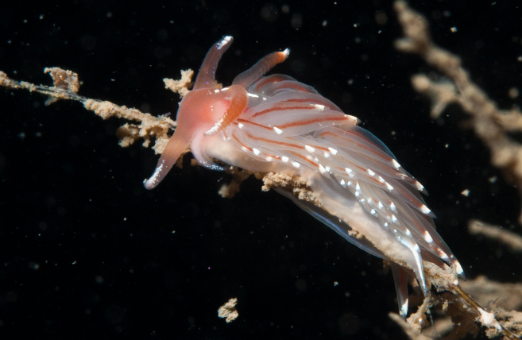
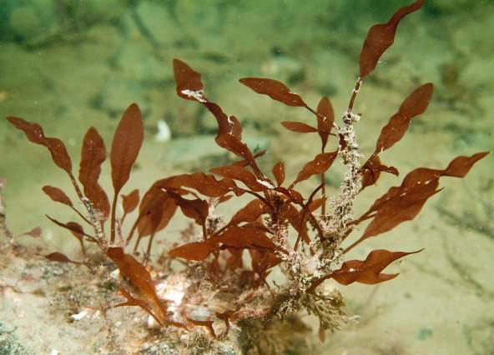
Delesseria sanguinea
Facelina bostoniensis
A sparse faunal component was found both on the Laminaria fronds and below the canopy. The most conspicuous animals in the biotope were the mobile crustaceans, Pagurus bernhardus, Macropodia rostrata and Carcinus maenas and the echinoderms, Asterias rubens and Echinus esculentus. Large, solitary ascidians, particularly Ciona intestinalis and Ascidia mentula were occasionally present. Also recorded were tube worms such as Pomatoceros spp., Terebellidae, Sabella pavonina, Arenicola marina and rarely, Chaetopterus variopedatus.

A large concrete mooring block (1m x 1m x 1m) was present at 7m and was covered by a diverse and dense animal fauna that was unrelated to the biotope surveyed.

Main Cover or Characterising Species
IR.LIR.K.Lsac.Pk

Delesseria sanguinea | O | Laminaria hyperborea | R
Laminaria saccharina | F | Phycodrys rubens | R
Polysiphonia elongata | R | Red coralline crust | O
Rhodophyta unident. | R | Ulva sp | R
Haliclona urceolus | R | Porifera unident. | R
Caryophyllia smithii | R | Cerianthus lloydii | R
Hydractinia echinata | O | Kirchenpaueria pinnata | R
Obelia geniculata | O | Protanthea simplex | O
Sagartia elegans | R | Sagartiogeton laceratus | R
Arenicola marina | O | Chaetopterus variopedatus | R
Polychaeta indet. | R | Pomatoceros triqueter | O
Sabella pavonina | O | Terebellidae indet. | R
Aequipecten opercularis | R | Chiton unident. | R
Facelina bostoniensis | R | Gibbula cineraria | O
Lacuna vincta | R | Eubranchus pallida | R
Pecten maximus | R | Polycera quadrilineata | R
Onchidoris muricata | R | Turritella communis | R
Bryozoan unident. | O | Crisea sp. | R
Membranipora membranacea | O | Scrupocellaria scruposa | R
Balanus crenatus | R | Carcinus maenas | O
Galathea squamifera | O | Inachus dorsettensis | R
Liocarcinus depurator | O | Macropodia rostrata | O
Munida rugosa | R | Mysidacea indet. | R
Pagurus bernhardus | O | Pagurus cuanensis | R
Palaemon serratus | R
Asterias rubens | F | Echinus esculentus | O
Marthasterias glacialis | R | Ophiothrix fragilis | R
Ascidia conchilega | R | Ascidia mentula | O
Ascidiella aspersa | R | Ciona intestinalis | R
Gobiusculus flavescens | R | Lissoclinum perforatum | O
Pholis gunnellus | R | Pomatoschistus minutus | O
Pomatoschistus pictus | R
Eutrigla gurnhardus

