OUTPUT MONITORING GROUP

OUTPUT MONITORING REPORT: Quarter 2 2017-18

1. Introduction

This document summarises what has been achieved for customers against Scottish Water’s Delivery Plan for the 2015-21 period and confirms the position up to the end of September 2017 (Quarter 2 2017/18). It has been prepared for the Output Monitoring Group (OMG) which was set up by Ministers to monitor and report on the delivery of their Objectives.

The OMG comprises the main stakeholders in Scotland’s water industry: Scottish Government, Scottish Water, Citizens Advice Scotland, Scottish Public Services Ombudsman and the regulators (the Water Industry Commission for Scotland, the Scottish Environment Protection Agency and the Drinking Water Quality Regulator). It is chaired by Scottish Government and operates under a Terms of Reference agreed by Ministers.

2. What We Monitor

Each quarter the OMG assesses Scottish Water’s progress with the delivery of outputs using a metric, Overall Measure of Delivery (OMD), to measure Scottish Water’s progress against targets agreed in its Delivery Plan.

Delivery progress is also monitored against the outputs agreed for individual programmes in Scottish Water's Delivery Plan, as shown in the following Appendices:

- Appendix A: Providing continuous high quality drinking water (includes drinking water quality, reliability and security of supply).

- Appendix B: Protecting and enhancing the environment (includes flood risk management).

- Appendix C: Supporting economic development (includes climate change and improving the long term cost of service).

Each Appendix highlights where a programme area is ahead or behind target; and, if behind, the reason and remedial actions being taken by Scottish Water. The year end status for each programme area has been measured against Scottish Water’s Delivery Plan update approved by the Scottish Government in March 2017.

The Output Monitoring Group also monitors Scottish Water’s progress in completing those projects due but not delivered by 31 March 2015 so that the benefits to customers can be delivered as quickly as possible.

3. Key points

The key points to report on Scottish Water’s output delivery in the period up to the end of September 2017 (Quarter 2 2017/18) are:

- The overall measure of delivery (OMD) position was 122 points in Quarter 2, against a September 2017 target of 101 points. This is an increase of 7 points from the Quarter 1 2017/18 position of 115 points. As we approach the half way point of the regulatory period over half of the investment projects are on site. There remains considerable on the ground delivery over the coming years to reach internal acceptance.
- Providing continuous high quality drinking water: of the 10 output programmes in this category, 10 were on or ahead of target at the end of Quarter 2. 3 key projects at Amlaird, Bradan and Tullich have missed their regulatory undertakings. An Enforcement Notice is in place for Amlaird and DWQR has since issued Enforcement Notices for Tullich and Bradan water treatment works. All projects in the drinking water programme are being managed closely and reviewed with the DWQR.
- Protecting and enhancing the environment: of the 10 output programmes in this category, 9 were on or ahead of the year-end target at the end of Quarter 2. As a result of the delay in the Amlaird project, improvements covered by the Water Framework Directive programme are forecast to be behind plan until Quarter 3 2018/19 to allow Scottish Water to more effectively manage the resilience of the supply of drinking water to customers. The overall strategy for Amlaird is being reviewed with the DWQR and SEPA.

- Supporting economic development: of the 6 output programmes in this category, 2 were ahead of target and 4 underway but demand driven at the end of Quarter 2.

- Projects due to have been completed by March 2015: by the end of Quarter 2 Scottish Water had completed 32 of the 37 projects that were outstanding at March 2015. Scottish Water is forecasting all projects to complete by 2019/20.

4. Overall Measure of Delivery (OMD)

The Overall Measure of Delivery provides a high level measurement of Scottish Water’s progress against its Delivery Plan; it assesses the progress of the investment outputs monitored by OMG across each of the five key delivery milestones, combining this information to give an overall score. Progress with delivering late projects from previous investment periods and demand led schemes (such as new capacity to support economic development) are not included in the OMD.

At the beginning of the programme the OMD score starts at zero and at 31 March 2021 should reach 250 points confirming that all milestones and outputs due to be delivered by that date have been delivered. At the end of September 2017 Scottish Water’s OMD position was 122 points, against an OMD target of 101 points. This is an increase of 7 points from the Quarter 1 2017/18 position of 115 points as illustrated in Figure 1.

Dec
2016
Target
March
2016
Target
June
2017
Target
Sept
2017
Target

Figure 1 – Overall Measure of Delivery to Quarter 2 2017-18

5. Progress against milestones

To demonstrate the progress being made through each of the 5 programme milestones monitored by OMG, Figure 2 below shows the cumulative % budget through each milestone for the reported programmes. Of particular note is that over half (56%) have started on site.
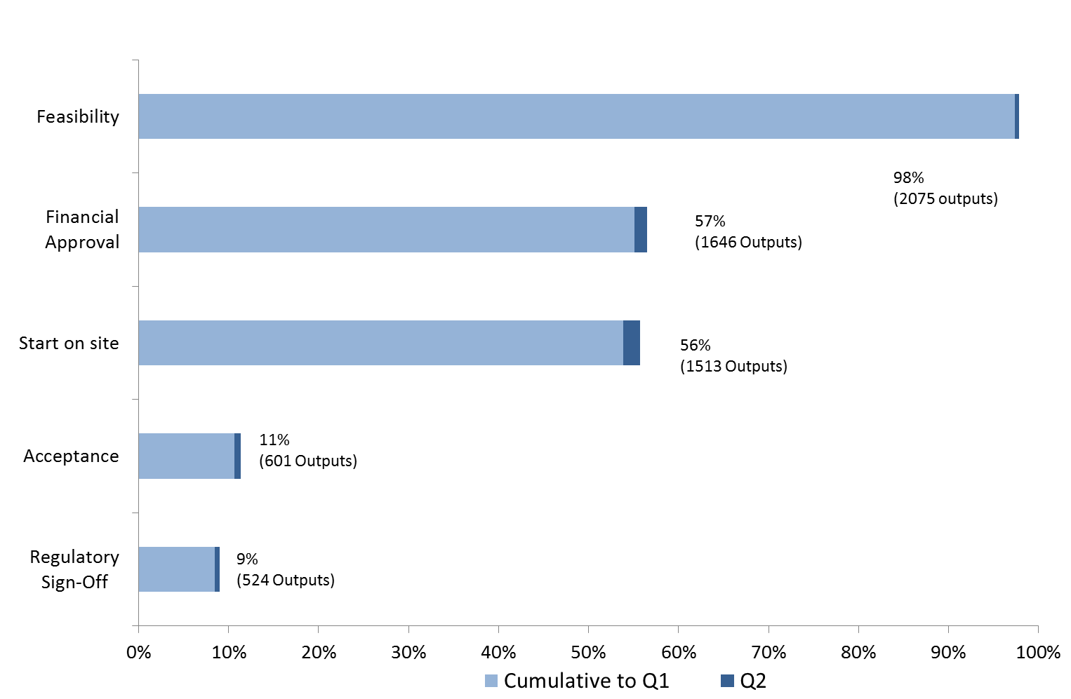
Figure 2 – Reported output programmes – cumulative % budget through each milestone

6. Projects due but not delivered by 31 March 2015

Scottish Water started the 2015-21 period with 37 projects from the previous programme which were due but not completed by March 2015. Scottish Water has achieved regulatory sign-off for 32 of these projects at the end of September 2017. Scottish Water remains focussed on delivering the projects due to have been completed by March 2015.

 | 2017/18 | 2018/19 | 2019/20 | 2020/21
Planned completion | 31 - 33 | 33 - 36 | 36 | 37
Latest forecast completion range | 33 - 34 | 35 - 36 | 37 | 37

7. Conclusion

The OMG notes the good progress made to date with the delivery of outputs required by Ministers during the 2015-21 regulatory period, as measured through the Overall Measure of Delivery and the individual programme milestones. It notes that there are a small number of projects for which emerging issues particularly in the drinking water quality programme are presenting challenges to delivery. On the environment programme, improvements to meet the requirements of the Water Framework Directive are forecast to be behind plan until Quarter 3 2018/19 as a consequence of Scottish Water’s need to more effectively manage the resilience of the supply of drinking water to customers whilst all phases of the Ayrshire Resilience Project are completed.

Ministers have stressed to Scottish Water the importance of maintaining and achieving the milestones as agreed in Scottish Water’s Delivery Plan.

RAG Status

The following colour coding is applied to the forecast in the output delivery tables (Appendices A to C), using the definitions outlined below:
Red | Progress is behind target and there is no prospect of recovery over the year
Amber | At risk of not delivering the output within the year
Green | On or ahead of programme, or if off track will recover within the year
Blue | Output complete

Appendix A: Providing continuous high quality drinking water

Scottish Water is undertaking work associated with the 10 programme areas in the table below.

Objective | Quarterly monitored programme areas | Q2  2017/18  Actual | 2017/18  Year end  Target | 2017/18 Year end Forecast | Total number of outputs over the regulatory period
Drinking water quality and reliability | Number of water treatment works improved | 1 | 4 | 8 | 27
Drinking water quality and reliability | Number of zones made compliant with iron & manganese standards | 1 | 0 | 13 | 88
Drinking water quality and reliability | Number of improvements to reliability of supply (catchments and treatment) | 4 | 4 | 12 | 47
Drinking water quality and reliability | Number of improvements to reliability of supply (networks and storage) | 12 | 9 | 18 | 82
Drinking water quality and reliability | Distribution mains cleaned (km) | 0 | 93 | 157 | 5,928
Drinking water quality and reliability | Number of water quality etc studies to inform future periods | 138 | 124 | 212 | 345
Drinking water quality and reliability | 2010-15 outputs planned to complete in the 2015-21 period | 7 | 6 | 9 | 22
Drinking water security of supply | Water supply resilience strategy and improvements made | 8 | 6 | 9 | 18
Drinking water security of supply | Number of zones with improved security of supply (SOSI) | 1 | 1 | 2 | 10
Drinking water security of supply | Number of security measures and improvements to the infrastructure of critical reservoirs | 145 | 118 | 164 | 689
Total |  | 322 | 272 | 453 | 1,328

Appendix B: Protecting and enhancing the environment

Scottish Water is undertaking work associated with the 10 programme areas in the table below.

Objective | Quarterly monitored programme areas | Q2  2017/18  Actual | 2017/18  Year end  Target | 2017/18 Year end Forecast | Total number of outputs over the regulatory period
Protecting and enhancing the environment | Number of WWTWs improved to meet UWWTD | 8 | 8 | 20 | 25
Protecting and enhancing the environment | Number of waste water networks improved to meet UWWTD | 17 | 17 | 22 | 59
Protecting and enhancing the environment | Number of improvements required to meet UWWTD - Glasgow completion | 41 | 42 | 50 | 93
Protecting and enhancing the environment | Number of improvements required to meet the Water Framework Directive | 1 | 10 | 2 | 21
Protecting and enhancing the environment | Studies to inform requirements under the revised Bathing Waters Directive | 0 | 1 | 7 | 11
Protecting and enhancing the environment | Number of environmental studies to inform future periods | 6 | 1 | 37 | 126
Protecting and enhancing the environment | Number of improvements required by the Compliance Assessment Scheme; odour reduction and sludge management | 20 | 13 | 31 | 42
Protecting and enhancing the environment | 2010-15 outputs planned to complete in the 2015-21 period - WW | 10 | 9 | 12 | 15
Flood risk management | Reservoirs Act - Number of improvements to dams | 11 | 17 | 27 | 57
Flood risk management | Flood Risk Management Act - models and integrated catchment studies | 38 | 24 | 69 | 218
Total |  | 152 | 142 | 277 | 670

Improvements covered by the Water Framework Directive programme are forecast to behind plan until Quarter 3 2018/19 to allow Scottish Water to more effectively manage the resilience of the supply of drinking water to customers from the Amlaird system. Scottish Water is working hard to deliver the environmental improvements at Amlaird as quickly as possible; however it is likely that the existing Amlaird works will remain in operation until the Ayrshire Resilience Scheme is completed. The overall strategy is being reviewed with the DWQR and SEPA.

Appendix C: Supporting economic development

Scottish Water continues to support the Scottish economy by meeting the demand for water and waste water connections to new households and businesses and where necessary has initiated projects to increase strategic capacity. Connections have been made to 62,411 new household and businesses to September 2017. Scottish Water has also installed over 9,508 first time wholesale meters and replaced 25,502 wholesale meters as shown in the table below.

Objective | Quarterly monitored programme areas | Q2  2017/18  Actual | 2017/18  Year end  Target | 2017/18 Year end Forecast | Total number of outputs over the regulatory period
Supporting economic development | Number of new connections to households and businesses | 62,411 | Demand driven | Demand driven | 56,500
Supporting economic development | Delivery of new waste water capacity for 58,000 people | 2,143 | Demand driven | Demand driven | 58,000
Supporting economic development | Number of first time non domestic meters installed | 9,508 | Demand driven | Demand driven | 18,000
Supporting economic development | Number of wholesale meters | 25,502 | Demand driven | Demand driven | 75,500
Climate change | Number of climate change vulnerability assessments | 55 | 55 | 57 | 122
Long term cost of service | Improvements in renewable power and energy efficiency (GWh) | 10.04 | 7.9 | 15.46 | 17.5

.
Glossary of Terms

Assets | Physical plant and equipment used to produce and transfer water, to collect and treat waste water such as water treatment works and water mains, sewers and sewage works etc.
Climate Change Adaption and Mitigation | ‘Adaptation’ is the action taken by Scottish Water to increase the resilience of its assets to climate change variability and extremes whereas ‘mitigation’ is the steps to permanently eliminate or reduce its carbon emissions associated with its activities.
Delivery Plan | Scottish Water’s annual statement of investment outputs and financial targets.
DMA | District meter areas (DMA) help to identify any localised leakage by the installation of online flow monitors.
Intervention Definition Process (IDP) | Scottish Water’s process to identify scope options and select preferred option to achieve the outcome required.
IR18 | Rolling Investment Review 2018 to consider priorities and outputs for the 2018-21 period and beyond.
Leakage | The water lost from Scottish Water’s network of water pipes and its assets (service reservoirs etc.) between putting water into supply and it arriving at customer taps.
Ministerial Objectives | A statement of requirements (deliverables) set out by Scottish Ministers.
Outputs | Tangible deliverables, such as an improved waste water treatment facility, which benefit customers, the environment or both.
Output Monitoring Group (OMG) | Representatives of Scotland’s water industry who are accountable for the monitoring the progress of output delivery.
Overall Measure of Delivery (OMD) | The metric used to assess Scottish Water’s delivery of its investment-related outputs.
Overall Performance Assessment (OPA) Score | A comparative overview of company performance which is calculated each year. It covers measures of water supply, sewerage service, customer service and environmental performance.
UID | Unsatisfactory Intermittent Discharges. An overflow on the sewer network that requires to be improved so as to meet environmental standards for the water body into which it discharges or which it affects.
UWWTD | The Urban Waste Water Treatment Directive is a European Union directive concerning the "collection, treatment and discharge of urban waste water and the treatment and discharge of waste water from certain industrial sectors".
WWTW | A waste water treatment works (WWTW) treats waste water before returning it to the environment.

19 points relate to outputs that will be confirmed in the investment review 2018 (IR18).
Excludes 5,928km of mains cleaning as this programme area is measured on a per km basis rather than on the number of outputs or improvements made.
Target of 56,500 new connections is for 2018, target for 2021 will be confirmed as part of IR18.

