OUTPUT MONITORING GROUP

OUTPUT MONITORING REPORT to OMG: Quarter 1 2016-17

1. Introduction

This document summarises what has been achieved for customers against Scottish Water’s Delivery Plan for the 2015-21 period and confirms the position up to the end of June 2016 (Quarter 1 2016/17). It has been prepared for the Output Monitoring Group (OMG) which was set up by Ministers to monitor and report on the delivery of their Objectives.

The OMG comprises the main stakeholders in Scotland’s water industry: Scottish Government, Scottish Water, Citizens Advice Scotland, Scottish Public Services Ombudsman and the regulators (the Water Industry Commission for Scotland, the Scottish Environment Protection Agency and the Drinking Water Quality Regulator). It is chaired by Scottish Government and operates under a Terms of Reference agreed by Ministers.

2. What We Monitor

Each quarter the OMG assesses Scottish Water’s progress with the delivery of outputs using a metric, Overall Measure of Delivery (OMD), to measure Scottish Water’s progress against targets agreed in its Delivery Plan.

Delivery progress is also monitored against the outputs agreed for individual programmes in Scottish Water's Delivery Plan, as shown in the following Appendices:

- Appendix A: Providing continuous high quality drinking water (includes drinking water quality, reliability and security of supply).

- Appendix B: Protecting and enhancing the environment (includes flood risk management).

- Appendix C: Supporting economic development (includes climate change and improving the long term cost of service).

Each Appendix highlights where a programme area or service measure is ahead or behind target; and, if behind, the reason and remedial actions being taken by Scottish Water. The forecast year end status for each programme area has been measured against Scottish Water’s 2016 Delivery Plan update approved by the Scottish Government in April 2016.

The Output Monitoring Group also monitors Scottish Water’s progress in completing those projects due but not delivered by 31 March 2015 so that the benefits to customers can be delivered as quickly as possible.

3. Key points

The key points to report on Scottish Water’s output delivery in the period up to the end of June 2016 (Quarter 1 2016-17) are:

- The overall measure of delivery (OMD) position was 78 points at Quarter 1, against a June 2016 OMD target range of 54 – 56 points. This is an increase of 5 points from the Quarter 4 position 2015-16 of 73.

- Providing continuous high quality drinking water: of the ten output programmes in this category, 10 were on or ahead of target at the end of Quarter 1.

- Protecting and enhancing the environment: of the ten output programmes in this category, 10 were on or ahead of target at the end of Quarter 1

- Supporting economic development: of the six output programmes in this category at the end of Quarter 1, 2 were ahead of target and 4 underway and consistent with levels of demand.

- Projects due to have been completed by March 2015: by the end of Quarter 1 Scottish Water had completed 25 of the 37 projects that were outstanding at March 2015. Scottish Water is currently forecasting to have between 8 and 11 of these projects outstanding at March 2017.

4. Overall Measure of Delivery (OMD)

The Overall Measure of Delivery provides a high level measurement of Scottish Water’s progress against its Delivery Plan; it assesses the progress of the investment outputs monitored by OMG across each of the five key delivery milestones, combining this information to give an overall score. Progress with delivering late projects from previous investment periods and demand led schemes (such as new capacity to support economic development) are not included in the OMD.

At the beginning of the programme the OMD score starts at zero and at 31 March 2021 should reach 250 points confirming that all milestones and outputs due to be delivered by that date have been delivered. Performance is considered to be ‘on target’ if it is within 2.5% of the agreed OMD score. At the end of June 2016 Scottish Water’s OMD position was 78 points, against an OMD target range of 54 – 56 points. This is an increase of 5 points from the Quarter 4 2015-16 position of 73 points and is illustrated in Figure 1.

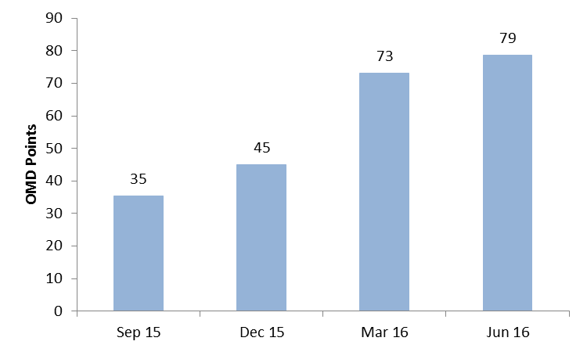
March 2016 target range

June 2016 target range

Figure 1 – Overall Measure of Delivery to Quarter 1 2016-17

5. Progress against milestones

To demonstrate the progress being made through each of the 5 programme milestones monitored by OMG, Figure 2 below shows the cumulative % budget through each milestone for the reported programmes.
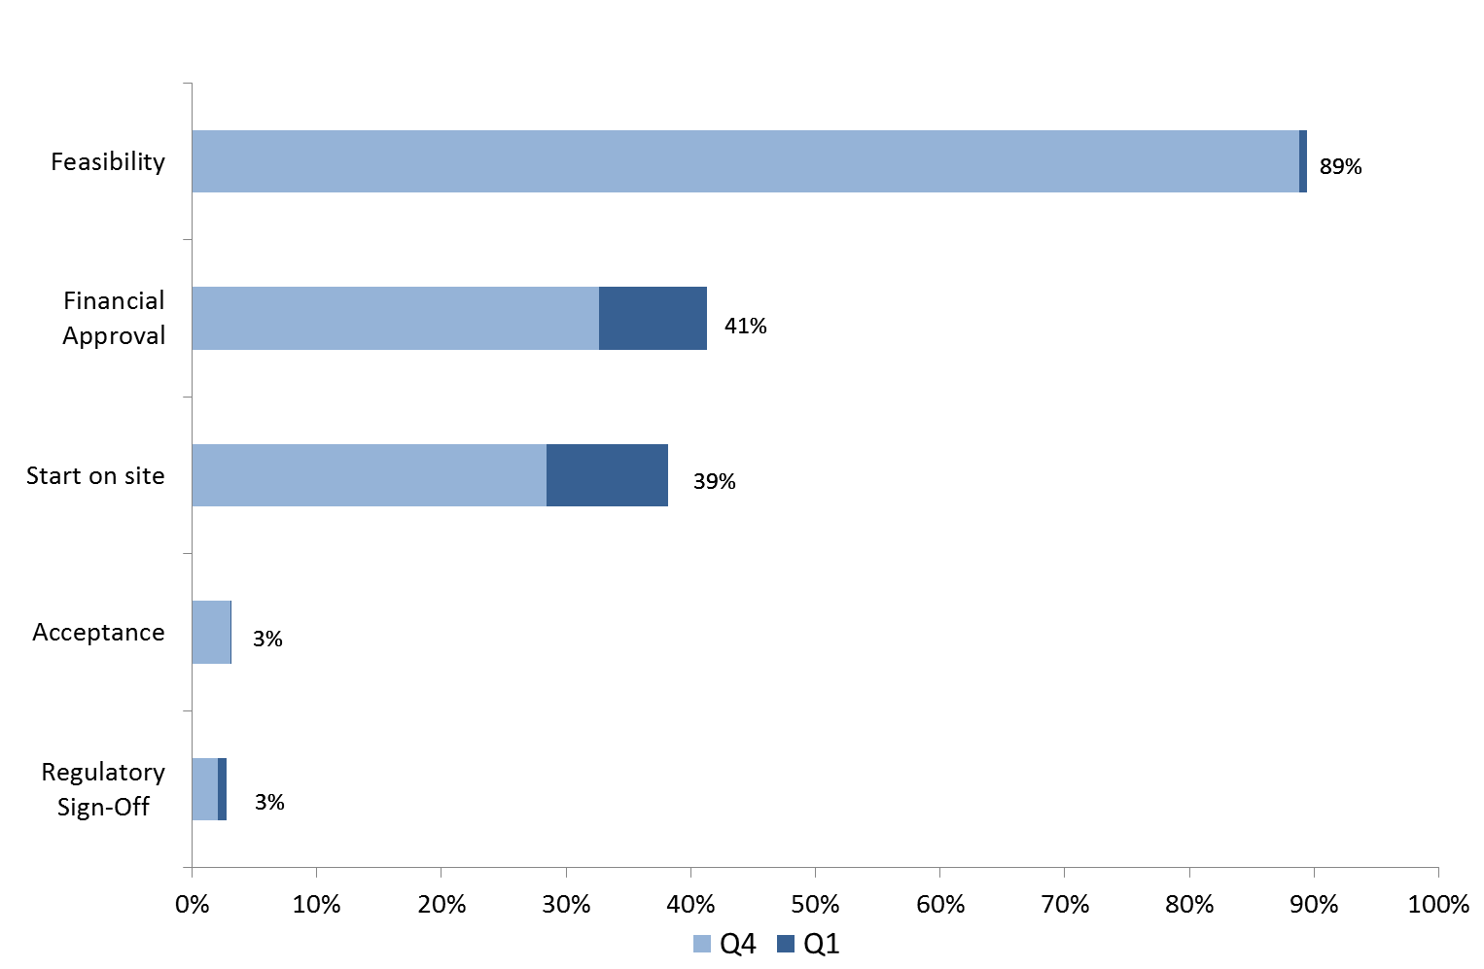

Figure 2 – Reported output programmes – cumulative % budget through each milestone
6. Projects due but not delivered by 31 March 2015

Scottish Water started the 2015-21 period with 37 projects from the previous programme which were due but not completed by March 2015. Scottish Water has achieved regulatory sign-off for 25 of these projects at the end of Quarter 1 2016-17. Scottish Water remains focussed on delivering the projects due to have been completed by March 2015 in line with the profile in its Delivery Plan update 2016 shown below.

 | 2016/17 | 2017/18 | 2018/19 | 2019/20 | 2020/21
Planned completion | 26 - 29 | 31 - 33 | 33 - 36 | 36 - 37 | 37

7. Conclusion

The OMG notes the progress made to June 2016, Quarter 1 2016-17, of the 2015-21 regulatory period with the delivery of outputs required by Ministers, as measured through the Overall Measure of Delivery and programme milestones.

While progress against the re-baseline remains ahead or on target at this stage, Ministers continue to stress to Scottish Water the importance of maintaining momentum in progressing delivery and achieving those milestones due in 2016/17 and beyond.

RAG Status

The following colour coding is applied to the forecast in the output delivery tables (Appendices A to C), using the definitions outlined below:
Red | Progress is behind target and there is no prospect of recovery over the year
Amber | At risk of not delivering the output within the year
Green | On or ahead of programme, or if off track will recover within the year
Blue | Output complete

Appendix A: Providing continuous high quality drinking water

Scottish Water is undertaking work associated with the 10 programme areas in the table below.

Objective | Quarterly monitored programme areas | Q4  2015/16  Actual | Q1  2016/17  Actual | 2016/17  Year end  Target | 2016/17 Year end Forecast | Total number of outputs over the regulatory period
Drinking water quality and reliability | Number of water treatment works improved | 0 | 0 | 1 | 1 | 27
 | Number of zones made compliant with iron & manganese standards | No outputs planned to be delivered in 2016/17 |  |  |  | 88
 | Number of improvements to reliability of supply (catchments and treatment) | 2 | 2 | 1 | 3 | 47
 | Number of improvements to reliability of supply (networks and storage) | 1 | 3 | 9 | 9 | 82
 | Distribution mains cleaned (km) | No outputs planned to be delivered in 2016/17 |  |  |  | 5,928
 | Number of water quality etc studies to inform future periods | 10 | 10 | 45 | 81 | 341
 | 2010-15 outputs planned to complete in the 2015-21 period | 2 | 2 | 2 | 5 | 23
Drinking water security of supply | Water supply resilience strategy and improvements made | 4 | 6 | 3 | 7 | 18
 | Number of zones with improved security of supply (SOSI) | 1 | 1 | 1 | 1 | 11
 | Number of security measures and improvements to the infrastructure of critical reservoirs | 3 | 3 | 30 | 39 | 689
Total |  | 23 | 27 | 92 | 146 | 1,326

Appendix B: Protecting and enhancing the environment

Scottish Water is undertaking work associated with the 10 programme areas in the table below.

Objective | Quarterly monitored programme areas | Q4 2015/16  Actual | Q1 2016/17 Actual | 2016/17  Year end  Target | 2016/17 Year end Forecast | Total number of outputs over the regulatory period
Protecting and enhancing the environment | Number of WWTWs improved to meet UWWTD | 6 | 7 | 7 | 7 | 22
 | Number of waste water networks improved to meet UWWTD | 4 | 7 | 7 | 14 | 61
 | Number of improvements required to meet UWWTD - Glasgow completion | 24 | 25 | 26 | 36 | 94
 | Number of improvements required to meet the Water Framework Directive | 1 | 1 | 1 | 1 | 21
 | Studies to inform requirements under the revised Bathing Waters Directive | No outputs planned to be delivered in 2016/17 |  |  |  | 7
 | Number of environmental studies to inform future periods | 0 | 0 | 0 | 3 | 129
 | Number of improvements required by the Compliance Assessment Scheme; odour reduction and sludge management | 10 | 10 | 10 | 20 | 41
 | 2010-15 outputs planned to complete in the 2015-21 period - WW | 7 | 7 | 7 | 10 | 16
Flood risk management | Reservoirs Act - Number of improvements to dams | 8 | 8 | 8 | 12 | 45
 | Flood Risk Management Act - models and integrated catchment studies | 0 | 0 | 0 | 17 | 218
Total |  | 60 | 65 | 66 | 120 | 654

Appendix C: Supporting economic development

Scottish Water continues to support the Scottish economy by meeting the demand for water and waste water connections to new households and businesses and where necessary has initiated projects to increase strategic capacity. Scottish Water has also installed over 4,900 new non-domestic meters and over 9,500 wholesale meters as shown in the table below.

Objective | Quarterly monitored programme areas | Q4 2015/16  Actual | Q1 2016/17 Actual | 2016/17  Year end  Target | 2016/17 Year end Forecast | Total number of outputs over the regulatory period
Supporting economic development | Number of new connections to households and businesses | 15,098 | 21,064 | Demand driven | Demand driven | 56,500
 | Delivery of new waste water capacity for 58,000 people | 1,351 | 1,557 | Demand driven | Demand driven | 58,000
 | Number of first time non domestic meters installed | 4,069 | 4,915 | Demand driven | Demand driven | 18,000
 | Number of wholesale meters | 7,729 | 9,596 | 18,200 | Demand driven | 75,500
Climate change | Number of climate change vulnerability assessments | 4 | 7 | 4 | 55 | 122
Long term cost of service | Improvements in renewable power and energy efficiency (GWh) | 1.64 | 5.0 | 6.8 | 6.8 | 17.5

Glossary of Terms

Assets | Physical plant and equipment used to produce and transfer water, to collect and treat waste water such as water treatment works and water mains, sewers and sewage works etc.
Climate Change Adaption and Mitigation | ‘Adaptation’ is the action taken by Scottish Water to increase the resilience of its assets to climate change variability and extremes whereas ‘mitigation’ is the steps to permanently eliminate or reduce its carbon emissions associated with its activities.
Delivery Plan | Scottish Water’s annual statement of investment outputs and financial targets.
DMA | District meter areas (DMA) help to identify any localised leakage by the installation of online flow monitors.
Intervention Definition Process (IDP) | Scottish Water’s process to identify scope options and select preferred option to achieve the outcome required.
IR18 | Rolling Investment Review 2018 to consider priorities and outputs for the 2018-21 period and beyond.
Leakage | The water lost from Scottish Water’s network of water pipes and its assets (service reservoirs etc.) between putting water into supply and it arriving at customer taps.
Ministerial Objectives | A statement of requirements (deliverables) set out by Scottish Ministers.
Outputs | Tangible deliverables, such as an improved waste water treatment facility, which benefit customers, the environment or both.
Output Monitoring Group (OMG) | Representatives of Scotland’s water industry who are accountable for the monitoring the progress of output delivery.
Overall Measure of Delivery (OMD) | The metric used to assess Scottish Water’s delivery of its investment-related outputs.
Overall Performance Assessment (OPA) Score | A comparative overview of company performance which is calculated each year. It covers measures of water supply, sewerage service, customer service and environmental performance.
UID | Unsatisfactory Intermittent Discharges. An overflow on the sewer network that requires to be improved so as to meet environmental standards for the water body into which it discharges or which it affects.
UWWTD | The Urban Waste Water Treatment Directive is a European Union directive concerning the "collection, treatment and discharge of urban waste water and the treatment and discharge of waste water from certain industrial sectors".
WWTW | A waste water treatment works (WWTW) treats waste water before returning it to the environment.

20 points relate to outputs that will be confirmed in the investment review 2018 (IR18).
The number of outputs reduced from 28 to 27 due to the removal of the output at Beasdale as it was no longer cost effective to progress.
Excludes 5,928km of mains cleaning as this programme area is measured on a per km basis rather than on the number of outputs or improvements made.
Total number of outputs dropped from 62 to 61 due to the removal of the outputs at Greenside Street/Burnbank Street as it was no longer required.
Total number of outputs dropped from 131 to 129 due to the removal of the outputs at Orbiston and Loch Benachaly as they were no longer required.
Total number of outputs increased due to the addition of 3 sludge holding facilities at Londornoch, Salvabes and Torra and as approved by the OMG.
Total number of wholesale meters for the 2015-21 period was reduced from 84,000 to 75,500 in Scottish Water’s Delivery Plan 2016 update.

