Summary of Salmon Conservation Regulation Methodology

In 2016 Scottish Government introduced Salmon Conservation Regulations with the aim of determining whether or not salmon stocks can support exploitation by fisheries. As in England, Wales, Ireland and Norway, each stock is assessed by setting an egg requirement for the stock and estimating whether or not this requirement is met. As recommended by the North Atlantic Salmon Conservation Organisation the egg requirement is set to maintain the sustainability of a stock, rather than maximise juvenile output or other alternate measures used by local managers. Numbers of eggs are used as the basis for assessment to account for changes through the season and over the years in biological characteristics such as size of the fish or sex ratio of the stock.

Assessments are undertaken for each river, except in those areas where fishery catch cannot be assigned to individual rivers. In such cases, rivers are combined to form assessment groups. The process for each assessable area is summarised below as five steps. These steps are carried out for each of the most recent five years.

Step 1: Converting Reported Rod Catches to Numbers of Returning Salmon

In Scotland there are a small number of rivers with fish counters on their lower reaches which can be used to measure numbers of returning adult salmon directly. Hence, for any given month at these sites, there are measures of both counts and catches of salmon. It is then possible to produce an equation (mathematical model) that best estimates the total number of fish for any given catch of salmon.

In common with methods used in other countries, catches of salmon are used to estimate salmon numbers in areas without counters. The model gives a monthly correction factor which is multiplied with catch numbers to estimate the actual number of salmon. The correction factor:

- accounts for changes between months where, for a given count, catches are lower during the summer than during the spring/autumn;
- uses flow to account for changes in angling conditions with salmon shown to be more catchable in higher flows than in low flow conditions. For example, out of 100 fish entering a river during June it is estimated that 4 would be caught in low flow conditions compared to 7 in normal flows and 11 in high flow conditions.

The pattern of catches within the fishing season is then used to estimate numbers returning outside the fishing season.

For 2020 additional steps were taken to account for the reduction in fishing effort related to the COVID-19 pandemic (details given here)

Step 2: Converting Numbers of Returning Salmon to Numbers of Spawning Females

The total number of returning salmon is then used to determine the number of spawning females. Information on the ages of the salmon is first required due to differences in the proportion of one-sea winter (1SW) and multi-sea winter (MSW) fish that are female.

Information from 208,457 salmon collected from 42 rivers throughout Scotland between 1963 and 2018 was used to examine how the percentage of female fish in each age class differs with month, year and location within Scotland. This figure is combined with the estimated number of returning salmon for each river and year to produce the number of returning adults for each age class. These numbers are converted to the number of females using available information from 10 sites throughout Scotland which found that 49.5% of 1SW and 71.4% of MSW salmon were female.

The number of spawning salmon is calculated as the number of returning salmon minus those killed by the rod fishery (all retained fish + 10% of released fish) and minus 9% to account for other in-river mortality factors (e.g. predation, disease).

Step 3: Converting Numbers of Spawning Females to Numbers of Eggs

The number of eggs produced by a spawning female salmon is related to its size and age. Information on the sizes and ages of 205,544 salmon collected from 39 sites throughout Scotland between 1963 and 2018 was used to estimate the egg content of individual salmon with respect to month, year and location within Scotland. These estimates of the egg contents of individual females are combined with the numbers of spawning females for each different age/month combination and summed.

Step 4: Egg Requirement

The numbers of eggs required to produce sustainable salmon stocks in different Scottish rivers was estimated from 11 rivers where information on stock-recruitment relationships was available. Mathematical models of these data were developed to produce egg requirement estimates for areas without stock-recruitment data using information on its geographic location and productivity. Egg requirements are expressed as the number of eggs required for every square metre wetted area of salmon habitat (in order to achieve the maximum sustainable yield). The wetted area available to salmon for each assessable area was calculated using the most up to date information on the distribution of salmon from historical records and recent consultations with local Fishery Trusts and Boards. The wetted area and egg requirement are multiplied together to produce an overall egg requirement for each river.

Step 5: Number of Eggs vs. Egg Requirement

With perfect information, the conservation status would be determined by whether or not the number of eggs deposited by spawning salmon is greater than the egg requirement. However, calculations are complicated by uncertainties in the estimates of the numbers of eggs produced by returning adults, the egg requirement and the area accessible to salmon. Instead these uncertainties are combined to calculate the percentage chance that the egg requirement has been reached for each of the last five years (2014-2018) and used to determine the grade for each river.

- Grade 1. At least an average (mean) chance of 80% that the egg requirement has been met over the past 5 years.
- Grade 2. An average chance of 60-80% that the egg requirement has been met over the past 5 years.
- Grade 3. An average chance of less than 60% that the egg requirement has been met over the past 5 years.

It is recognised that fisheries may not be the main drivers of change in salmon stocks, nor will compulsory catch and release on its own necessarily lead to conservation limits being attained. However, it is clear that when stocks are below their conservation limit, reducing numbers killed by fisheries will help towards CLs being met in the future.

Worked example: River South Esk

The following example illustrates each of the steps described above using data for the River South Esk assessment. To account for uncertainty in some of the data used in the assessment, such as salmon distribution and the correction factors to convert catches to estimated numbers of salmon, these estimates are expressed as distributions rather than single numbers. The model then runs the calculations 10,000 times, randomly picking values from these ranges on each run. The results from these calculations are then also expressed as distributions. In the case of step 5, the probability that the number of eggs exceeds the egg target is simply the percentage of runs where this is the case.

Step 1: Converting Reported Catches to Numbers of Returning Salmon

The reported catches for the River South Esk during 2015 to 2019 are given below (black = retained, blue = released):

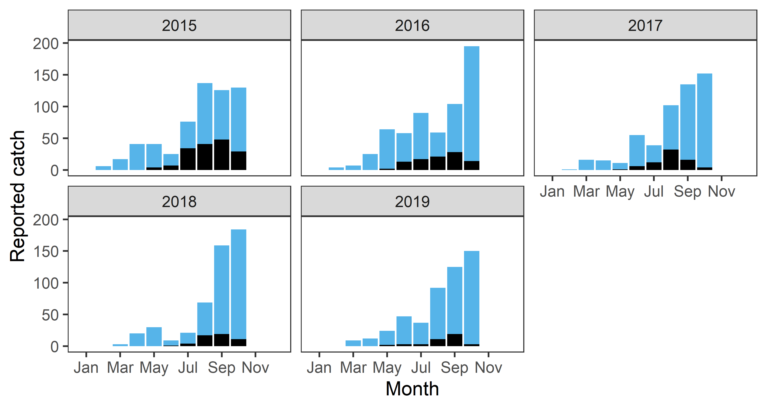

Flow data obtained from SEPA for the River South Esk are given below. Data have been adjusted to show changes from the mean flow across the period 1989-2016, points above the line are higher than average flow, below reflect drier than usual conditions.

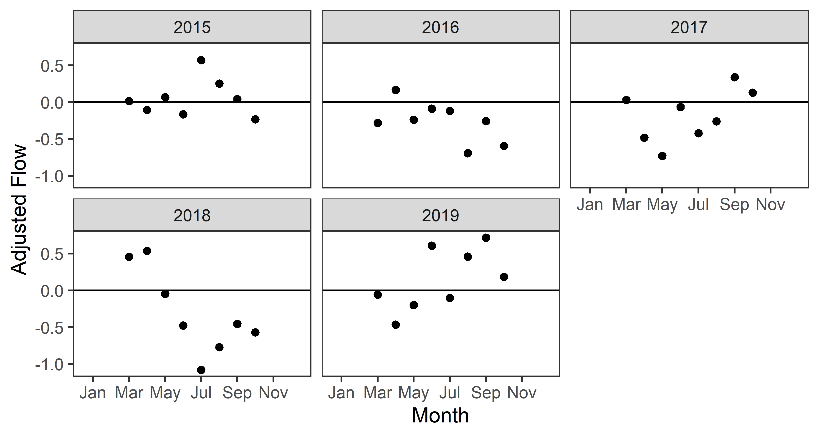

The flow data are used to produce a monthly correction factor which is then applied to the catches to produce the following estimates of the numbers returning to the South Esk each month. The plots highlight the uncertainty around these estimates, with 50% of the estimates falling within the range of values covered by the wide bars; 70% in the medium width bar and 90% in the range depicted by the line. Months shown in black are out of season estimates, where there are no rod catch data. These are produced by applying the seasonal patterns in numbers returning over a fish counter for counter site in Scotland.

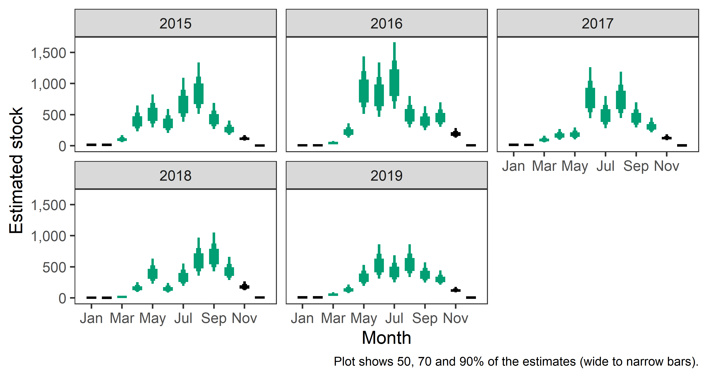

These estimates can be added together to give an estimate of the number of salmon returning to the river in each of the 5 years:

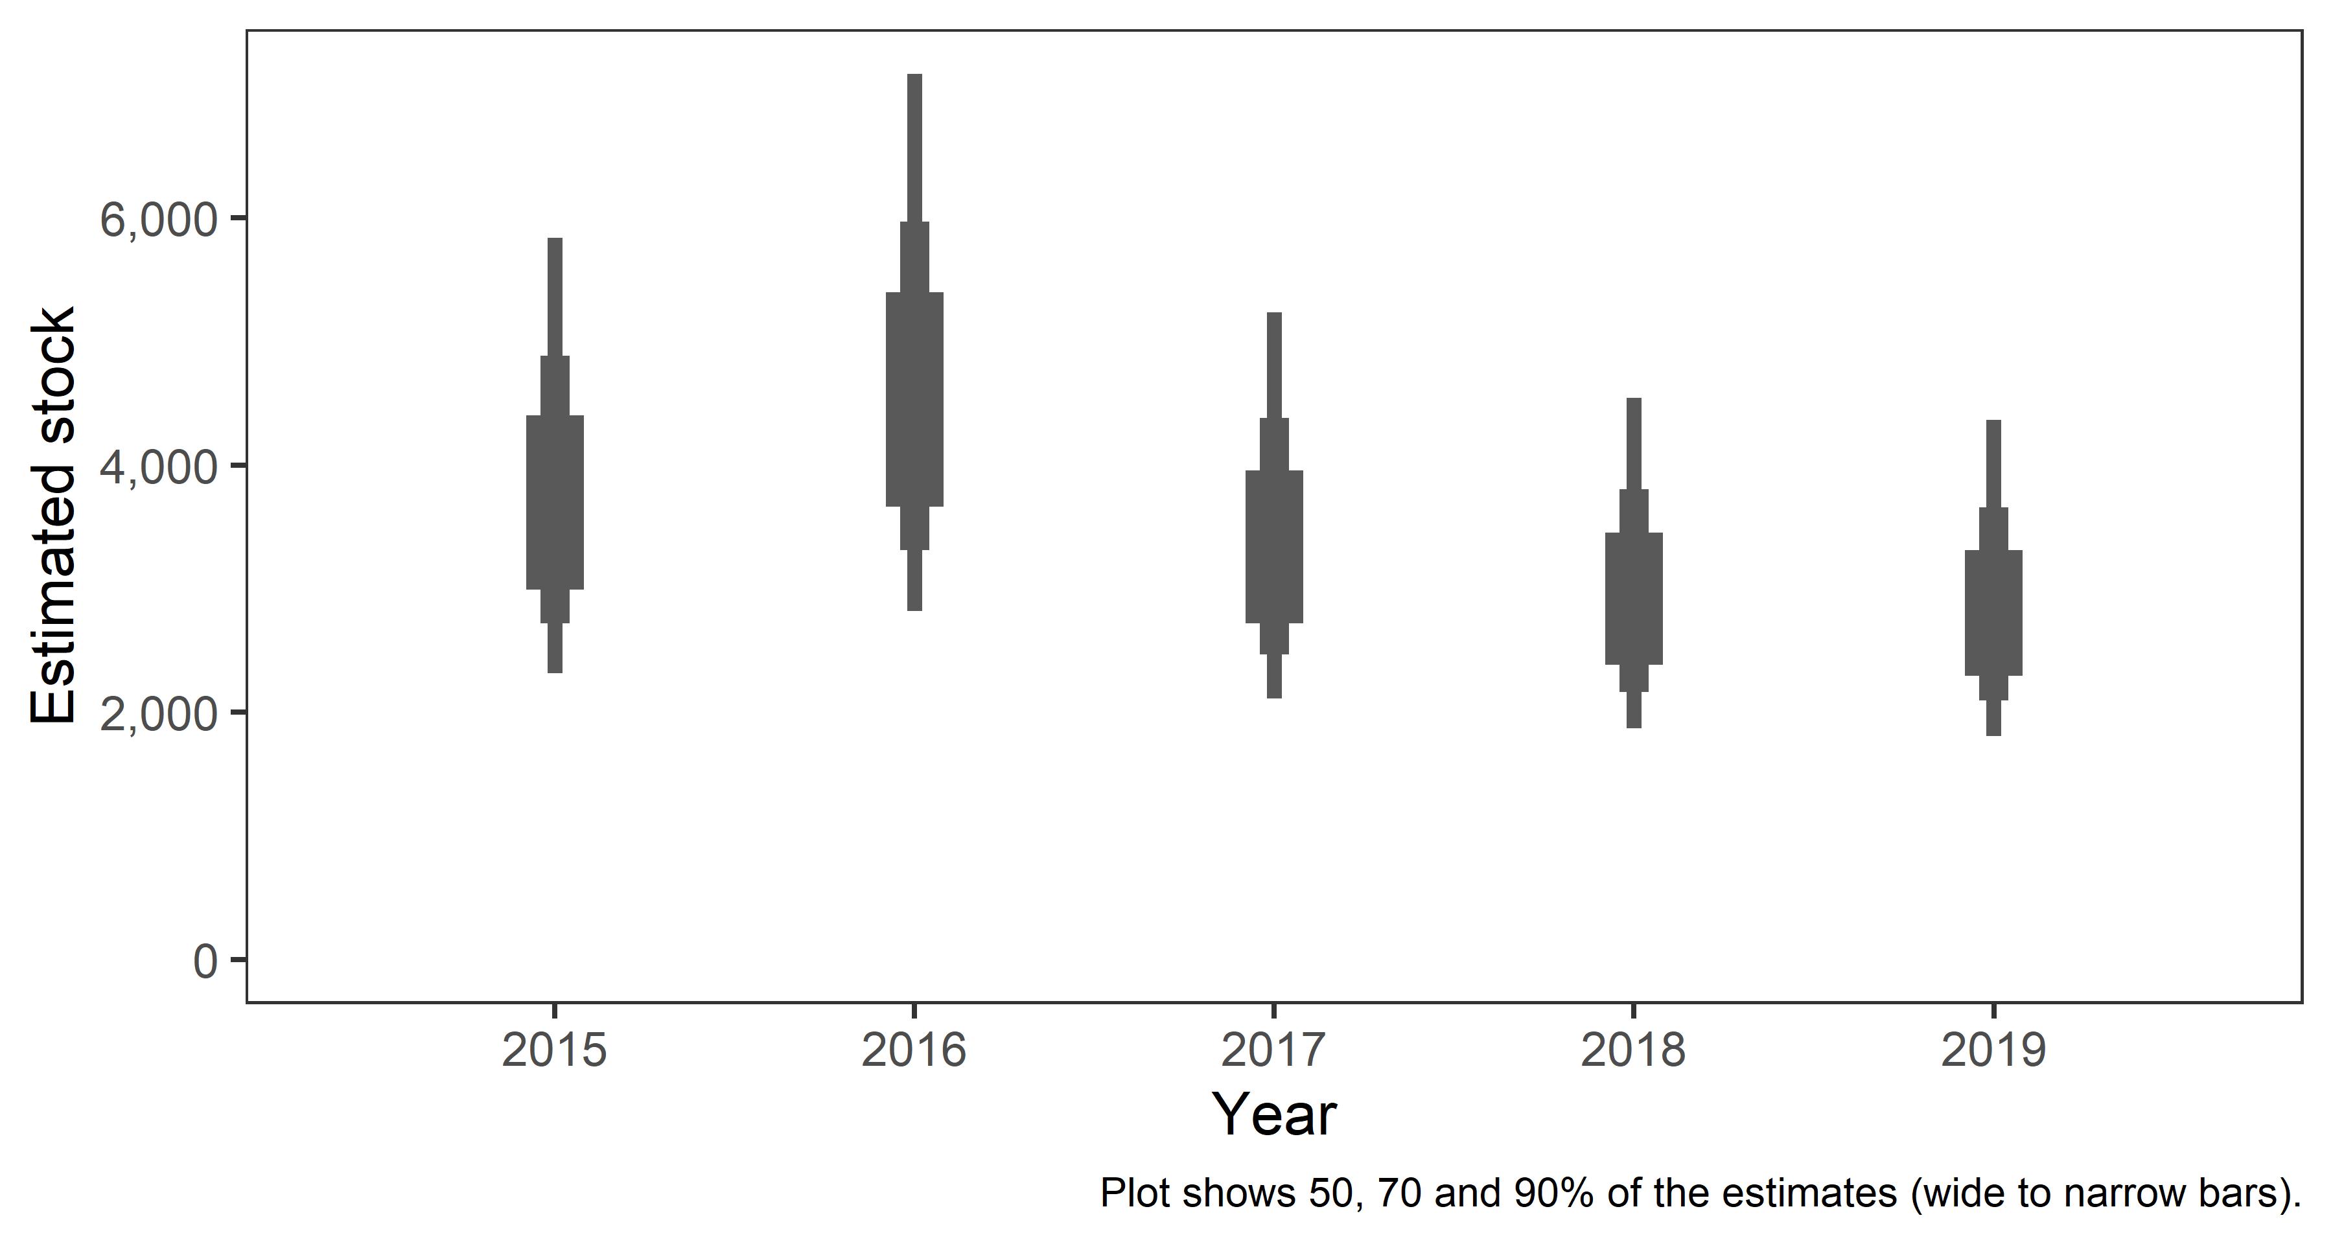

Step 2: Converting Numbers of Returning Salmon to Numbers of Spawning Females

Information on the age composition of salmon returning to the River South Esk during 2015-2019 is presented below:
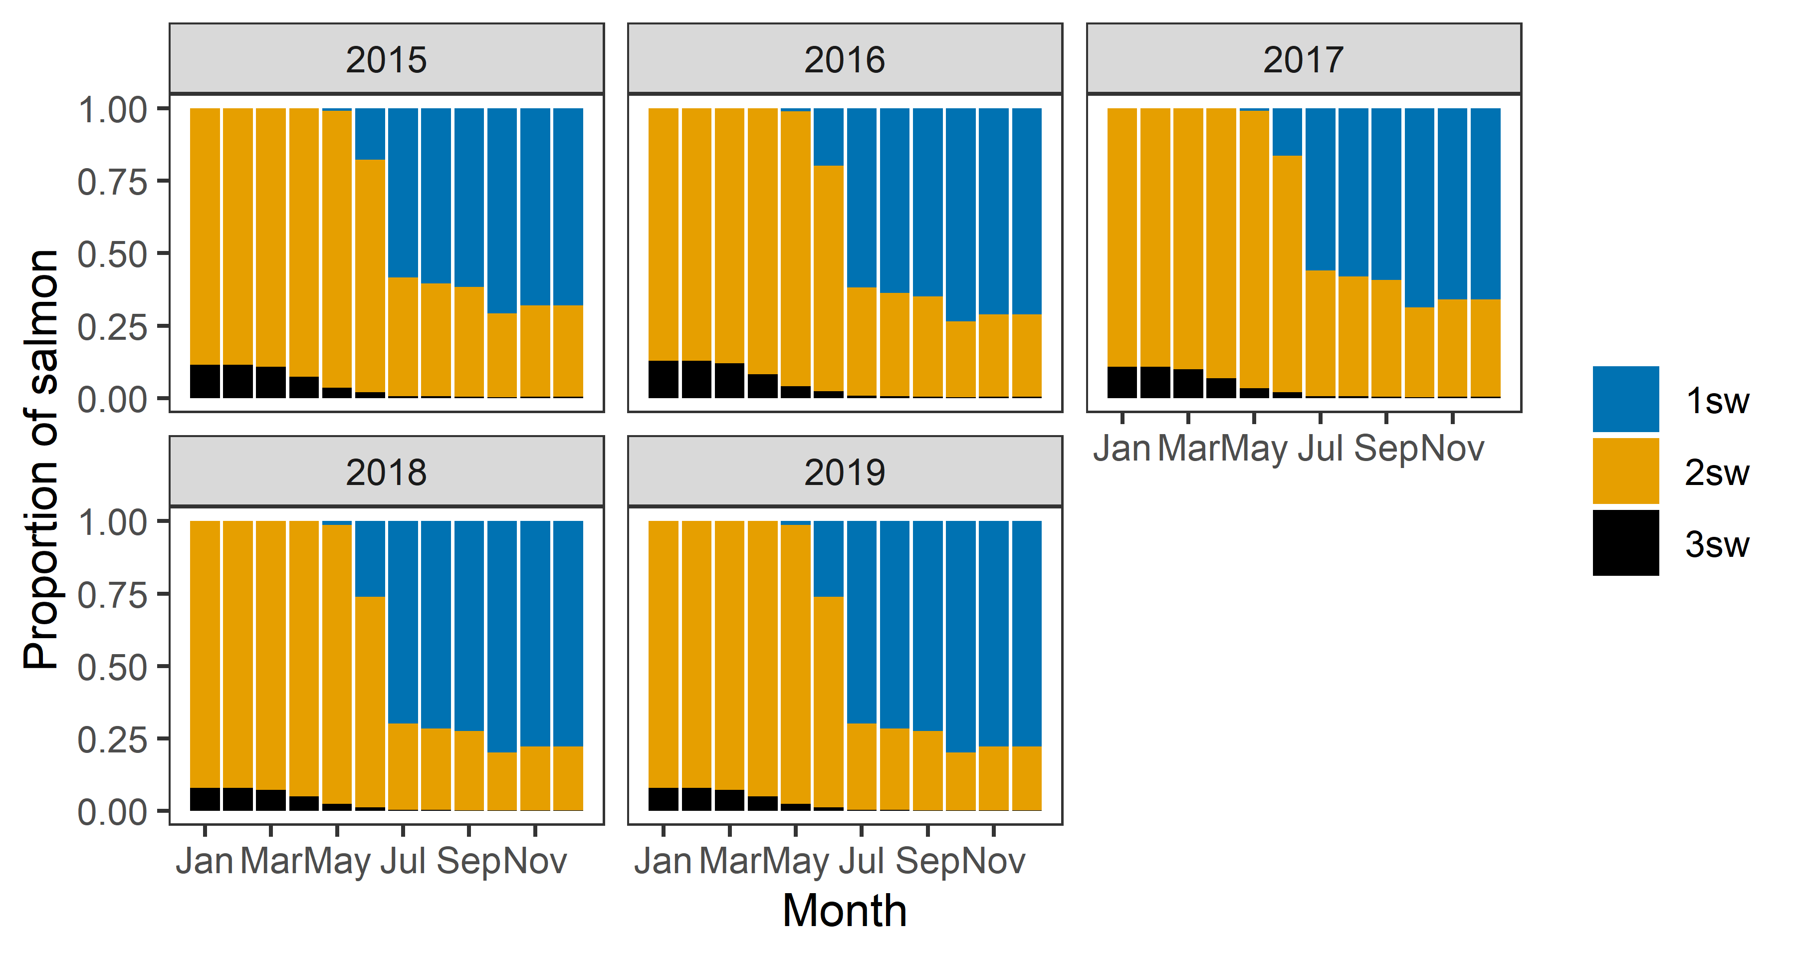

This information is used to convert the number of returning salmon into numbers of different age groups. After removing the fish killed by the fishery, accounting for natural mortality and the percentage female fish the number of female spawners for each age is estimated to be:

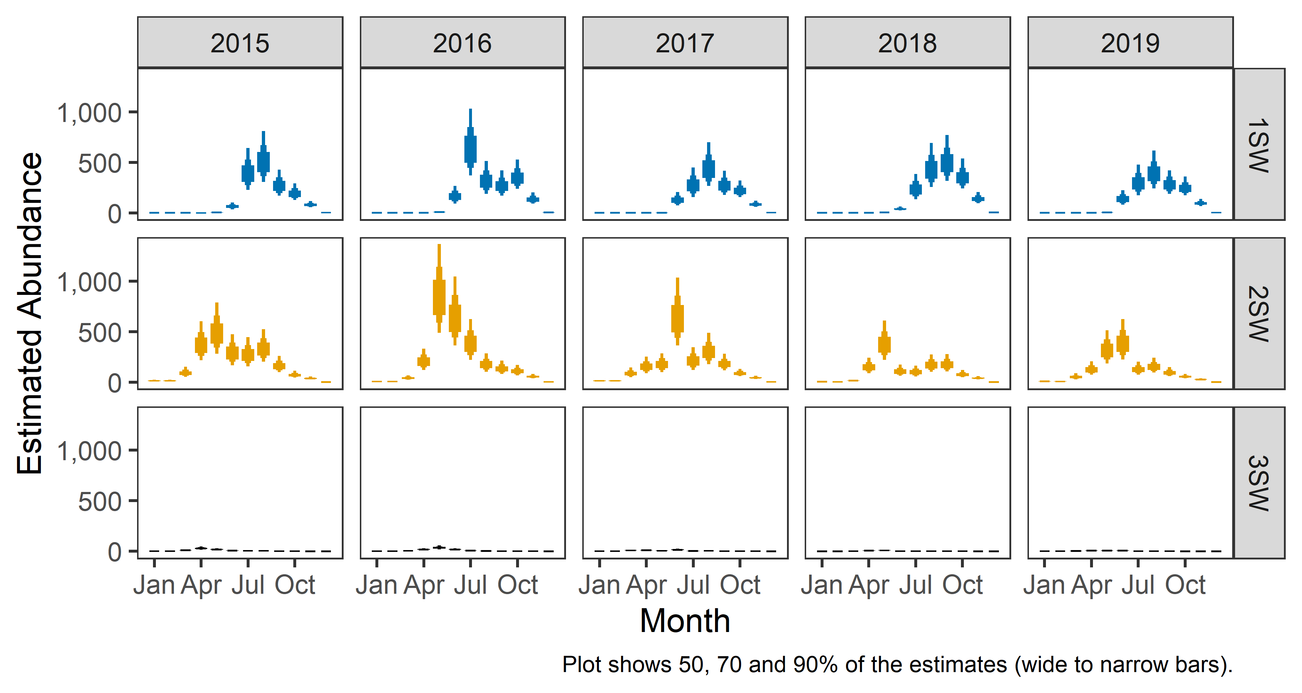

Step 3: Converting Numbers of Spawning Females to Numbers of Eggs

For the South Esk the egg content of individual females was estimated to be:

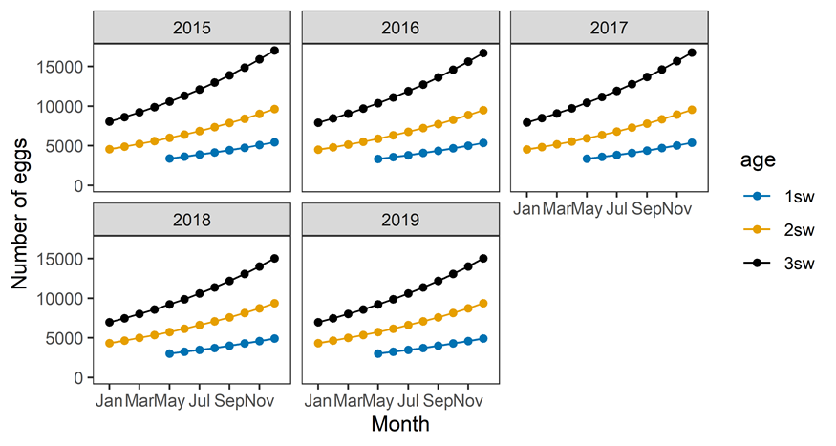

These figures are then combined with the number of females to estimate the number of eggs:

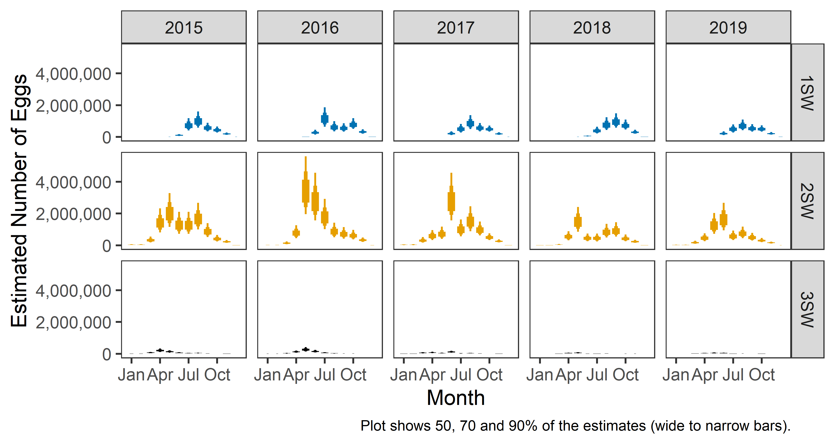

These monthly estimates for the different ages of fish can then be combined to estimate the total number of eggs each year:

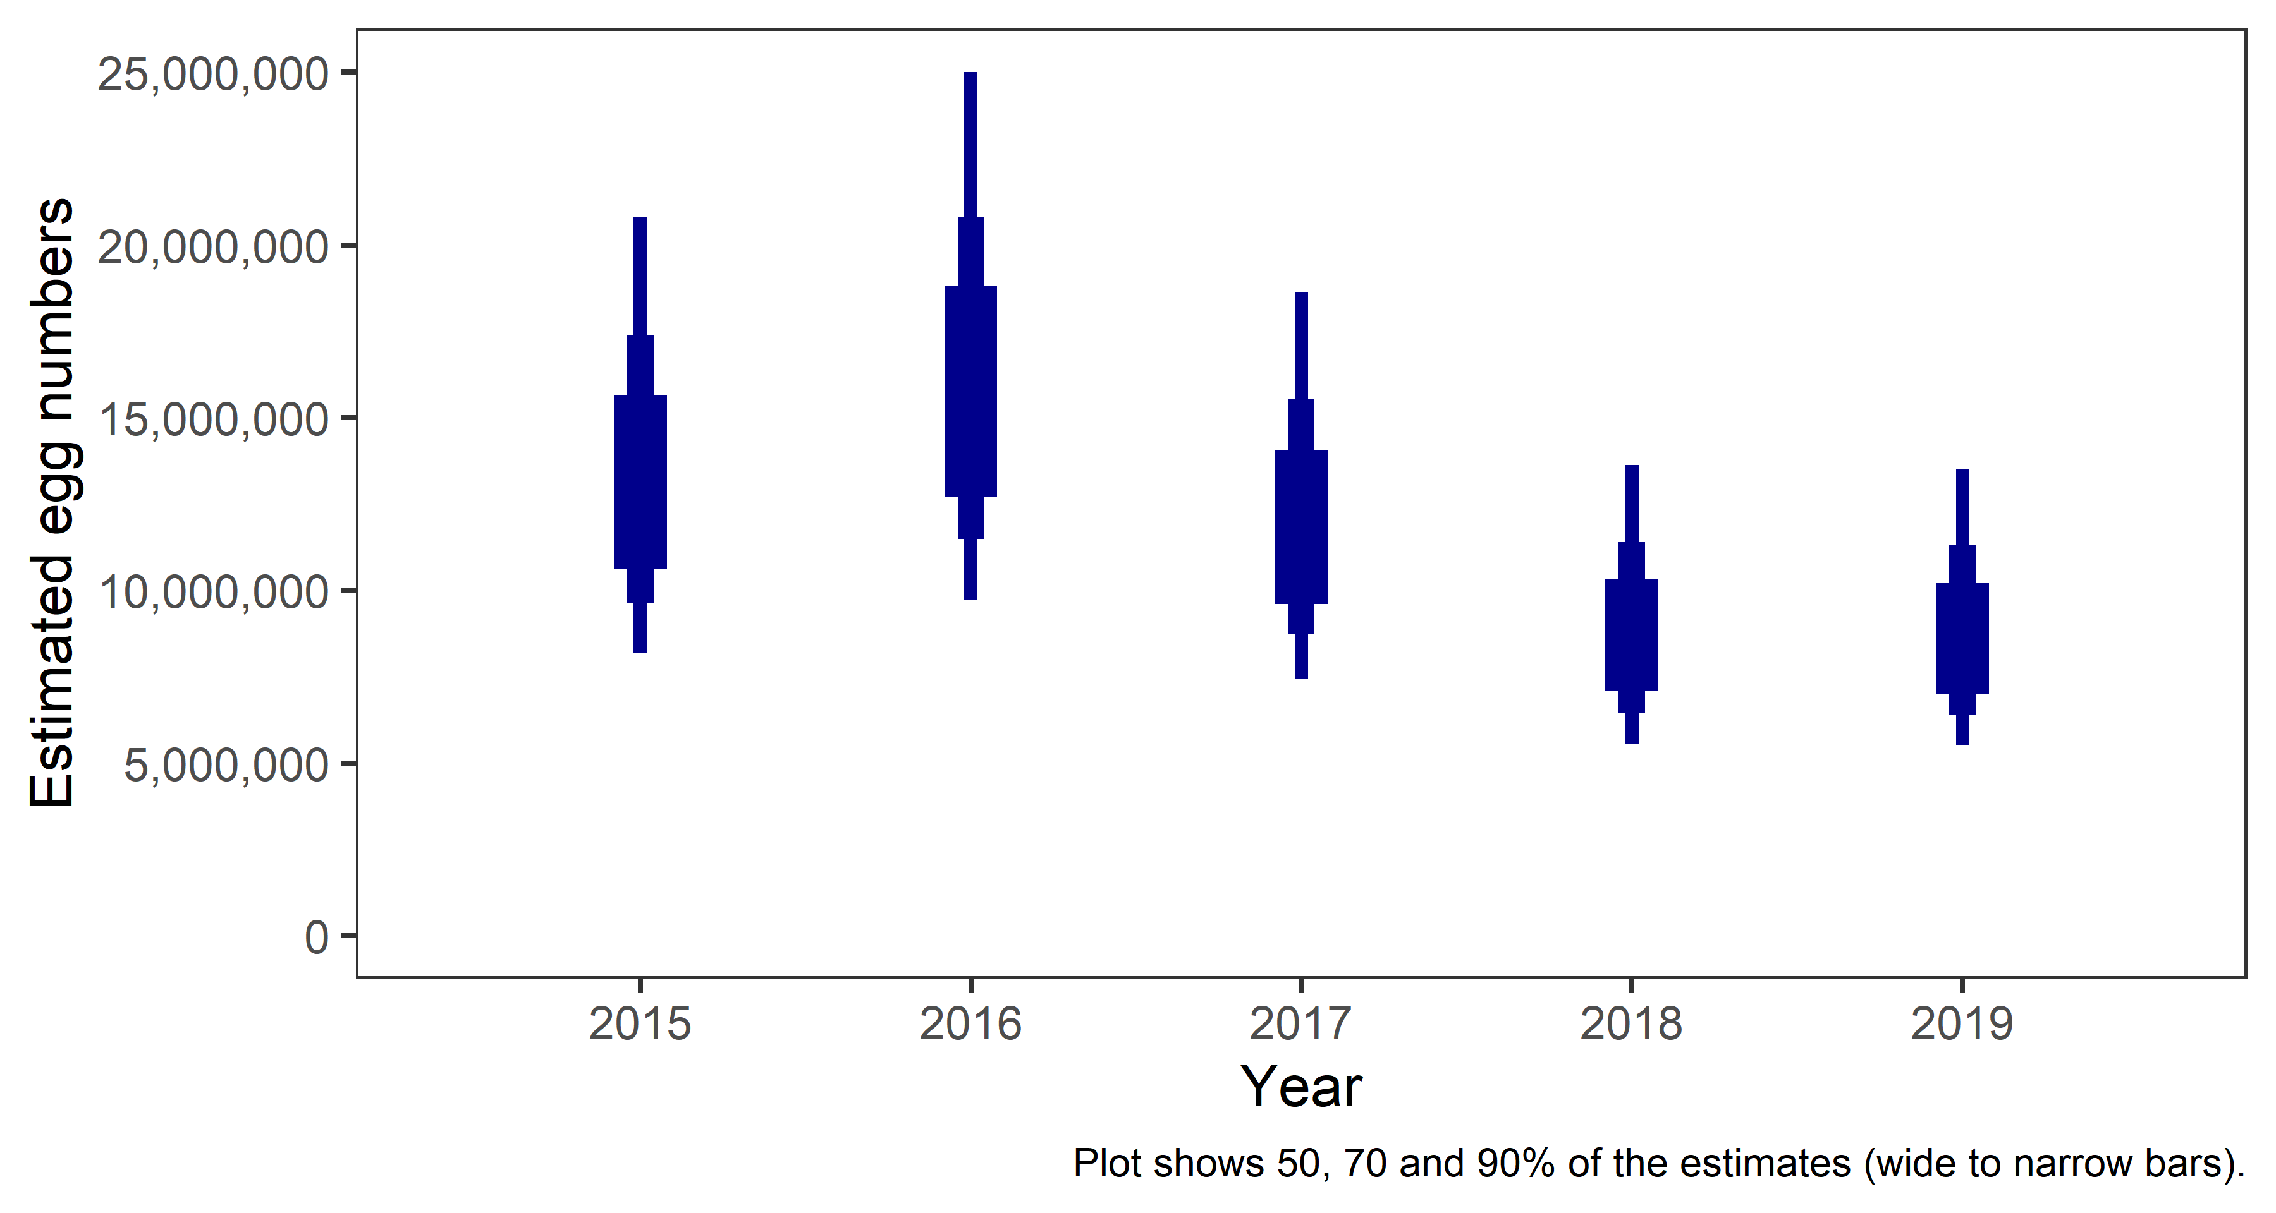

Step 4: Egg Requirement

The average egg requirement for the South Esk is 2.84 eggs for every square metre wetted area of salmon habitat in the river, although there is considerable variation around this estimate. Wetted areas were estimated following discussions with local Fishery Trusts and Boards regarding the distribution of salmon within the rivers, with an estimated 2,281,060 square meters of known salmon habitat in the River South Esk and a further 23,422 square meters where salmon may be present. Accounting for all the uncertainty given the following egg requirement for the South Esk:

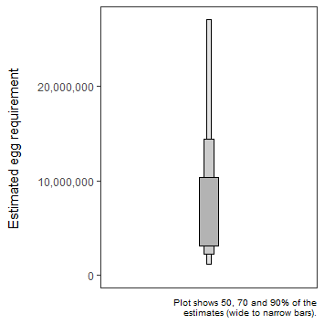

Step 5: Number of Eggs vs. Egg Requirement

For each year, in order to assess the certainty around whether the egg target is met a single egg requirement is taken from the range shown in step 3 above and compared to a single egg requirement taken from step 4. For example:

Egg requirement | Number of eggs
10,000,000 | 8,000,000
6,000,000 | 9,500,000
4,000,000 | 5,500,000
9,000,000 | 10,500,000
13,800,000 | 11,000,000
6,000,000 | 3,500,000
5,000,000 | 7,000,000
12,000,000 | 13,000,000
7,500,000 | 6,000,000
5,500,000 | 8,000,000

In this example the number of eggs exceeds the egg requirement in 7 out of 10 (70%) cases (shown in bold).

For each year this process is repeated 10,000 times and the percentage of cases where the egg target has been reached calculated. The percentage chance that the egg requirements have been reached for the last 5 years are set out in the following table:

Year | % above requirement
2015 | 80.6
2016 | 86.1
2017 | 77.6
2018 | 66.5
2019 | 66.1
Average | 75.4

The chances are averaged over the last 5 years and as the average falls between 60 and 80% the South Esk is Grade 2.

