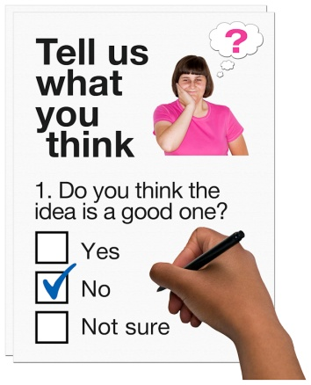
The same as you? Consultation Easy Read
 | Are you? (Please put a tick beside your answer)  Mr Ms Mrs Miss Dr  Or write it here…………………………
 | What is your first name?
 | What is your last name?
 | What is your address and postcode?
 | What is your phone number?
 | What is your email address?

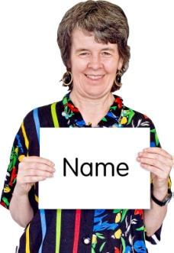




I am answering as…………. (please tick your answers)


Question 1
A Person

Are you happy for your answers to be seen by other people? (on the Scottish Government website)

Yes No

If you are happy for your answers to be seen by other people please tick one of the boxes below.

Yes, show my answers, name and address.

Yes, show my answers but not my name and address.

Yes, show my answers and name but not my address.

Are you happy for the Scottish Government to contact you about your answers?

Yes No

An Organisation

The name and address of your organisation will be seen by other people (on the Scottish Government website)

Are you happy for your answers to be seen by other people?

Yes No

Are you happy for the Scottish Government to contact you about your answers?

Yes No

Do the things in the easy read consultation report reflect your views and opinions about services for people with learning disabilities?
(Please tick your answer)


Yes No
You can put any comments about this question here.

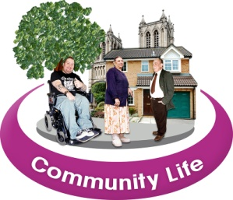
Question 2
What do you think has worked well over the last 10 years for people with learning disabilities and family carers?
This could be changes in your local community or all over
Scotland.
Please write your answer here.


Question 3
What do you think still needs to be done by the Government to make the lives of people with learning disabilities and family carers better?

Please write your answer here.


Question 4 - (this question is for organisations only)
- What have you done in your organisation to improve services for people with learning disabilities in your local area?
- What have you done in your organisation to improve access to services for people with learning disabilities in your local area?
Please write your answer here.

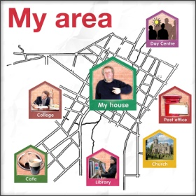
Question 5
What have you done to make things better in your local area for people with learning disabilities and family carers?

Please write your answer here.

Question 6

What do you thinks needs to be done to help people with learning disabilities get access to good healthcare?

Please write your answer here.


Question 7
What do you think needs to be done to improve access to better education and learning for people with learning disabilities?

Please write your answer here.

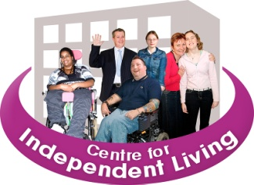
Question 8
What do you think needs to be done to help people with learning disabilities live more independent lives?

Please put your answers here.

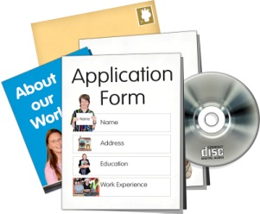
Question 9
What do you think needs to be done to help people with learning disabilities get jobs?

Please write your answer here


Question 10
What do you think are the things we need to do in the future to make the lives of people with learning disabilities better?
Please write the most important things first.

Please write your answers here.


Thank you for taking the time to answer the questions. Your answers are important to us so that we can do the right things to help people with a learning disability have better lives.

Please send your answers to:

Sarah Grant by 30th September 2012
By email Sarah.Grant@scotland.gsi.gov.uk

Or by post to:
Sarah Grant

The Scottish Government
Learning Disability Strategy
Adult Care and Support Branch
Room 2ER
St Andrews House
Edinburgh
EH1 3DG


Telephone: 0131 244 4749


