Marine Fund Scotland (MFS)
MFS application guidance note

Contents

1 Introduction 3
2 Home page & registration 4
3 System login 8
4 Making an application 10
4.1 Starting the Application Process 10
4.2 Create an Application 11
4.2.1 Create application screen 11
4.2.2 Project Description 13
4.2.3 Employment, Equality and Diversity 15
4.2.4 Application Details 15
4.2.5 Measure information 16
4.2.6 Project Finance 16
4.2.7 Claim and Reporting Schedules 20
4.2.8 Application Compliance and Declaration 21
4.2.9 Submit Application 23
4.2.10 Return Your Application 23
4.2.11 My Applications 24
4.3 Delete an Application 25
4.4 Withdraw an Application 26
4.5 Checking progress of a submitted application 26
4.6 Successful application 28
4.7 Unsuccessful application and appeals 28
5 Making a claim 29
5.1 Claim details 30
5.2 Claim Finance 30
5.3 Claim Declaration 31
5.4 Claim Submission 31
5.5 View Claim 32
6 Progress report submission 33
7 Notification of change 34
7.1 Create a Notification of Change 34
7.2 View or Modify a Notification of Change 36
8 Update registration details 37
9 Users 38
10 Updating your details 39
11 Post project monitoring 40
12 Contact us 40

1 Introduction
This Guidance Note is intended to assist you with the application process for a MFS grant. Details on eligibility, priority Scottish Government objectives, intervention rates and other matters can be found in the MFS General Guidance. Applicants should also read the MFS Business Case Guidance. Both documents are on the website Marine and fisheries grants - gov.scot (www.gov.scot)

There is an online application system for the MFS, we are using our current MFF system Home - MFF (marinemanagement.org.uk) .

All applicants must use the online application system, which enables you to manage and track your applications, submit claims, progress reports and upload documents directly on to the system.

Applicants should come from one of the following sectors, noting that topics such as Innovation and Environment are relevant within each of the sectors:
- Commercial Fishing
- Aquaculture
- Processing and Marketing
- Seafood related operations at Ports and Harbours
- Aspects of environmental protection and improvement of the marine environment within the scope of each of the categories above.
- Aspects of coastal community support where they directly relate to the categories above.

Section 5.2.1 of this Guidance Note provides further details on how different sectoral applicants should complete the online forms.

MFS applications will also be assessed against benefits to the Scottish blue economy and seafood industry according to a range of outcomes. These outcomes may require to develop over time, however at present the identified outcomes are as follows:

Overarching/public good
- Supporting collaboration, partnerships, knowledge and technical expertise which enable better decision making, regulation, science and innovation
- Enhancing the marine environment, including quality, reputation and marine products
- Reductions in emissions and support for the drive to net zero
- Removal of waste.

Supply chain/marketing.
- Fairer and greener supply chains
- Developing direct selling and new and existing markets which deliver sustainable economic benefits.
- Matching processing and supply chain capacity with landings and production capacity.

Sectoral/Community outcomes
- Development and delivery of training including safety and sectoral training.
- Promoting fair work and opportunities for new entrants to the seafood and marine sectors
- Improving marine infrastructure.
- Diversification projects which enhance the marine tourism, sea fisheries and/or aquaculture sectors or coastal communities.
- Improving resilience, including that of communities, supply chains and businesses.

You should identify which of the Outcomes your project is addressing at the top of the third text box, described in Section 5.2.2 of this Guidance Note.

2 Home page & registration
The main screen to access the MFF e-system can be found here. The home page is shown below. Note that this is an existing system we are using for the MFS grant scheme, that is why the generic Maritime & Fisheries Fund (MFF) title appears in many parts of the system.

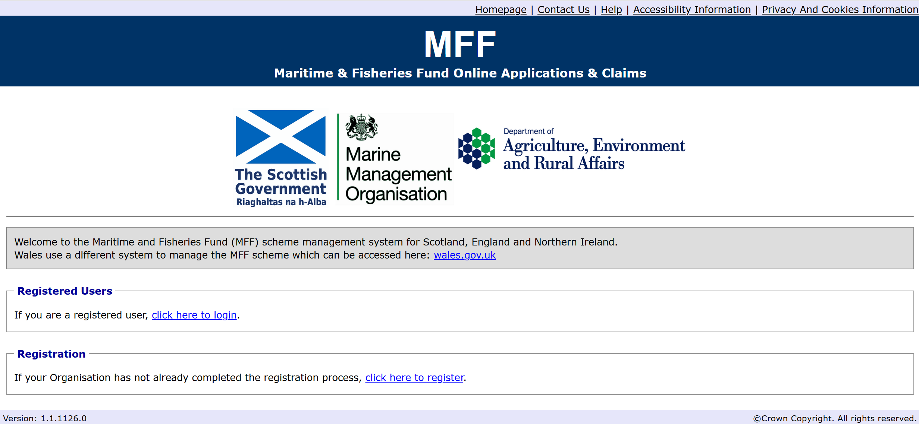
FIG.1 Home screen

You need to register for an MFF e-system account to apply for funding and make your claims, and please note you will need an e-mail address to complete this step. Even if you were a registered user of the previous EMFF system, you will still need to register for the MFF system.

If you are a business who will have more than one applicant using the MFF e-system for your organisation, you only need to register your business once. Additional users/applicants can be attached to your business account by following the guidance in Section 10 of this document. This approach allows you to view and manage all of the MFF applications for your business from one account.

To register, click the register link under Registration as shown in the screenshot below.

This will take you to the registration details screen as shown in the screenshots below, the red boxes represent mandatory fields. You will need to complete your details, these will be saved but can be changed at a later date if required (guidance on changing your registration details is covered in Section 9 of this document).

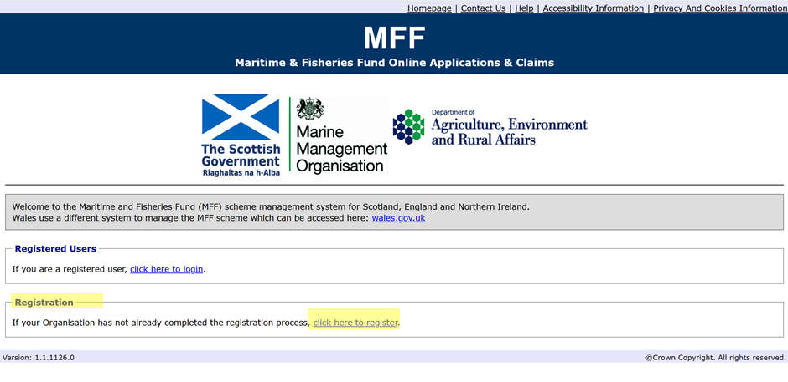

Although the registration page is only one page long, it has been broken it down in the screenshots below to provide further information on the questions we ask.

You will need to provide the applicants title, name and gender. Gender is split into four categories, these are male, female, other (for those who don’t identify themselves as male or female) there is also a prefer not to say category in case you do not feel comfortable sharing this information.

We require the name of your business, if you don’t have a business name or a registered trading name, please insert your first and last name here instead.

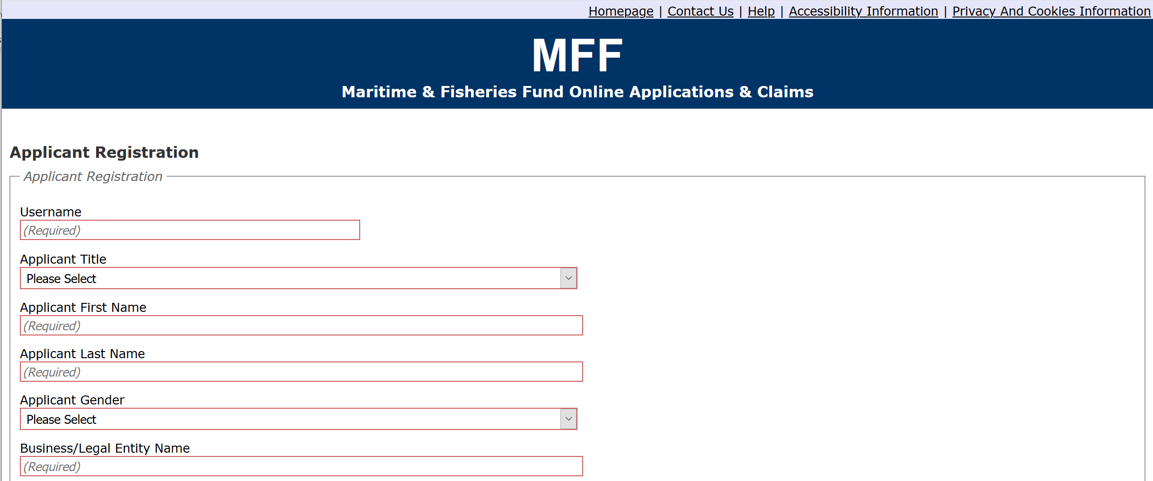

We also ask for your address and contact details to allow us to contact you regarding your application and claims. You need to have an e-mail address to use the MFF e-system as this will be our primary way of communicating with you.

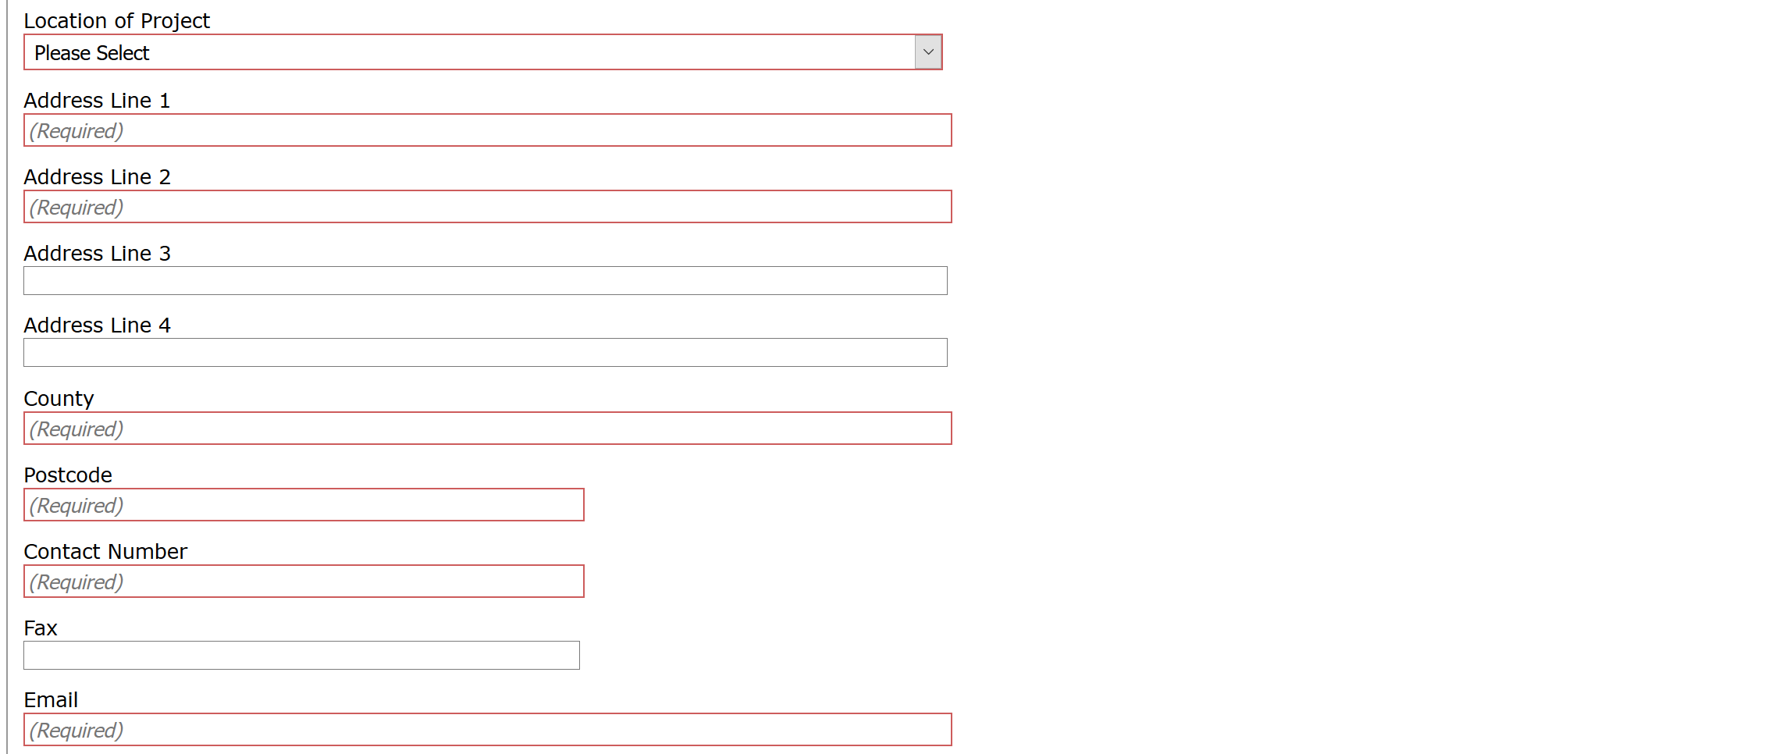

We ask for your company registration number, if you do not have a company registration number then leave this box blank.

We need to know the type of organisation you belong to as different organisation types can apply for different items supported by MFF and are also eligible for different amounts of grants. By selecting the appropriate option the e-system will be able to guide you through what you can apply for and how much you could receive.

If you are a sole trader or a partnership you need to provide us with either a certified copy of your driving licence or passport, If you are not a sole trader or a partnership you will not see a ‘Proof of identity’ question. If you do not have a driving licence or passport you need to provide us with two utility bills less than 3 months old which show the applicants name and address. Please let us know which you are attaching to your application, the local fisheries/coastal employees in your intermediate body will certify the copy for you free of charge, there is a fee for the post office or a solicitor to certify for you.

You need to tell us how you heard about the MFS scheme, this will help us to plan the best way to promote the scheme in future.

We need to know if you are VAT registered. If you are VAT registered you will need to provide your VAT registration number.

You will need to choose a unique username, this will be the username you log into the MFF e-system with. Your username can be anything that is memorable to you, it doesn’t have to be an e-mail address.

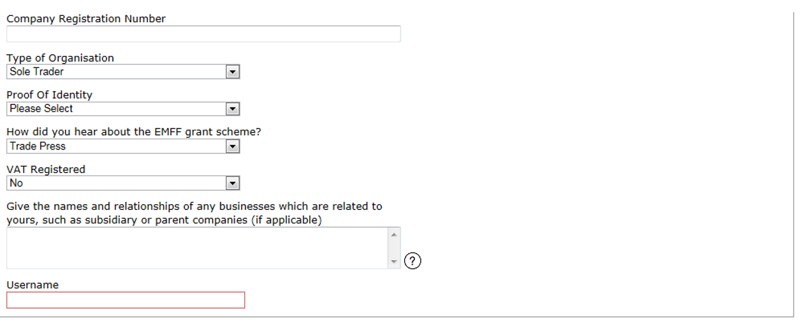

Only complete the table shown below if you would like someone else to be set up to manage your e-system account and make applications or claims on your behalf. Please provide this person’s details, although someone can complete the information in your application and claims forms, as the applicant you will still need to sign the declarations on the forms as you are accountable for the information being accurate and responsible for any MFS funds received.

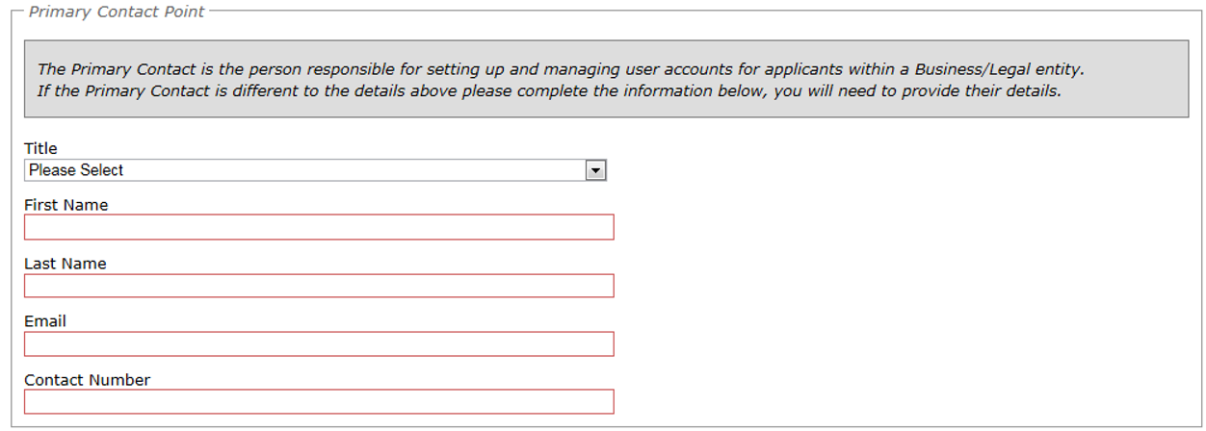

The disclaimer details the data protection fair processing rules and you must tick to say you understand and accept this disclaimer statement before your MFF e-system account can be set up (the version on the application system is out of date and the current disclaimer is on our website - see contact details). If you do not understand, please don’t hesitate to contact us using the details in Section 12 of this guide.

Once you are happy with the information provided please click Submit to complete your registration.

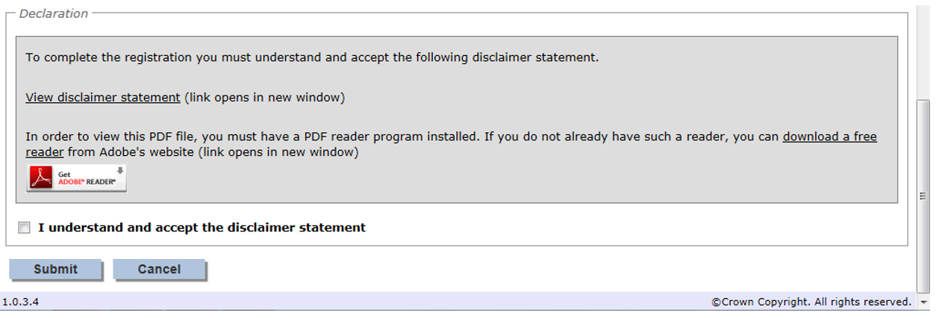

Once registration is complete, an email will be sent to the registered email address containing your username. A second will also be sent containing your temporary password. If you do not receive an e-mail, please check your junk mail and mark this as a safe sender so these appear in your in box in future.

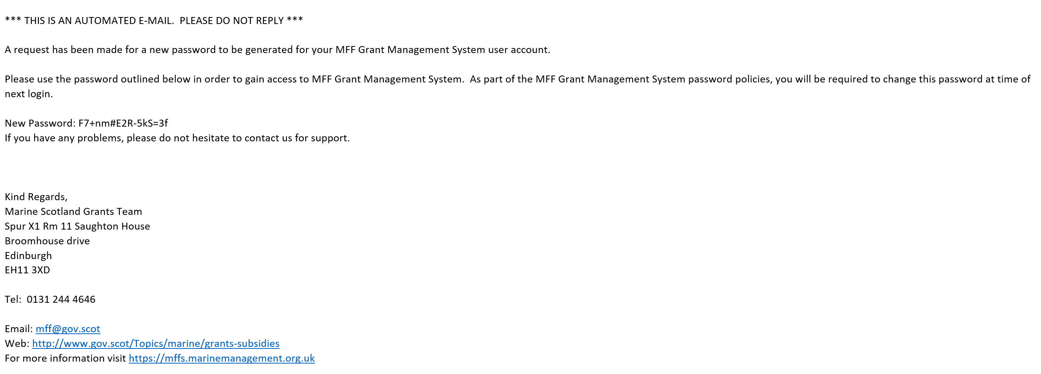

3 System login
To access the system and submit an application, click the login link under Registered Users and input your user name and the password which you will have received by e-mail. If you have not received a password, please check your junk mail in case they have appeared in there and if you still can’t find them please contact the Fisheries Grants Team using the details in Section 12 of this guide.

When first logging in, you will be presented with a Login Details section requesting the password is changed.

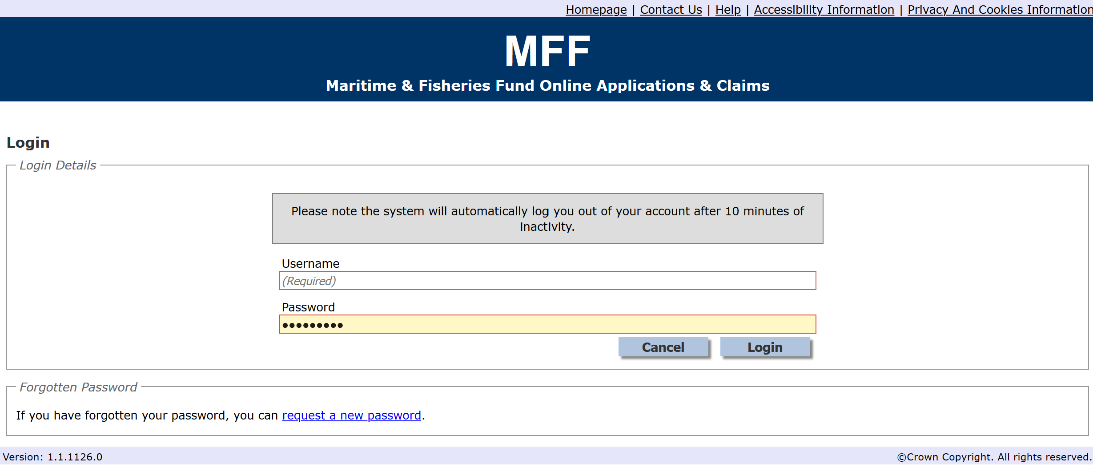

Enter the Username and Password from the received emails and choose a replacement. Your password must be at least 8 characters long and must include at least:
- 1 letter
- 1 number
- 1 non-alphanumeric character from (){}!"$%^&*-_+=[];:'@~#/?.,|\.

When finished, click Login.

You will then be presented with the Applicant home page section of the system, as shown below.

Please note if you can’t remember your password you can request a new password by clicking the link as shown in the screen print above. If you can’t remember your username, please contact the Fisheries Grants Team using the details in Section 13 of this guide, they will verify your identification and provide you with your username.

The applicant home page is a central location from which to navigate. This includes:

- Creating, submitting and amending applications and claims
- The ability to search applications and claims
- Project monitoring
- Notify changes
- Update Applicant Details and Users
- Logout of the system.

The quick access menu will show you options as they become available, for example when you first log in you can access Create application and my details however once you create your first application you will have an additional option called My Applications as this/these are now in progress. Once you have accepted an offer you will have an option for my claims and so forth.

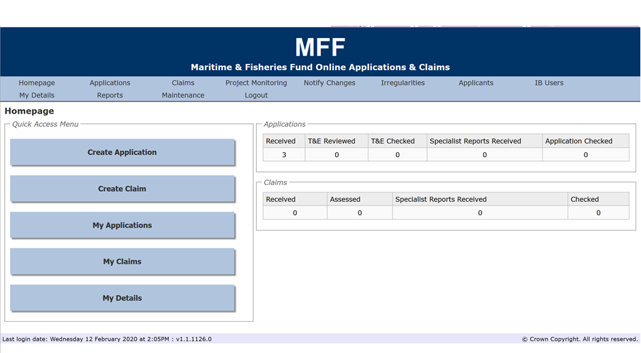
You can also use the buttons at the top of the screen to help you navigate as shown below. This toolbar is present at the top of all screens within the e-system to simplify navigation.

4 Making an application
If you are interested in the funding available, you should read our general guidance and application guidance on our website before starting your application.

4.1 Starting the application process

Once you are logged in you will be taken to the applicant home page, there will be a button to create an application as shown below.

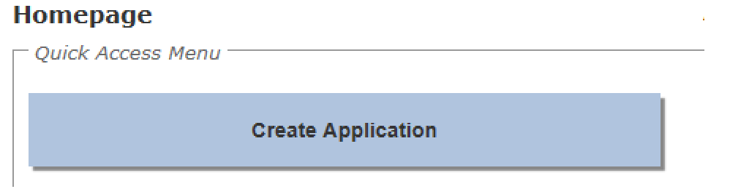

Before you proceed with creating an application you may wish to have the following items at hand or be aware that they will be necessary to accompany your application when it is submitted.
- A Business Case, which is required for all MFS applications
- Financial Information: Current & expected turnover, balance sheets and profit
- Quotes for costs to be incurred
- Company and VAT Registration numbers if applicable to your circumstances
- Organisation headcount numbers if applicable to your circumstances.

4.2 Create an application

To create an application, select the Create button on your homepage. The system will navigate to the Create Application screen to allow you to select an application form appropriate for your project.

4.2.1 Create application screen

In this initial screen, the first step is to identify yourself as the Applicant. Your registered name should drop down from a list of all registered users.

You should then manually enter your Project Title.

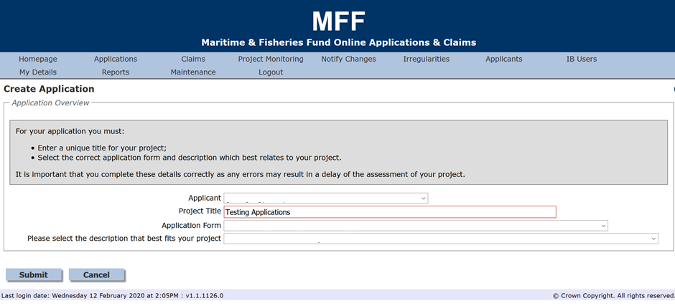

The next step is to choose from the most appropriate of the drop-down Application Forms, which are:
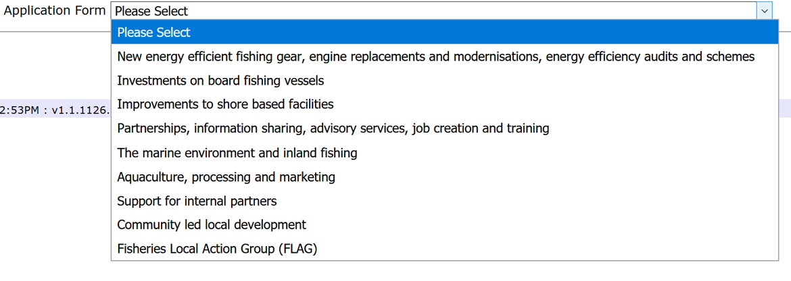
The application forms listed in the drop down above do not match the Blue Economy Outcomes, please choose the best fit for the industry sector your project is in.

The appropriate application form for most other types of project should be self-evident, but do contact the Fisheries Grants Team if you are uncertain.

The final entry box, Please Select the Description that Best Fits your Project, this only appears once you have selected the appropriate Application Form. The drop-down options will depend upon which Application Form you chose, but an example for a Fisheries Innovation or a Ports and Harbours project is shown below. You should select the best fit for your project.

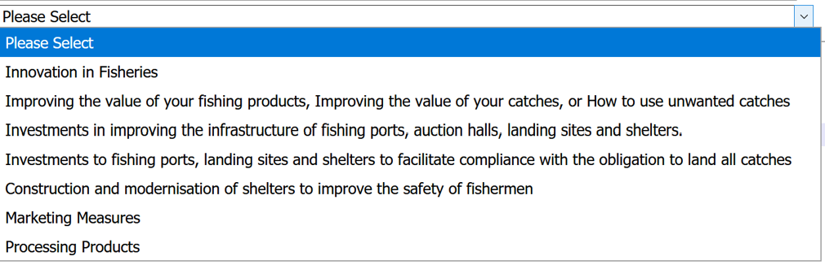

When you have completed the Create Application page, select the Submit button at the bottom of the page. The system will automatically allocate a unique project reference number and take you to the first page of the application form.

While you are within an application form you will notice that every page displays a section showing your project title and reference number at the top of the page.

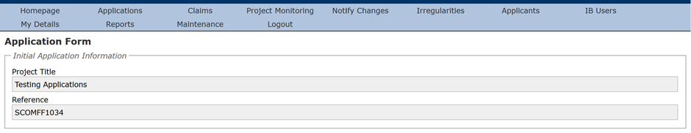

The Application form page displays summary information about the completeness of your application and links to all sections of the application form. You will notice that the Submit button is not active until all sections of the application form have been completed.

Please note that the e-system has been designed to allow an application to be completed over a number of sessions and once a section has been saved, the information will be retained until it is updated or removed by the applicant.

The e-system will attempt to validate each section of the application as it is completed to ensure that all mandatory fields have been populated and also to ensure that correct information has been entered into the more complex screens, such as the Project Finance screen. Please note that precise error messages will not be presented on this screen but they will be available by performing a check for errors within the section itself, as described below.

To access each of the sections click on the links in the application details section: Project Description, Employment Equality and Diversity, etc. It is logical to work through each section in order, but you can revisit earlier sections if you have not completed all the details required.

At the bottom of each of the section pages are four buttons:
- Save: This will save the application but the system will not navigate from the current screen.
- Save and Return: The application will save and the system will navigate back to the Application Detail screen. The system will also validate your application.
- Check for errors: This will check the application for completeness and correctness but the system will not navigate from the current screen. If there are any errors then a summary section will appear. Appropriate error messages will be displayed here to assist you with completing or correcting the information entered.
- Return to previous page: This will exit the screen without saving any changes.

Finally in this sub-section, before proceeding any further, take a moment to remind yourself of the eligible and ineligible types of expenditure/projects that might be support by the MFS – see the MFS General Guidance Note on our website.

4.2.2 Project description

The first application section to complete is the Project Description. This is to be used to provide an overview of your project and to explain why you are applying for funding.

All boxes outlined in red or noted with ‘(Required)’ are mandatory and must be completed. Text Boxes that state that a Maximum of 2000 characters is permitted will allow you to exceed this limit but the application will fail when you check for errors. The number of characters used is therefore displayed for your convenience.

You are required to insert a project start and end date, there is no need for you to calculate the project duration as the e-system will do this automatically.

Next you will need to provide a brief description of your project, explain if your project will go ahead if you do not receive the funding and provide a list of your organisation directors/shareholders/partners, you will need to say ‘none’ if this doesn’t apply to you.

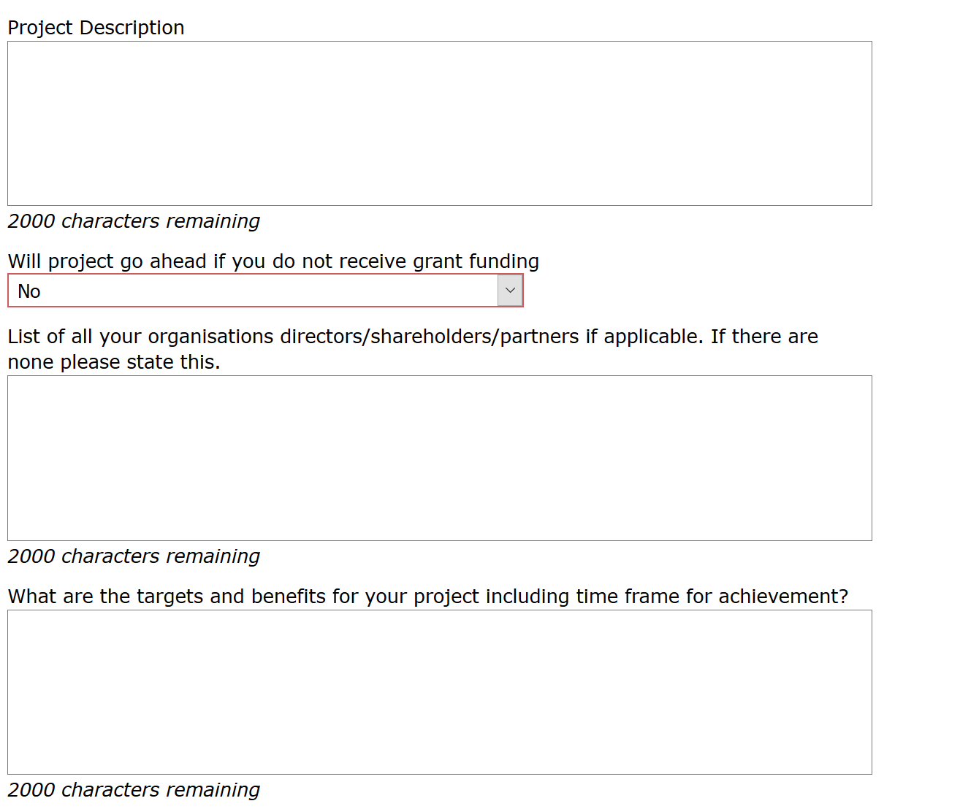

You will need to provide the targets and benefits for your project, our General Guidance (http://www.gov.scot/Topics/marine/grants-subsidies) provides useful examples of good targets and benefits. This box is where you should highlight, at the start, the main MFS Priority Theme(s) & Blue Economy Outcome(s) your project contributes to and give specific information how it contributes (See Section 1).

You need to provide the names and relationships of any business related to yours to register any conflict of interest with your applications.

Lastly the system asks for information on your turnover, balance sheet and profit to calculate the size of your organisation as the grant rates available differ. You can input £0 if this doesn’t apply to you. Your application will still be considered if you are not in profit, as delivery of this project may change your situation for the better.

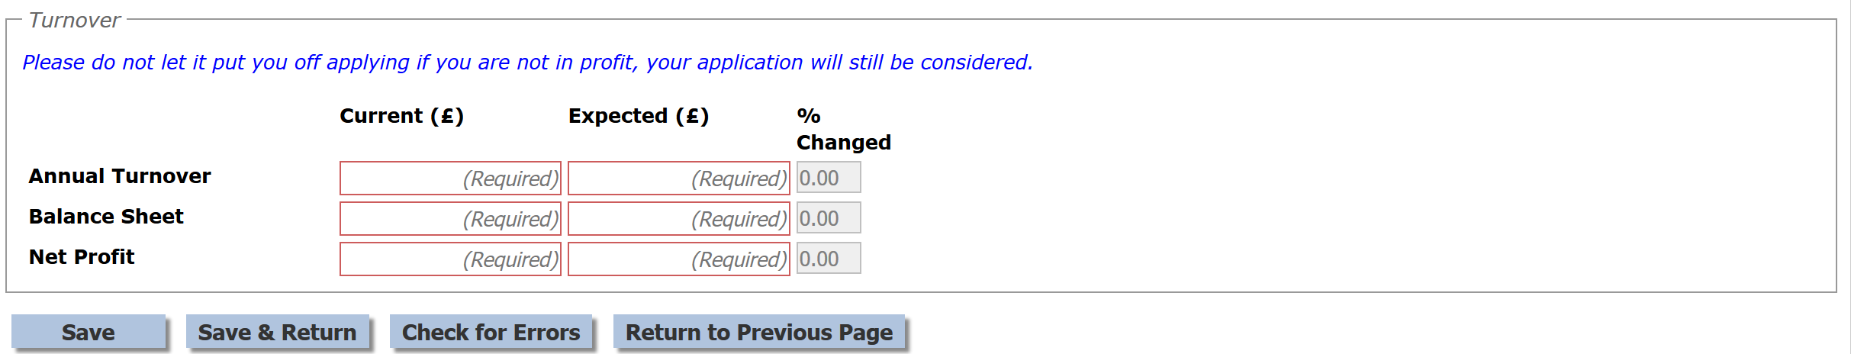

4.2.3 Employment, equality and diversity

The employment, equality and diversity screen is used to highlight any changes to the headcount within your organisation, this allows the system to gather information to calculate the size of your enterprise (micro, small, medium, large) and to enable us to report equality and diversity information.

We appreciate it is difficult to estimate post project if you will have recruited male, female or other, however we ask that you provide your best guess.

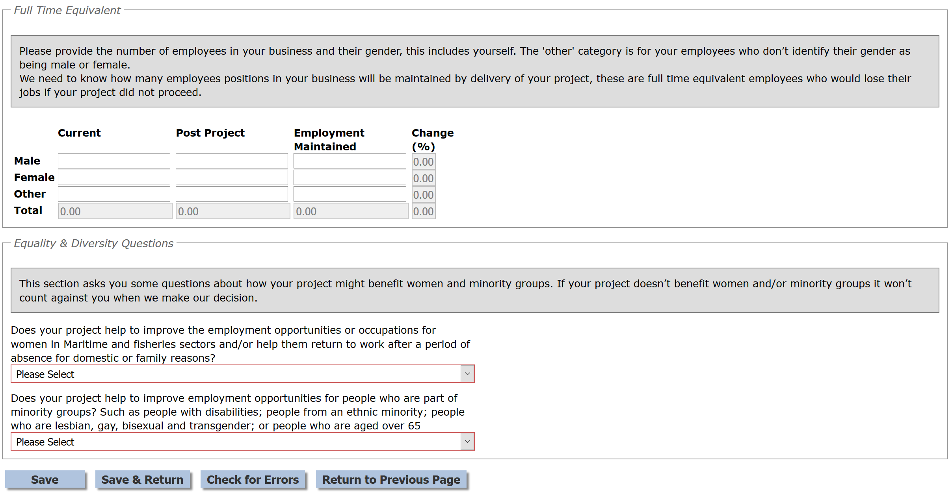

4.2.4 Application details

The information displayed on the Application details page is dependent on the type of project you are undertaking. An example is shown below.

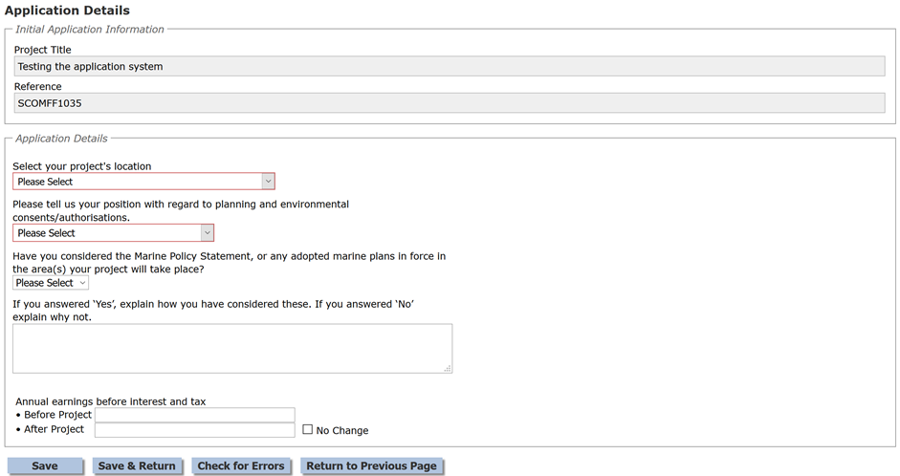

All boxes outlined in red or noted with ‘(Required)’ are mandatory and must be completed.

4.2.5 Measure information

The information displayed on the Measure information page is dependent on the type of project you are undertaking. The information gathered on this page is required for our performance review.

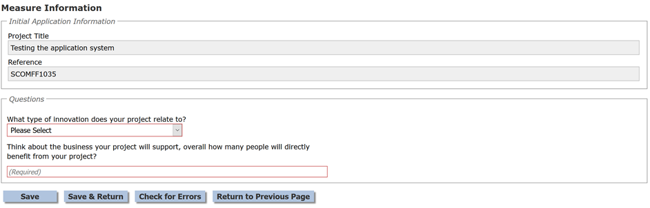

All boxes outlined in red or noted with ‘(Required)’ are mandatory and must be completed.

Please complete these questions as best you can, they may not be applicable in all cases, but you have the opportunity to further explain the measureable benefits of a project in your business case. Please ensure benefits are ‘SMART’ (Specific, Measureable, Attainable, Relevant, Time-bound).

4.2.6 Project finance

The Project Finance screen is used to tell us about how much your project will cost and how this will be funded. This screen is split into the following sections

4.2.6.1 Eligible costs and quote details

We need to understand how much a project will cost, this section allows you to provide information for each cost related to your project.

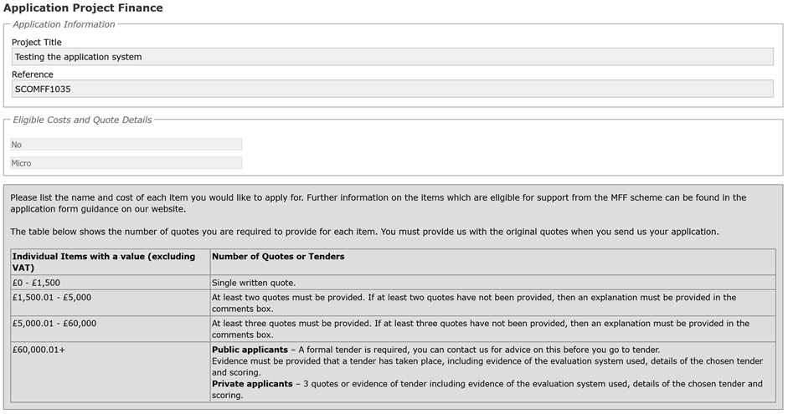

Note that different rules apply to different applicants when obtaining quotes for projects. The rules for public applicants such as public authorities and government organisations and the rule for private applicants such as private businesses are shown above.

The first section to complete on this screen relates to the total cost of your project as shown in the screen shot below. You build up your total project costs by making a series of entries concerning quotes for different project elements. The initial screen is shown below, but it will gradually expand as you make your series of entries.

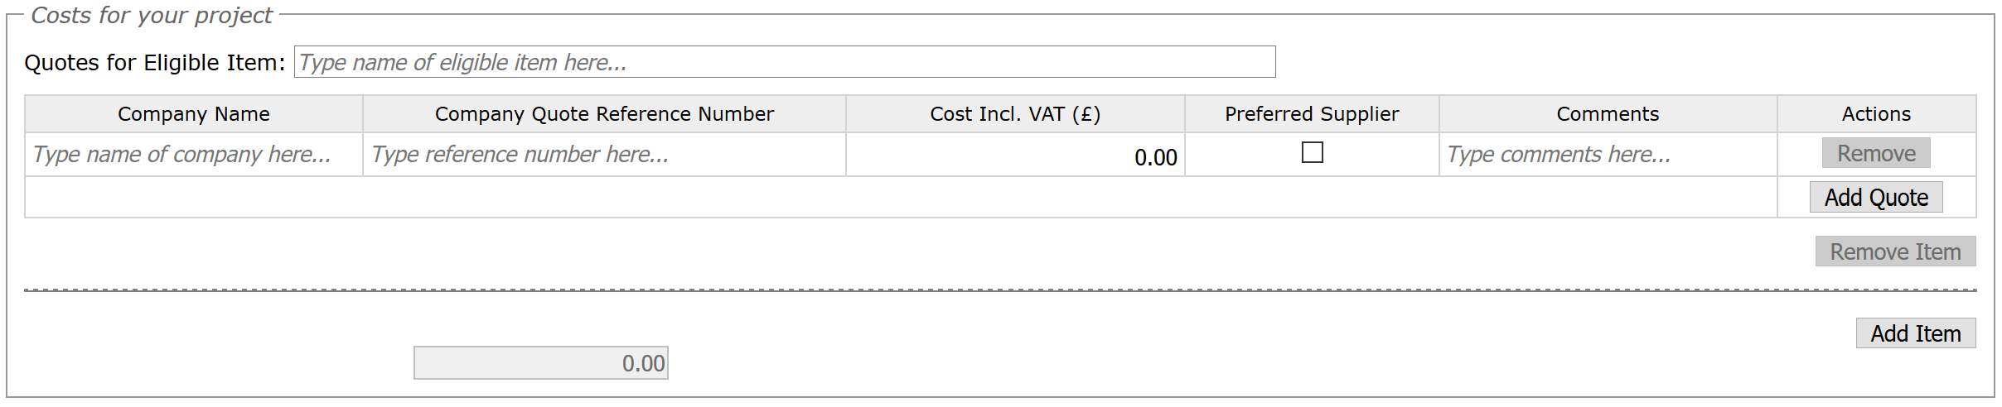

The quotes for the eligible item box is where you put the name of the item, for example this could be equipment, a service that you require, the name of a training course or fitting of gear.

You then need to provide the name of the company providing the quote, your quote reference number will be either the reference number on the quote you have been provided with, or, this may be an item reference number from a website/retailer catalogue. The cost of the item on your quote should be shown.

To add further quotes please select the add quote button (highlighted below). You must select at least one supplier per item so we can see what the project will cost.

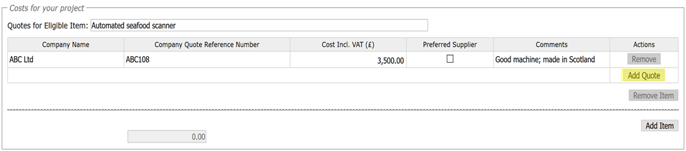

The comments box can be used to provide further information that supports and/or provides an explanation for the quotes provided. You MUST choose a preferred supplier/quote (see the highlight below) so we know which one you are using. If you forget to choose a supplier you will receive an error message when you check for errors on the screen.

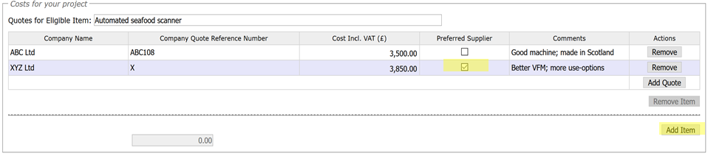

The Add Item button will generate another cost table, for another piece of equipment or service that is required for the project.

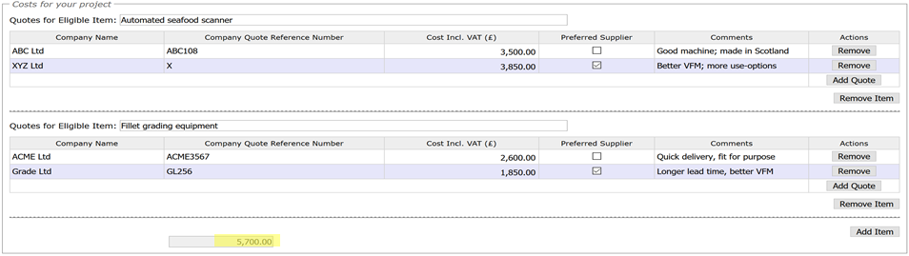

After adding the quotation details for the new equipment or service, you can continue to Add more Items and insert quotes for these. When you have completed this for all your required inputs (or if you wish to pause this session and return to it later), press the Save and Recalculate button at the bottom of the page. As the screen shot shows, the total cost of all your preferred quotes for items or services is automatically calculated and displayed. You can also Check for Errors at this stage.

4.2.6.2 Details relating to the funding of your project

This section is used to collect information on how the project will be funded. You need to provide information relating to any other sources of funding that is available to you to finance your project. This includes any funding that you will be expected to provide yourself. You type in the amounts in the boxes, and shown in the highlights below.

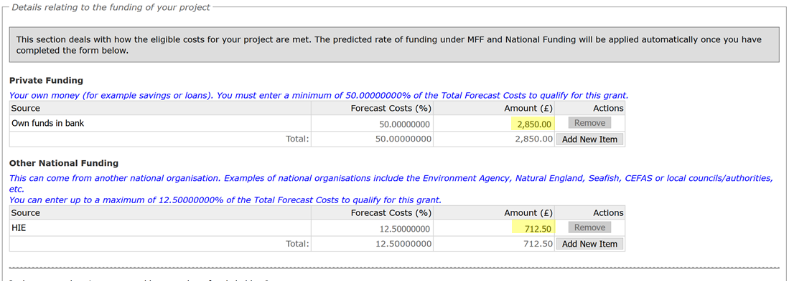

There are some additional questions on this screen which can affect the rate of funding which can be provided. These must be answered and are shown below.

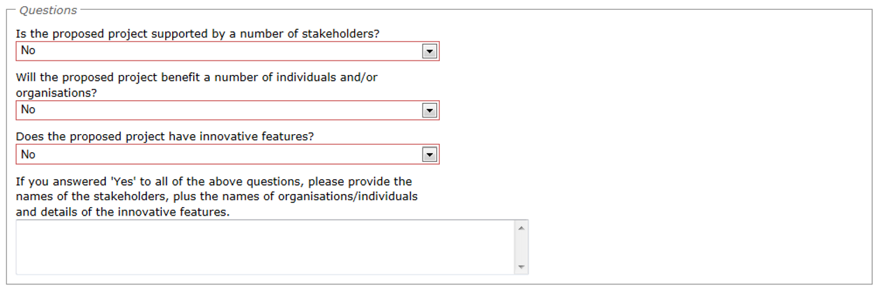

The minimum and maximum funding rates are shown for information if these apply to the type of project you are undertaking as this may influence how you finance your project.

The funding rates will vary dependant on the type of applicant you are and the project you are undertaking. Therefore the funding rates shown below are for demonstration purposes only. When completing an application the correct grant rate will be shown for that specific project.

The funding summary is a useful tool, you will need to provide the private and/or other national funding information, and this table tells you the % of your total project costs that is required. You can also hit the Check for Errors button at the bottom of the screen and the error message will tell you in £ how much you need to provide.

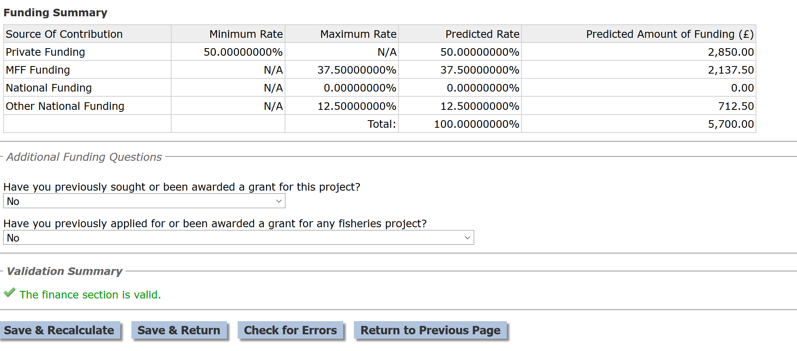
In the example above, a Check for Errors procedure delivered a valid response in the Validation Summary. An example of having made an incorrect assumption when entering amounts can be seen below, with the red text advice as to how you might correct the error.

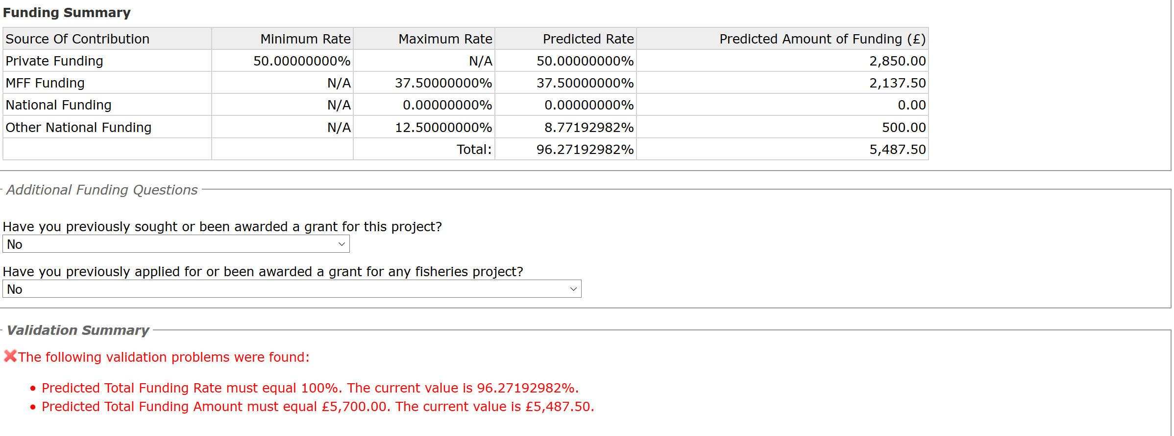
When you are content that all your entries are correct and valid, you can go back to the main Application Details section by pressing Save and Return, or Return to Previous Page as long as you have already saved all the entries.

4.2.7 Claim and reporting schedules

The Claim and Reporting Schedule page is to be used to tell us when you will be making your claims should your application be successful. This is to enable us to forecast the number of claims due in a period so we can plan our resources accordingly to process payments, however we would recommend you put down the most achievable date possible and encourage you to submit your claims at the earliest opportunity.

In the example below, there is only one anticipated claim period.

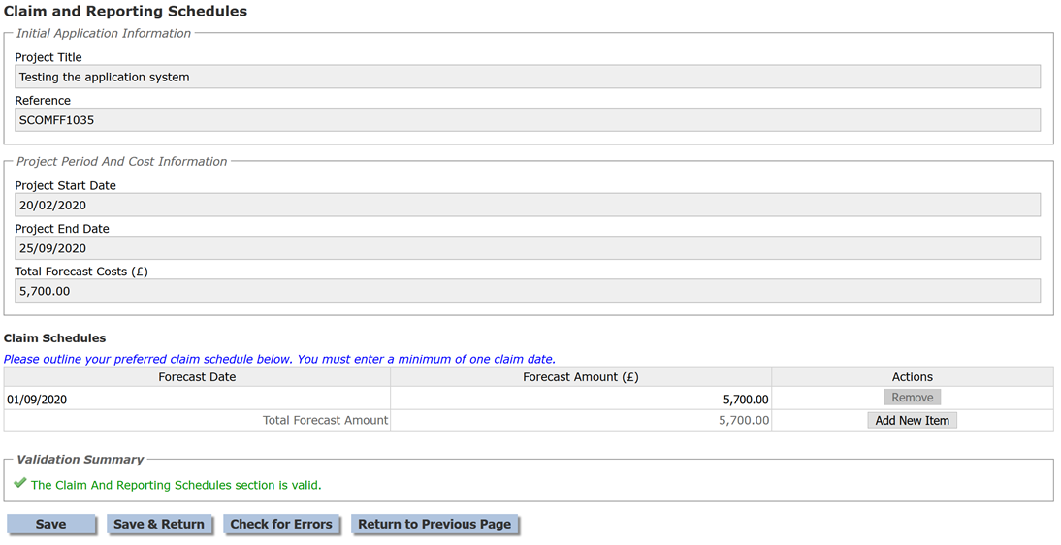

For ease of use your projects start and end dates are shown as well as the project costs which you will have input on the finance screen. You need to provide the dates you will make any claims, although if you are ready to claim earlier than you forecast please put your claim in at your earliest opportunity.

The forecast amount is the total amount that you expect to pay, you don’t need to work out the MFS funding element as the system will do that for you when you claim. Just provide the total cost which should match the costs you provided on the finance screen.

If you plan to make more than one claim, the Add New Item button can be used to add an additional row. Marine Scotland will either agree your claim schedule or propose a revised schedule in your offer of funding letter if your application is successful. The system will send you a reminder a couple of weeks before your claim is due and also if your claim becomes overdue. Further information on making claims can be found in Section 6 of this guide.

Once again, it is useful to Check for Errors before Saving and Returning.

4.2.8 Application compliance and declaration

The Application Compliance and Declaration screen is the final screen to be completed before the application can be submitted.

The Application Compliance and Declaration screen is the screen where you can upload any electronic copies of documents, such as your business case. To upload a document you need to select Browse, this will allow you to browse your folders, once you have selected a document you must select the Upload button otherwise your documents will not be uploaded into the systems document folders.

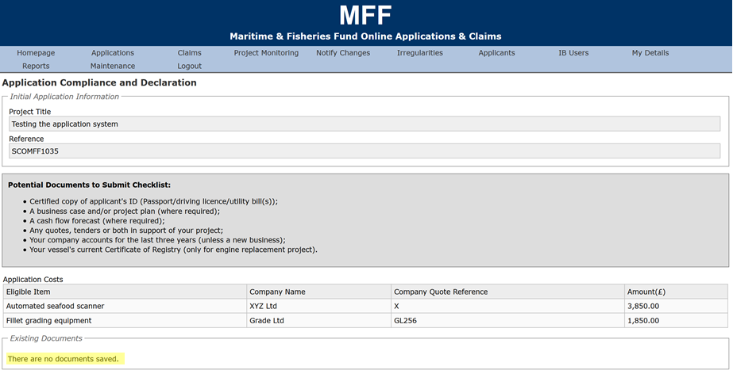

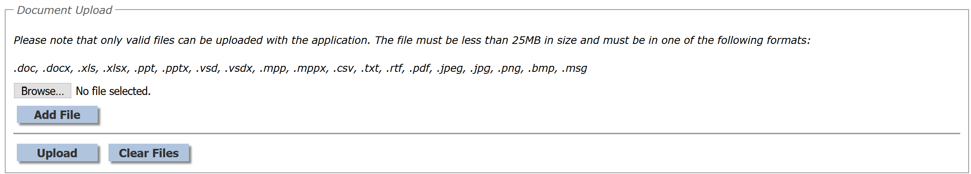

The next area contains a link to the terms and conditions, instead of this document see the revised Compliance & Declaration document on the our website. Please read and sign the Compliance & Declaration from the website & upload it to your application.

Please do not hesitate to contact us if you have any questions or don’t understand any of these and we will be happy to discuss. Contact details can be found in Section 13 of this guide.

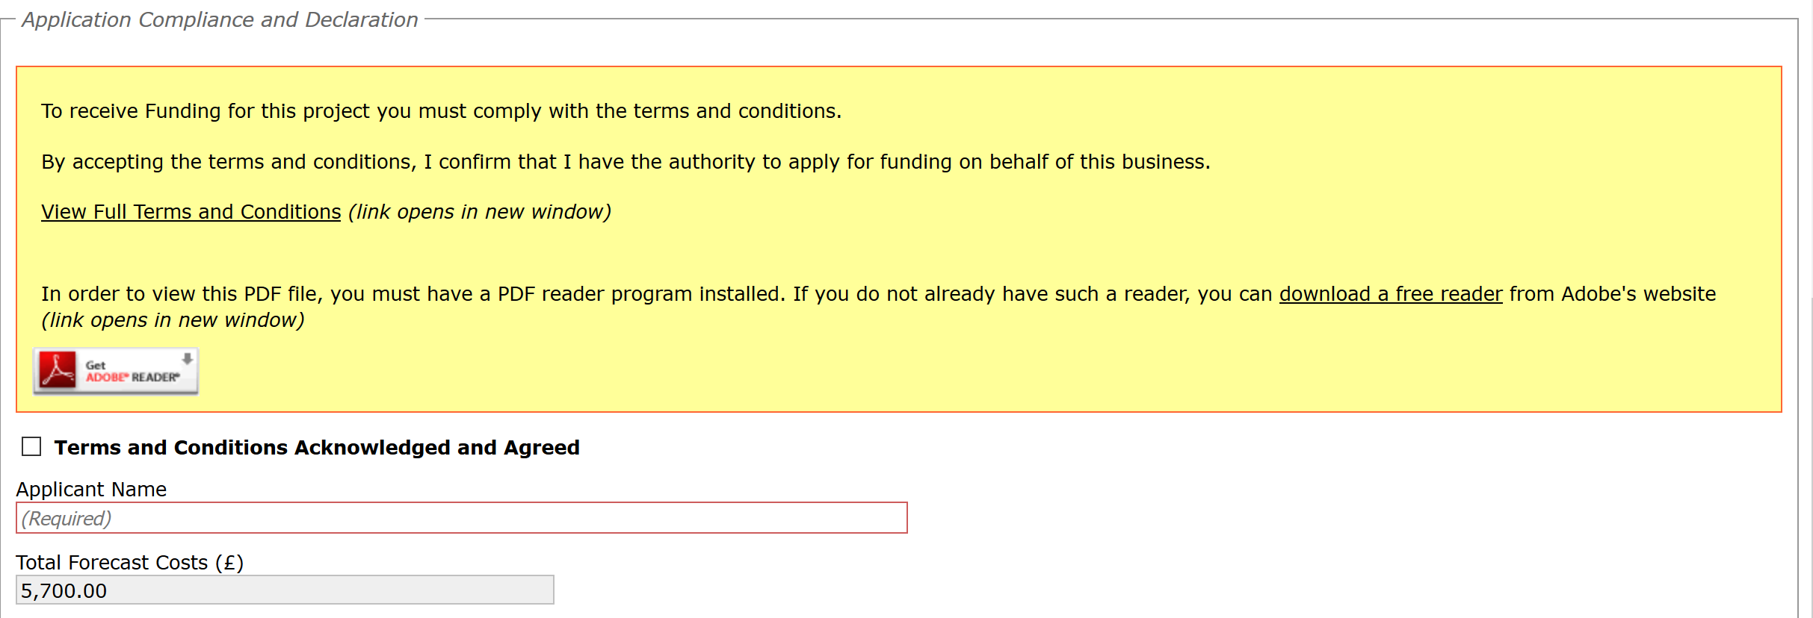

You are required to enter your name and acknowledge and agree to these terms and conditions.

The final section on this page can be used to enter the contact details for any 3rd party, such as an Agent, that is handling this project on your behalf.

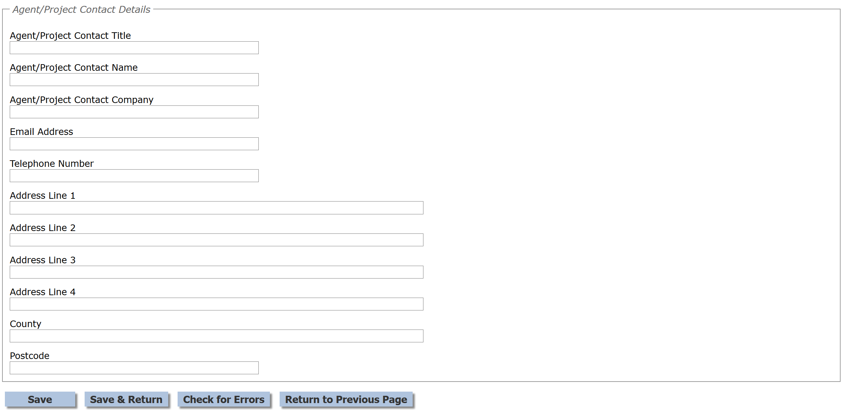

4.2.9 Submit application

Once all sections of the application have been completed and successfully validated, the Submit button will become available on the Application Detail screen. Once you select Submit your application is locked down and you are unable to make changes, therefore please be sure you are happy with all of the information you have provided.

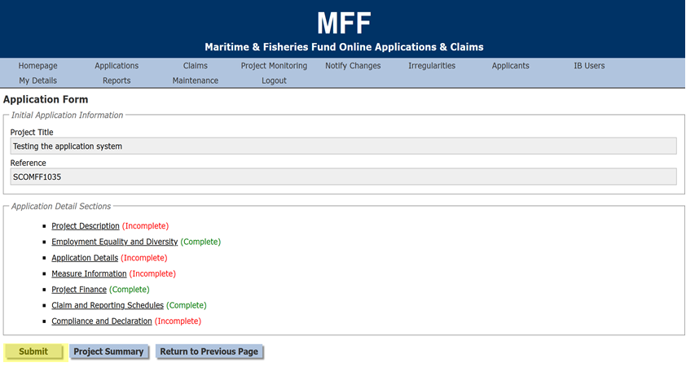

4.2.10 Return your application

After selecting the submit button you will be asked to print your application. Although the application has been submitted electronically we require you to sign the application form & email us a copy (using this electronic copy we will receipt the application), as well as posting us a hard copy with an ink signature, before we can process it.
Selecting the print button will initiate a download of a pdf document that can be opened or saved to your computer. This file should be printed and checked to make sure there are no errors. If any errors are identified then please contact us using the details in details in Section 13 of this guide.

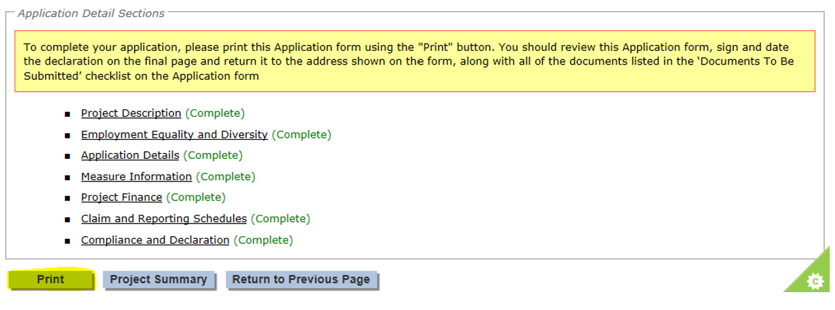

Once you are happy with your printed application, complete the Compliance and Declaration found on the website by:
- Indicating whether the applicant or the applicant’s agent completed the application
- Obtaining a signature and date of signature from the applicant
- Obtaining a signature and date of signature from the agent, where applicable.

If you have indicated that you are not VAT registered then you must also completed the VAT Declaration section on Page 8.

Once we receive your signed application (via email) we will record this in the system, you will be sent an application acknowledgement, this acknowledgement is important as your projects can commence after receiving this but you are proceeding entirely at your own risk as your project may not be approved.

Once your application has been assessed you will receive confirmation of acceptance or rejection via e-mail, further details on the decision can be found by logging into your application on the e-system.

4.2.11 My applications

Once you have submitted your application you can search for your application to see if there have been any progress updates. To do this you will need to log into the MFF e-system and select the My Applications button on your home page.

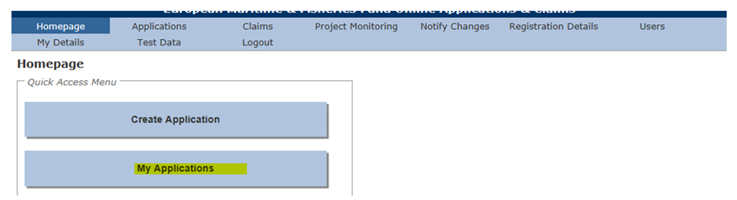

This takes you to the application search; the search screen uses a standard search form throughout the e-system application.

You are able to view all applications that you have created by leaving all of the search criteria blank (or as the default setting for drop down boxes) and selecting the Search button.

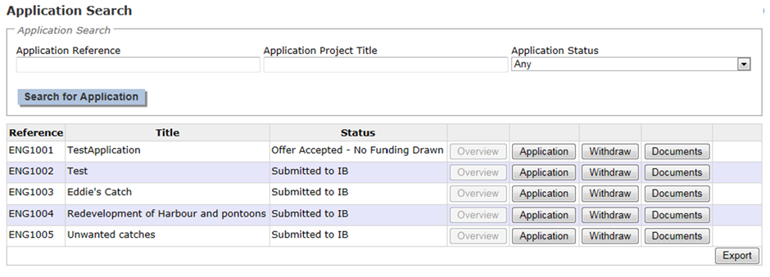
If you wish to narrow your search you can insert the application reference, title or filter on the status of the application.

The ‘%’ symbol can be used before or after your search criteria as a wildcard. For example entering ‘3’ as search criteria under the Application Reference will only return an application where the Application Reference is ‘3’. Entering ‘%3’ will return all Applications where the Application Reference ends with ‘3’ and entering ‘3%’ will return all applications where the Application Reference starts with ‘3’. Entering ‘%3%’ will return any application where the reference contains ‘3’.

4.3 Delete an application

During the completion of the application you have the facility to delete it if you do not wish to proceed.

The facility to delete an application is held within the My Applications screen. After you log in and select the My Applications button your applications will be listed on this page. A Delete button will be available as shown below.

This facility is removed and replaced by the ability to withdraw once the application has been submitted.

4.4 Withdraw an application

Once an application has been submitted it will be processed by the Fisheries Grants Team. If you decide not to proceed with the application at any time you are able to withdraw it.

To withdraw an application from your home page click on My Applications. This will take you to the application search screen. You must first search for the application you wish to withdraw by entering any appropriate search criteria. Once the application is present within the search results, the Withdraw button will be available.

Please note that withdrawing an application is permanent and cannot be reversed once the withdrawal has taken place. You will receive an e-mail to confirm the application has been withdrawn. If you have already been paid some MFS funds for your project, you may be required to repay those funds to the Scottish Ministers.

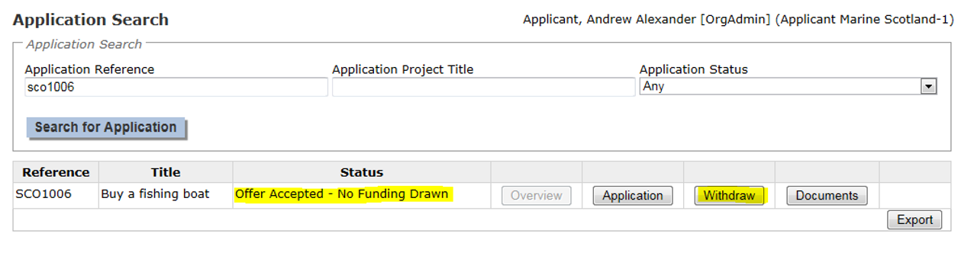
4.5 Checking progress of a submitted application

You can check on the progress of your applications by selecting My Applications from the homepage. This will take you to the application search screen where you can either view all of your applications or search for specific applications. The ‘application status’ column (as shown below) will inform you what stage of the process your application is at.

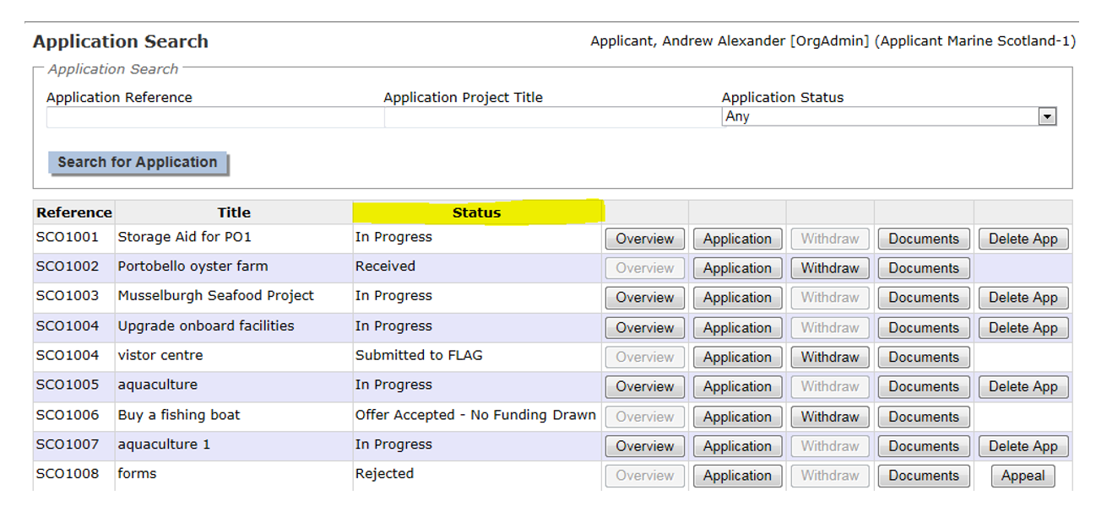

Explanation of the statuses shown
Application Status | What this means
Submitted to IB | Your application has been sent electronically however the application is not considered a live application until the signed emailed copy is received by the Intermediate Body (Fisheries Grants Team in Scotland).
Received | The signed hard copy application has been received in the Intermediate Body and the application is now ready to be assessed for completeness. At this stage the Fisheries Grants Team may contact you for further information.
Returned to IB | The application required further information and a member of the Fisheries Grants Team will request the information required from you.
T and E reviewed | This means the technical and eligibility checks have been conducted to ensure your application contains all of the required information and is eligible for MFS support.
T and E checked | A further check of the technical and eligibility has been conducted to confirm the application can proceed.
Specialist reports received | This shows the specialist information has been received and is being checked by the intermediate body. Some examples of specialists who provide information are: Marine Scotland Science or policy teams, Licensing teams or Compliance staff.
Application checked | Your application and any specialist reports have been checked and your application is now ready for a decision on MFS funding to be made.
Approved | Your application has been approved and is ready for an offer of grant funding to be issued.
Rejected | Your application was unsuccessful; you will be notified of the reasons why.
Offer issued | A Grant Offer letter has been issued to you, this is by post as you must sign and return the letter.
Offer accepted/ declined/ amendment requested | Your signed Grant Offer letter has been received by the Fisheries grants Team and we have noted your decision as to whether you accepted, declined or requested an amendment to your offer.
Offer accepted no funding drawn | This means you have not yet made any claims following acceptance of your offer. Once you make your first claim this will change to ‘Offer accepted – funding drawn’

4.6 Successful application

If your application is successful you will receive a Grant Offer Letter from the Scottish Ministers. Please note this may not be for the full amount of MFS funding support you requested.

If you choose to accept the offer, you must notify the Scottish Ministers of your decision by signing and dating the Grant Acceptance contained within your Grant Offer Letter and returning one copy of the Grant Offer Letter and Schedules, per the instructions in the Grant Offer Letter. You should retain a copy of the Grant Offer Letter and Schedules for your own records.

If you choose to reject the offer, you must notify the Scottish Ministers by e-mailing MFS@gov.scot to confirm that you are declining the grant offer.

If you reject the offer of grant funding, you cannot re-apply on the basis of the same application details and supporting documents, however, you may re-apply with an amended application. Your new application will be considered without prejudice unless fraud has been committed.

Any decision taken by the Scottish Ministers in connection with MFS funding can be appealed by the applicant or Grantee to whose application or grant funding the decision relates. See section [4.7] below for details about the appeals process.

4.7 Appeals process

If you wish to appeal a decision taken by the Scottish Ministers (which, for this purpose, includes Marine Scotland and any of Marine Scotland’s officials, agents or representatives) in connection with the MFS and which directly relates to you or your organisation, for example, a decision in respect to your application for MFS funding, any Grant Offer you or your organisation receives from the Scottish Ministers or any Grant Claim you or your organisation submit, then you should follow the appeals process below. We will also accept appeals made via email, the same criteria applies as described below for appeals via the MFF system.

You have 28 calendar days from the date of the letter or e-mail notifying you or your organisation of the decision in question to ask the Fisheries Grants Team to review the decision. If you want to appeal you will need to select the My Applications option on your homepage and search for the application you wish to appeal. There will be an option to appeal as shown below.

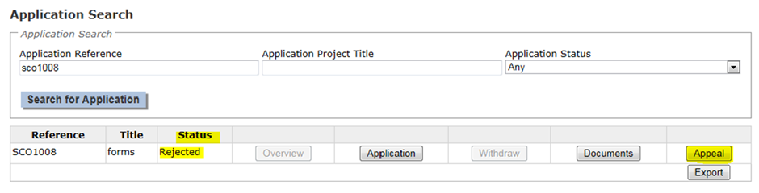

Select this appeal button and provide the reasons for your appeal. An appeal can only be made on the basis of the information and supporting documents which were submitted to the Scottish Ministers in connection with and prior to the decision which is being appealed, for example, the information and supporting documents comprising your application or a specific Grant Claim. You cannot add new information at this stage which the Scottish Ministers were previously unable to consider at the time of making the decision which is being appealed.

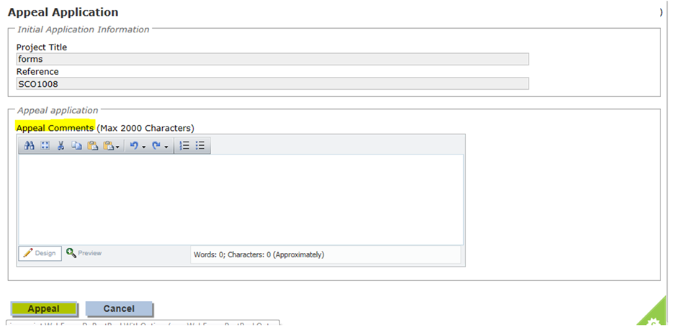

An Independent Appeal Officer will review the decision-making process and the appeal will either pass (which means the original decision is overturned) or the appeal will fail and the original decision will be upheld. We will notify you of the outcome of your appeal within 6 weeks of receiving it and of what the next steps are, if your appeal is successful.

If your appeal is unsuccessful, the appeal decision is final and no further correspondence will be entered into in respect of the appeal or the decision in question.

If a decision to reject your application is upheld, you cannot re-apply on the basis of the same application details and supporting documents, however, you may re-apply with an amended application. Your new application will be considered without prejudice unless fraud has been committed.
5 Making a claim
To make a claim you will need to click on My Claims from your home page. This will take you to the claim search screen where you can search for the application on which you wish to submit a claim. The system will have created a claim schedule using the information you provided in the application form.
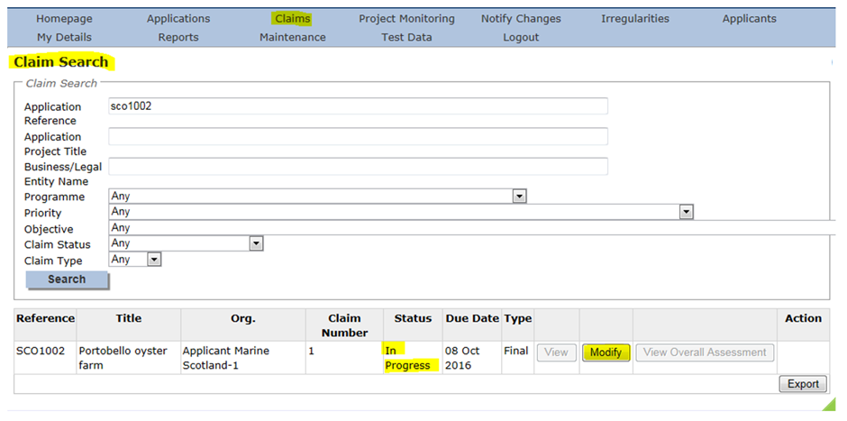
Select the modify button as shown above and you will be presented with the claim detail screen, if you do not wish to proceed you can select the cancel button at the bottom of the screen.

5.1 Claim details

There are two sections to complete in the claim detail screen, these are claim finance and claim declaration. The summary will advise you which sections are incomplete, you must complete these screens in order to submit your claim.

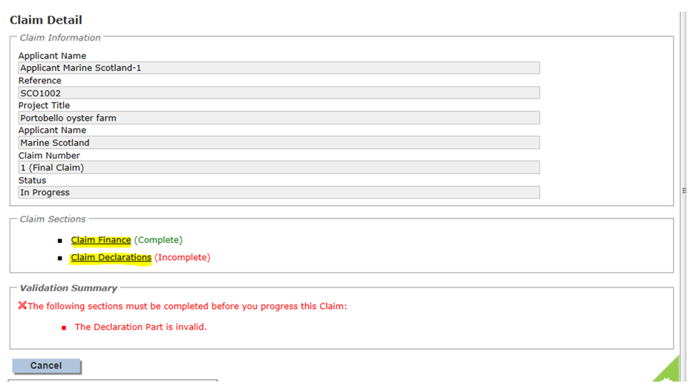

5.2 Claim finance

To complete the claim finance section click on the first bullet in the claim sections table as shown above. You will need to complete the following fields on the screen finance screen:
- Invoice number
- Invoice date
- Expenditure this claim (excl VAT), this is the total amount you have paid on the invoice not the amount of MFS funds you are claiming.

The system will display the approved forecast amount for this claim, if this claim does not match then a warning message will be displayed advising action to take. There is also a field for any comments you may wish to provide when submitting the claim. In order to complete the screen you must select the “check for errors” button prior to saving and returning to the claim detail screen where the section will be shown as complete.

5.3 Claim declaration

From the claim details screen shown above, select the claim declaration section.

Existing documents will be displayed here but you will also have the option to upload additional documents such as invoices. You must read the declaration terms and conditions which are shown in a yellow box. The tick below must be selected to show you have understood and accepted the disclaimer statement. Additional information can be provided in the comments box up to a maximum of 2000 characters. A word count is shown for your convenience as the screen will contain an error if the 2000 characters are exceeded. Select the ‘check for errors’ button to complete the screen and then you can return to the claim detail screen. You can also cancel out of this stage at any time by selecting the cancel button.

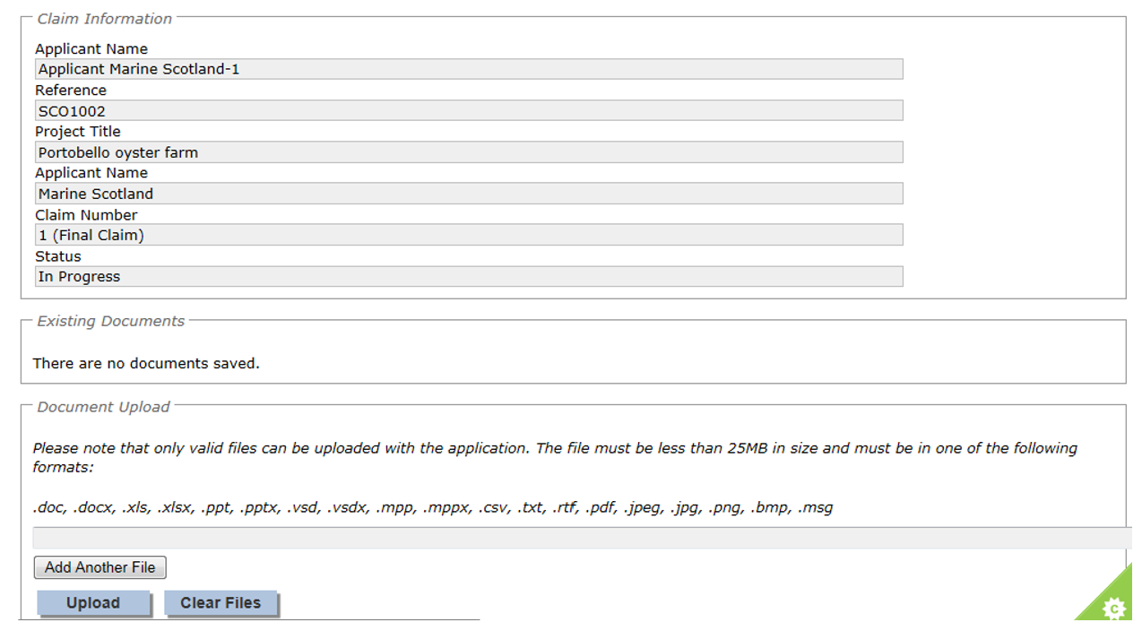

5.4 Claim submission

Once the claim finance and declaration screens are complete you can choose to submit or if you want to leave the information saved and go back to this later you can select the cancel option to return to the claim search screen. Please note once you select submit your claim will be locked down and any changes will have to be made by contacting the Fisheries Grants Team, therefore make sure you thoroughly check your claim before you decide to submit.

If you select submit the system will confirm that your claim has been submitted and will ask you to print and sign the claim forms.

Although your claim has been submitted electronically we require you to sign the claim form & email us a copy (using this electronic copy we will receipt the claim), as well as posting us a hard copy with an ink signature.

Selecting the print button will initiate a download of a pdf document that can be opened or saved to your computer. This file should be printed and checked to make sure there are no errors. If any errors are identified or you have problems printing then please contact us using the details in section 13 of this guide.

Once you are happy with your claim, complete the compliance and declaration details and email to the Fisheries Grants Team.

Once your claim has been assessed you will receive confirmation of approval via e-mail, further details on the decision can be found by logging into your application.

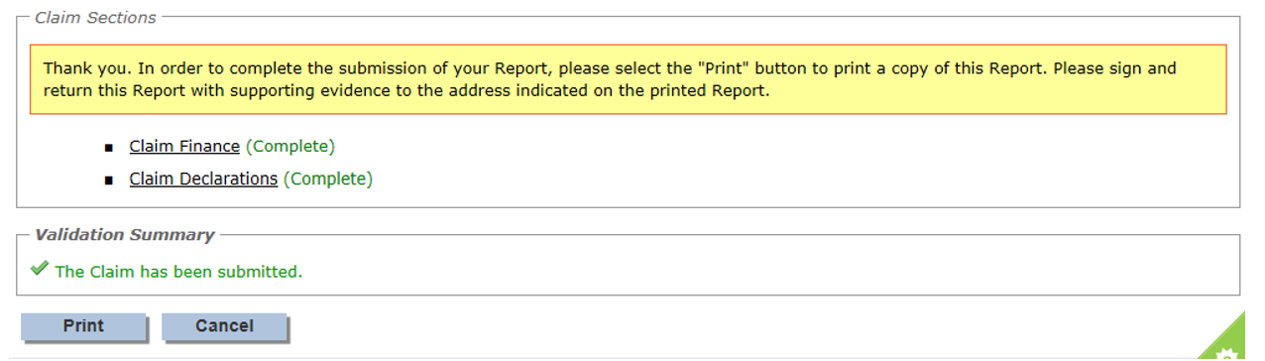

5.5 View claim

You can view progress of your claim at any time by logging into the system and selecting the claims tab on the console function, you can either search by claim number, or search all claims. The following status updates may be shown against your claim and a snapshot of the status updates is shown below.

Claim status | What this means
Not Started | Your claim form is ready and waiting for you to complete
In progress | This is when you have partially completed the form but not submit it to the Intermediate Body.
Submitted to IB | You have completed the form and submitted it on- line, you also need to and posted email a the signed copy to us, however it has not yet been received.
Received | We have received the claim form you emailed to us and it is ready to be assessed.
Assessed | We have assessed your claim to ensure the correct information has been provided
Specialist  Reports  Received | If we require further information from a specialist in relation to your claim we will note when we receive the information.
Checked | We have checked your claim and it is ready for an approval decision
Approved | We have approved your claim and it is ready for payment
Not approved | We have been unable to approve your claim and will contact you regarding this.
Payment processed | We have processed your approved claim for payment you will either receive your money very soon if you haven’t already.

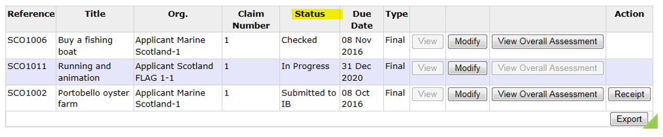

6 Progress report submission
If your application is successful we will tell you in your offer letter when we need you to send us a progress report. The system will have created a reporting schedule using the information you provided in the application form and will send you a reminder a couple of weeks before your progress report is due.

Progress reports are required with each claim, as set out in your award letter. Please find a template on the website and complete & upload this with each claim to evidence progress of the project.

If additional information is required following submission of your progress report you will be notified via email. You can re-submit once you have addressed any comments in the email.

7 Notification of change
Follow acceptance of your offer you will need to notify us of any changes (Your award letter will detail this further). By selecting the option Notify Changes from the home page you can
- Create a new notification of change
- Search for an existing notification of change using the application reference number
- Search all notifications of change to view the status.
We will also accept notifications of change via email, the same criteria applies as described below for notifications of change via the MFF system.

7.1 Create a notification of change

First select the Create option as shown below, if you have already created some changes these will be shown at the bottom of this screen.

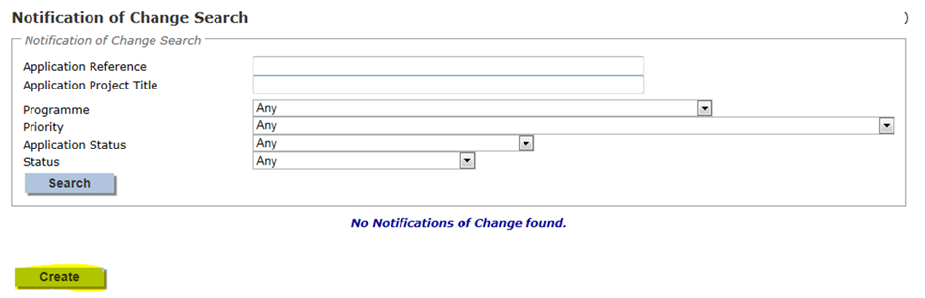

This will take you to the notification of change screen. You will be provided with a drop down list of all of your applications and you need to select which application the change refers to.

You must then enter a title for your change in “description of notification of change” and select which sections of your application need to be changed. There are then three tables to complete as follows:
- Details of changes requested
- Justification for change
- Impact of changes on project

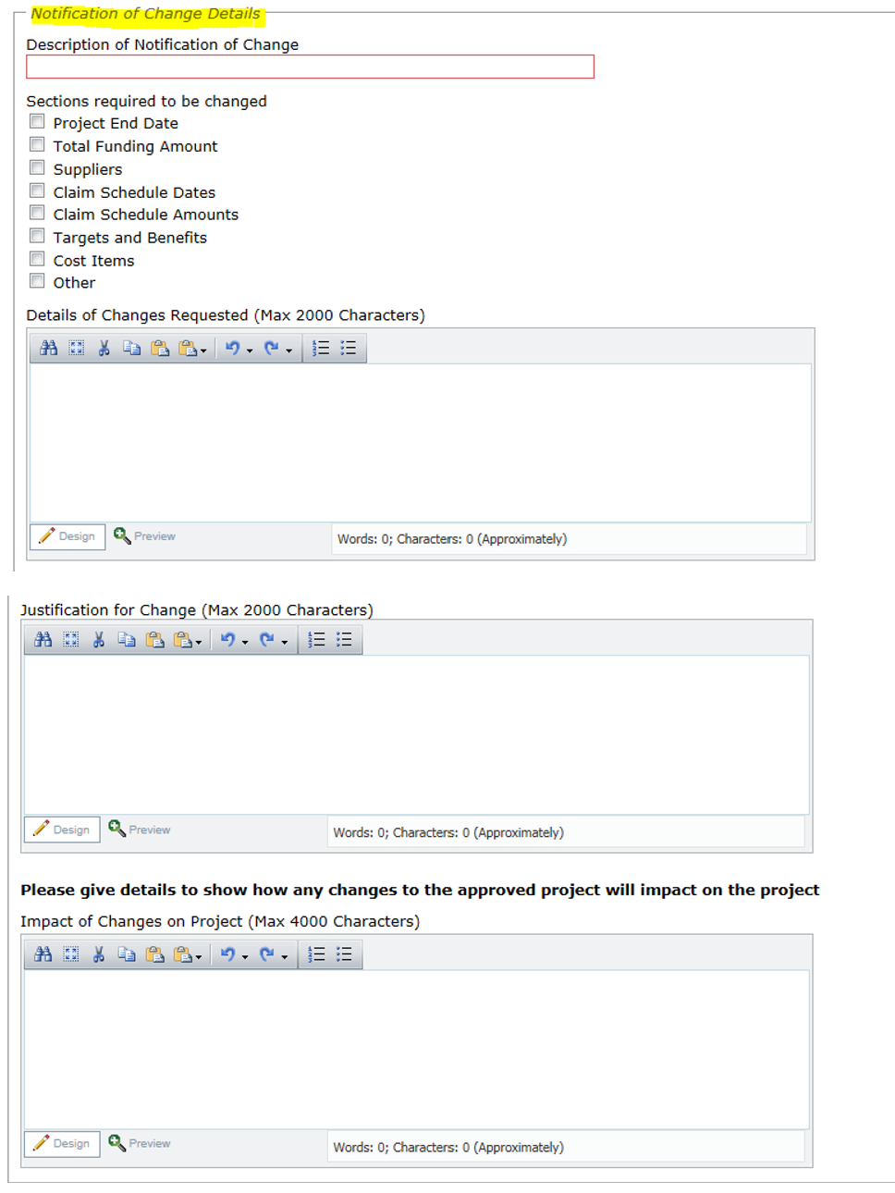
Once you have completed details of the change you must tick the declaration before choosing to save or submit the notification. As with other screens there is also the option to cancel out of the notification at any time.
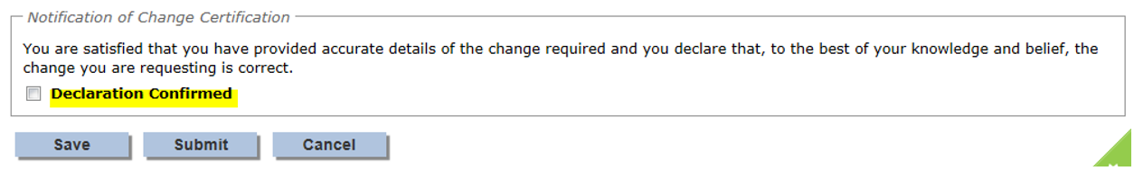
You will receive an e-mail confirming that the change has been received.

7.2 View or modify a notification of change

Following submission of a request for change you can view the status of this at any time by accessing the notification of change screen from your console and performing a search. The following are status fields which may apply to your change.

Status | What this means
In progress | You have created a change and this is your work in progress
Returned to applicant | We have come back to you or your agent for more information.
Deleted | You have chosen to delete the change
Submitted | You have notified the Fisheries Grant Team of the change and it is ready to be assessed
Assessed | The Fisheries Grant Team have assessed the change and it is ready to be checked
Checked | The Fisheries Grant Team have checked the change and it is ready for a decision.
Rejected | The change has been rejected, we will discuss if you can still meet the original intended benefits for the project. We will try and work with you to come to a resolution for your project.
Approved | Your change has been approved and the Fisheries Grant Team will make the changes to your application form.
Completed –  offer  unchanged | The Fisheries Grant Team have made the change to the application and your offer of funding remains unchanged. No further action is required.
Amended  offer issued | The Fisheries Grant Team have made the change to the application and a revised funding offer letter has been issued by post.
Amended  offer declined | You have returned your offer letter declining the amended offer. Please note any MFS funds paid to date will need to be returned to the Fisheries Grant Team.
Completed – Amended  offer accepted. | You have signed and returned your offer letter accepting the revised offer.

Deleting or modifying a change can be done from the NOC search screen, modifying the change allows you to update saved information, you can also delete the change prior to submitting to the Fisheries Grant Team. Please ensure you are happy with the information provided as this cannot be amended once you have submitted details of your change to the Fisheries Grants Team.

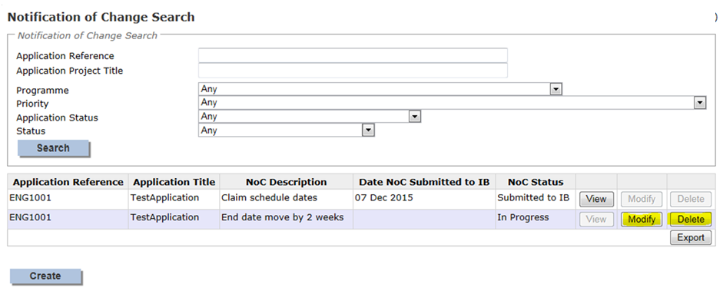

8 Update registration details
The Applicant details you provided when you registered can be updated at any time by either the applicant or someone set up in an applicant’s organisation. To do this select the ‘My details’ button from your home page.

This will take you to the Update Applicants Details screen where changes can be made and saved. Please note that selecting the cancel button will exit the screen without saving.
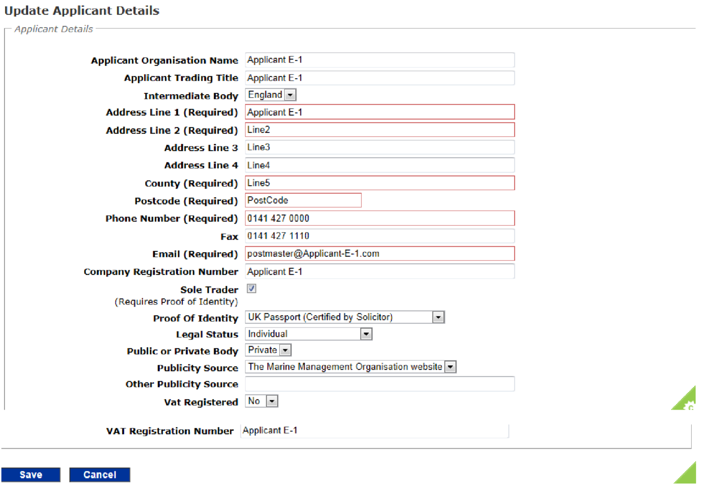
9 Users
The Users area is available to allow you to create additional user accounts for anyone that you wish to be able to complete applications on behalf of you or your organisation. You are also able to update the details of any existing users. Please note as an applicant you will still be required to sign all of the applications and claims created by the people you have set up as ‘users’ for your account.
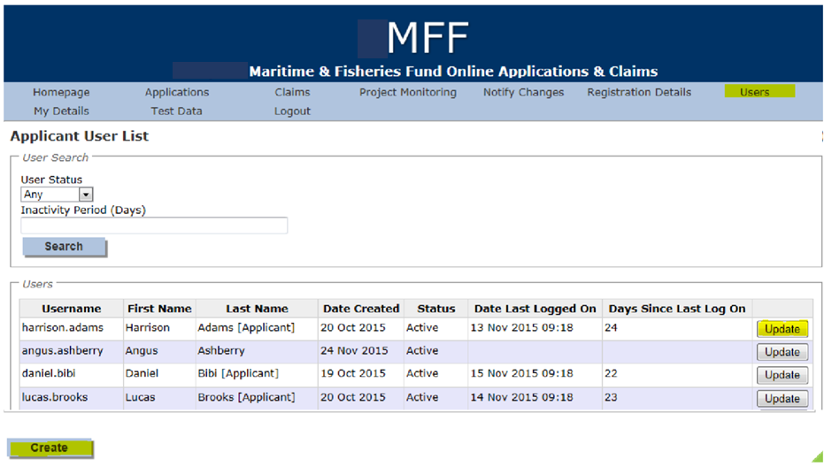
To create a new user account for your organisation select create and complete the user’s details.

You could also select update for an existing user which will enable you to make changes including changing their status to inactive to prevent them accessing the system. If you selected update for an existing user you are presented with the create user screen below, however this will be pre-populated and will allow you to edit the details. You must disable the account of anyone leaving your organisation.
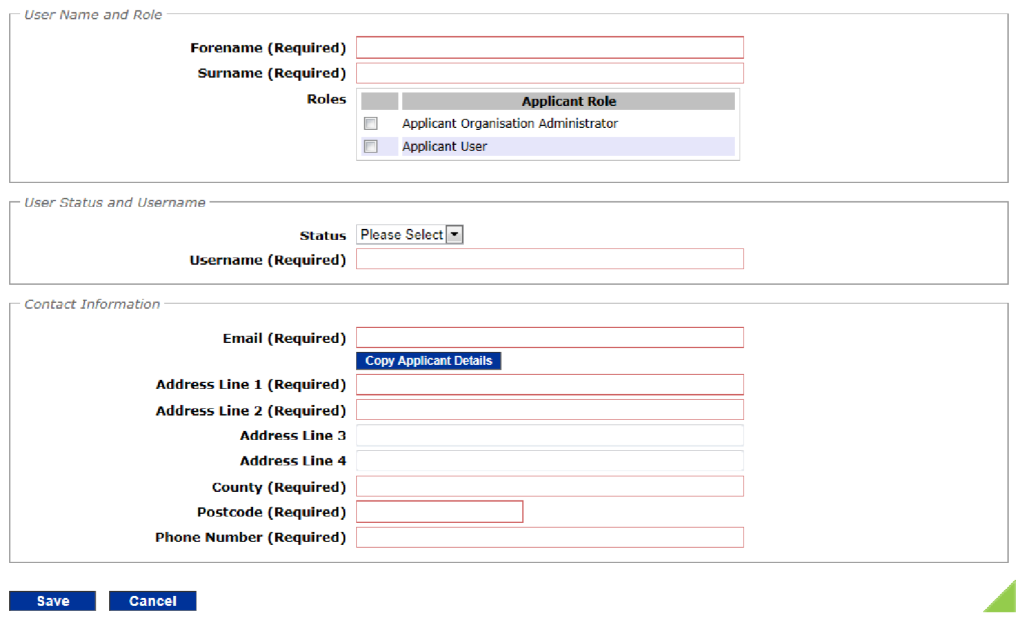
You need to insert the name of the person you are setting up in the system, if you select the first option ‘administrator’ this person will be able to create other users for you. However if you don’t need any other users, select the second option ‘Applicant user’.

Next you need to set their status as active and create a username for them. The system will e-mail them their username and a temporary password will be sent in a separate e-mail for them to access the system.

Once you are happy with the details you have entered select save, you can always cancel out of the screen and no changes will be saved.

10 Updating your details
To update your details select the My Details button on the homepage. This will allow you to change your password and contact information.

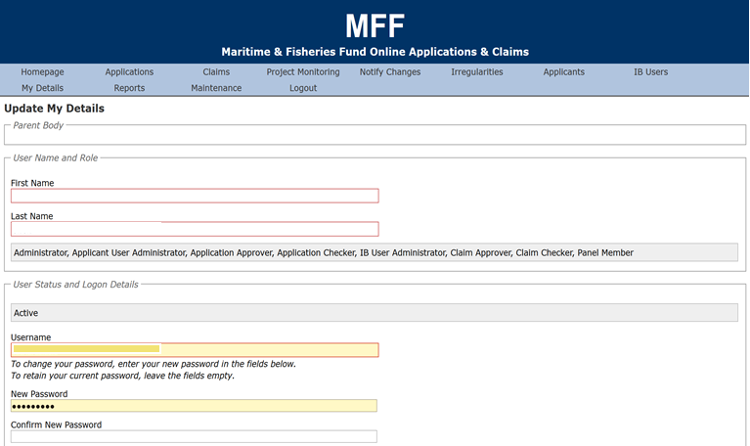

11 Post project monitoring
Following completion of your Project you may be asked to provide additional information as part of our post project monitoring process. We will e-mail details to you if this is required.

12 Contact us
Postal address -
Marine Scotland Grants Team
Spur X1 Rm 11 Saughton House
Broomhouse drive
Edinburgh
EH11 3XD

Email: mfs@gov.scot

Web: http://www.gov.scot/Topics/marine/grants-subsidies for more information and guidance.
To make an application visit https://mffs.marinemanagement.org.uk

