FARMING OPPORTUNITIES for NEW ENTRANTS (FONE) 2022

1. Introduction (everything you need to know about FONE)
2. The Big Picture
3. Land Opportunities/Achievements
4. FONE Priorities for 2022
5. Useful Links inc. Case Studies and Information for Letting Organisations
6. FAQs

EVERYTHING YOU NEED TO KNOW ABOUT FONE

1. Background

What is FONE?

FONE is an acronym for the Scottish Government’s Farming Opportunities for New Entrants programme.

Its origins?

New entrants to farming were first offered the chance to lease part-time starter units on Scotland’s Forestry and Land as part of a pilot initiative in January 2012. Following this, a programme was rolled out and in total nine tenancies were created across the Estate.

Following the success of this programme, an independent group was established by the Scottish Government to identify proposals to maximise starter opportunities on all publicly owned land. The group presented its findings in November 2016 and the report provided a clear picture of the barriers facing New Entrants to agriculture, including access to land.

The working group’s report – New Farming Starter Opportunities on Publicly Owned Land is here:
https://www.gov.scot/publications/report-new-farming-starter-opportunities-publicly-owned-land/

The report shows the steps all public bodies who possess land can take to open up farming to a new generation. Importantly, it also highlights the value of a co-ordinated approach. As a result, the Scottish Government put in place FONE.

Who is FONE?

The FONE group contribute a wealth of knowledge, good sense and willingness to progress their work and the Scottish Government is grateful to past, current and future members for their time and commitment.

FONE is led by Henry Graham, National Chair of Lantra Scotland, Chair of the Implementation Group for the Skills Action Plan for Rural Scotland and Scottish Government’s Education and Training Champion:

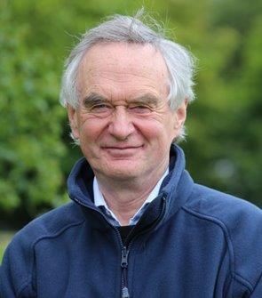

Henry Graham: is ably supported by a diverse and experienced committee including:

Derek Wilson: Head of Unit in Scottish Government’s Agriculture Transformation in Productivity

Stewart Hendry: Agricultural Advisor at Forestry and Land Scotland (FLS)

Harriet Donald: Land use manager Loch Lomond & Trossachs National Park ; FCS starter farmer Port of Menteith

Laura Henderson: SAC consultant and Farm Advisory Service (FAS) new entrants theme leader

Penny Montgomerie: Chief Executive - Scottish Association of Young Farmers Clubs

Stephen Young: Head of Policy at Scottish Land and Estates

James Mackessack-Leitch: Policy Officer at Scottish Land Commission

Lisa Hislop: National Farmers Union Scotland (NFUS) Next Generation representative

2. THE BIG PICTURE

So why do New Entrants matter?

New Entrants are of huge value for the simple, but vital reason that they are the future of Scotland’s agriculture industry. They drive innovation and best practice, improve efficiencies and contribute towards the economic vitality of the sector. But it is estimated that the average age of a Scottish farmer has risen to 58 and this trend shows no sign of reversing. It is crucial, therefore, to encourage a steady inflow of young and new entrants into the sector.

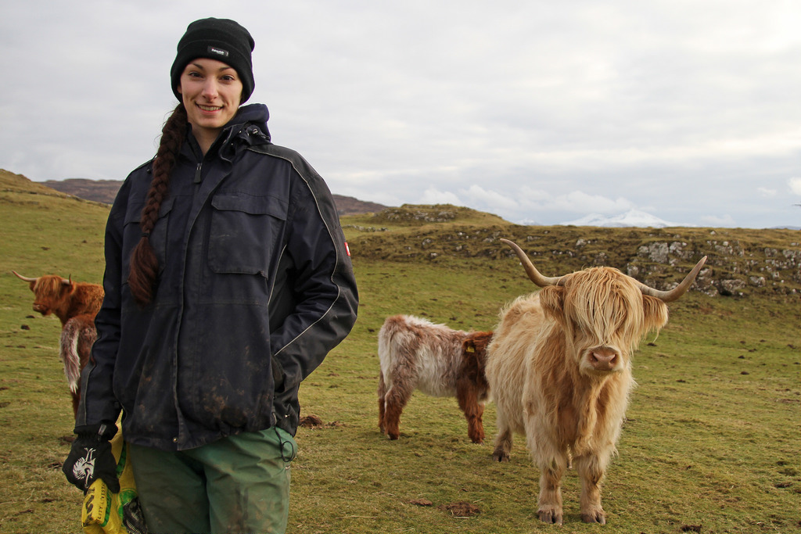

But why can we not rely on market forces?

Both land for purchase and rent are relatively scarce in Scotland and demand continues to outstrip supply. This demand means that land values and rents remain out of line with potential agricultural returns, with outside money and established farming businesses being able to outbid New Entrants for any available opportunities.

So surely the land needs to be of a certain quality, type, size, have a house, buildings etc.?

No and it is important to absolutely dispel any pre-conceptions about the need for specific land and infrastructure.

Under FONE, the basic remit is to provide a business opportunity to a New Entrant that will, typically, generate a part-time income and allow for second incomes. It is, therefore, vital that, in examining their estates, organisations should not assume that size, location and land quality are barriers. Indeed, smaller areas could be more influential in providing the initial opportunities needed. Horticulture projects are particularly relevant in that they efficiently use smaller areas of land, they produce locally grown, healthy food and they can be very therapeutic.

But are public bodies not expected to take into account obligations around the leasing or disposing of land and property assets contained in the Scottish Public Finance Manual?

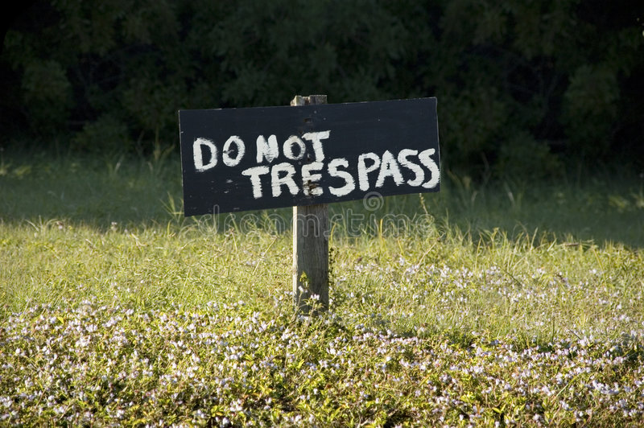

It is true that the Scottish Public Finance Manual places a duty of Best Value in Public Services delivery. But “Best Value” is concerned with balancing costs and quality whilst having regard to the economy, effectiveness, equal opportunities and the achievement of sustainable development. FONE considers that New Entrant opportunities can be tendered in a way that seeks to achieve the principles of Best Value.

Is FONE only interested in land owned by public bodies?

NO! While FONE started off with public land as its focus, it is interested in all opportunities, whether public or not.

3. LAND OPPORTUNITIES 2022 / ACHIEVEMENTS

Insofar possible, all land opportunities identified and advertised for 2022 will also be displayed on the FONE website: https://www.gov.scot/policies/agriculture-careers/new-entrants-to-farming/ including FLS now has a number of opportunities advertised for 2022 on the website here: Agriculture opportunities - Forestry and Land Scotland

The Story So Far

Since 2016, FONE has helped provide 112 land opportunities across 7070 hectares allowing 76 new entrants gain a foothold on the agricultural ladder. More detail is offered in the table below and in attached worksheet – a full list of achievements to date:

Year | Number of Units | Number of New Entrants | Area (ha)
2016 | 8 | 7 | 242
2017 | 20 | 15 | 757
2018 | 42 | 28 | 3359
2019 | 22 | 11 | 2203
2020 | 14 | 9 | 300
2021 | 6 | 6 | 210
Totals | 112 | 76 | 7070

4. FONE PRIORITIES FOR 2022

As key priorities for 2022, the FONE group will:

- Make available 400 hectares of publicly owned land to New Entrants.

- Take forward governance of Scotland’s Land Matching Service.

- Extend the scope of the Land Matching Service to cover Crofting and work closely with the Crofting Commission to look at alternative options to Crofting sub-lets, working with stakeholders to develop a consistent narrative of what is possible in terms of making best use of Crofts and attracting New Entrants.

- Advocate the support of New Entrants in future policy, ensuring that future support recognises the needs of New and Young Entrants and represents their interests in future policy.

- Continue beyond the public sector, highlighting opportunities to private estates and owner occupiers.

- Facilitate the promotion of case studies and other promotional material to include further development of general guidance and signposting for New Entrants.

- Facilitate three Starter Farm to progress beyond their 10-year tenure.

- Cabinet Secretary to continue to promote the benefits of FONE at key events to maintain momentum.

5. FONE THE EASY WAY – USEFUL LINKS

- A short film providing an overview and background of the FONE group and a new entrant relating his experience of a Forestry and Land Scotland (FLS) starter farm opportunity: https://youtu.be/kVLh2QYO6j8

- The November 2016 'New Farming Starter Opportunities on Publicly Owned Land' report, identified that most starter opportunities will be offered through short and longer term leases but also identified examples of successful share and contract farming arrangements. The Farm Advisory Service (FAS) website holds a library of case studies that provide an ideal source of information, including venture agreements: https://www.fas.scot/publication/new-entrant-case-study-stephen-withers-and-neil-sandilands-video/

- In addition, to helping promote the sector as a positive and rewarding carer choice, Lantra Scotland has produced short careers videos for agriculture, aquaculture and game & wildlife management. They can be accessed at: https://www.lantra.co.uk/scotland/careers

- Scottish Association of Young Farmers Clubs have created a series of inspirational videos highlighting the various careers within the agricultural industry. http://www.sayfc.org/news/2018-01-12/sayfc-s-career-videos
https://www.youtube.com/user/SAYFC1

- Scottish Water’s involvement in the Scottish Government-run FONE scheme (January 2019), saw the first new tenant farmer taking up tenancy on land owned by the country’s publicly-owned water utility:
Video: https://twitter.com/scottish_water/status/1087613511235186689

- Forestry Land Scotland (FLS) awarded in November 2020 an arable opportunity to a new entrant at Gourdie, by Dundee. 126.49 acres (51.19ha) on a 5-Year SLDT and at Mains of Lesmoir, site by Rhynie (16.89ha) has also been secured by a new entrant on a 5-Year SLDT (January 2021). FLS now has a number of opportunities advertised for 2022 on the website here: Agriculture opportunities - Forestry and Land Scotland

- Crown Estate Scotland - on 1 December 2020 an exciting opportunity was secured for new entrants to Scottish tenant farming sector. A local couple have been chosen to take over a 366-acre farm, called Uppercleuch Farm, on the Applegirth Estate in Dumfries & Galloway. Stuart and Chloe Graham have taken occupancy through an agreement with Crown Estate Scotland, who manage the Estate, following a rigorous tendering process (and using FONE scoring matrix below) with a large number of high calibre applicants.
Exciting opportunity secured for new entrants to Scottish tenant farming sector | News, media releases & opinion | Media centre | Crown Estate Scotland

- To assist the selection process (including a new FONE scoring matrix) a decision making has been developed, https://www.gov.scot/publications/fone-scoring-matrix/ . Members of FONE have also committed to making themselves available to support the decision making process.

AND…proof it works

East Lothian Council released 8.4 hectares of land for seasonal cropping near Tranent. They received nine offers and when working through the offers used the FONE scoring matrix to assist with the process. Delighted with the response, Janet Placido, Estates Team Manager said, “East Lothian Council are very keen to support young people in agriculture and are actively working to identify further parcels of land from the Council’s existing Estate, which will be suitable for the FONE initiative.”

Crown Estate Scotland, following the retirement of the previous tenant, emphasised their commitment to the FONE concept and the next generation of farmers with the selection of Andrew and Suzanne Jardine to take over a 242 acre farm on a ten-year tenancy on the Applegirth Estate in Dumfries & Galloway. Andrew Jardine said: “Coming from a local farming family, this tenancy is a fantastic opportunity for our family to both find a home and a farm business to manage and grow. The ten-year tenancy will give us the certainty to invest in the land and create a viable future.”

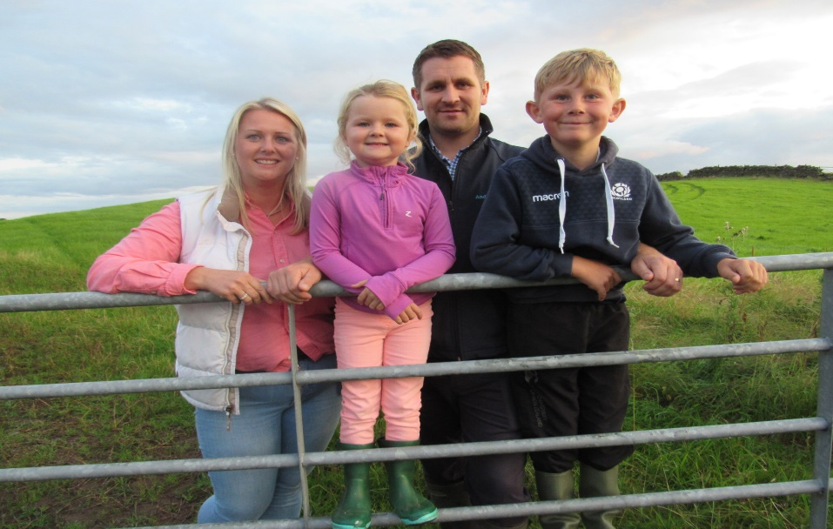

The Jardine Family

6. FAQs

Q. What is FONE?

A. Following the success of an initiative to lease part-time starter farms on Scotland’s Forestry and Land, a group was established by the Scottish Government to identify proposals to maximise starter opportunities on publicly owned land. Their report highlighted the value of a coordinated approach and as a result, FONE was put in place to coordinate a New Entrants opportunities programme.

Q. The need for intervention?

A. There have been a number of studies into the barriers around entering agriculture and access to land figures most prominently. However, both land for purchase and rent are relatively scarce in Scotland and demand outstrips supply. This demand means that land values and rents remain out of line with potential agricultural returns, with outside money and established farming businesses being able to outbid New Entrants for any available opportunities.

Q. How does this differ to that offered by the previous initiative on the Forestry and Land Scotland?

A. Though the initiative on Forestry and Land Scotland was a success, the conclusion was that this programme was more suited to prospective tenants with a degree of existing capital and experience. It was recognised that it was important to identify units that were truly rung 1 on the farming ladder and allowed for second incomes to off-set the significant capital often needed.

Q. What is the definition of a “rung one” New Entrant?

A. There is no exact definition but they are New Entrants unlikely to be able to fund a full time, equipped farming unit and may have only limited farming experience.

Q. But do land opportunities exist?

A. From all the information provided to the FONE group there is potentially a supply of starter opportunities. But in examining their estates landowners should not assume that size, location and land quality are barriers. Indeed, feedback suggests that smaller areas could be more influential in providing the initial opportunities needed.

Q. What type of agreement is most suitable?

A. Different types of agreements, e.g. share farming; contract farming; Short Limited Duration Tenancies; Limited Duration Tenancies; Modern Limited Duration Tenancies will suit different circumstances and flexibility is likely to be key in maximising starter opportunities.

Q. Where it is a lease for a fixed period, what are the chances of extension?

A. The final decision will rest with the landowner and will depend on individual circumstances. But the FONE group envisages that these opportunities will be for a defined period with the intention that the successful applicants will be able to build their business experience and capital and then move on at the end of the stated period. The process will begin again to help another new entrant. Successful applicants should be encouraged to consider their exit strategy from day one.

Q. How will candidates be selected?

A. Given the importance of appropriately matching candidates with available opportunities, the FONE group have developed a guide with a scoring matrix that favours new entrants (whilst not excluding established farmers) to help landowners with the selection process.

Q. What other support will be available to successful candidates?

A. Scotland’s Farm Advisory Service includes a dedicated programme providing advice on how to effectively enter and thrive in the industry, skills required and support measures available. It also includes a mentoring programme, giving New Entrants access to an experienced mentor, matched to specific needs and providing guidance through the vital set-up and early growth years of a business.

Q. Can applicants make more than one application?

A. Yes, though obviously applications need to be bespoke for each starter opportunity.

Q. What infrastructure will be attached to the land?

A. The opportunities will likely consist mainly of bare land with very little in the way of housing etc. Most of the land will be for grazing purposes.

Q. So, isn’t this just a token effort with very little long-term benefits?

A. On the contrary, it is evident through surveys of New Entrants that access to land is the key requirement and these should be looked at as a ladder allowing progression from very small beginnings up to larger units and into full scale farming businesses or agribusinesses.

Q. But is it the best use of publicly owned land?

A. The FONE group appreciate that public bodies have a duty to deliver the best outcome for tax payers, and understand there exist financial pressures in managing various commitments and statutory responsibilities. But equally, that through FONE these parcels of land can offer local economic and social benefits in the form of regular receipts to public bodies, environmental improvements, local food etc.

Q. So what level of rental incomes can be achieved?

A. It is very difficult to suggest income levels as no two units of land are ever likely to be alike. But as a barometer, Forestry and Land Scotland (FLS) in 2017 converted 4 sites in West Argyll forest district from summer lets to SLDTs. These were mostly low quality/rough grazings. On two of the sites the annual return stayed the same, and on one it increased but only very slightly. On the fourth site, FLS now receives more than double the rent than before.

