OLRAC recording of Juvenile in FAR and DIS

**3.       Specifying Juvenile state on catch entry**

•         **Figure 5,** below shows the list of product units already configured. There is also a field yellow highlighted “**Juvenile fish?”** which allow the user to specify yes or no.

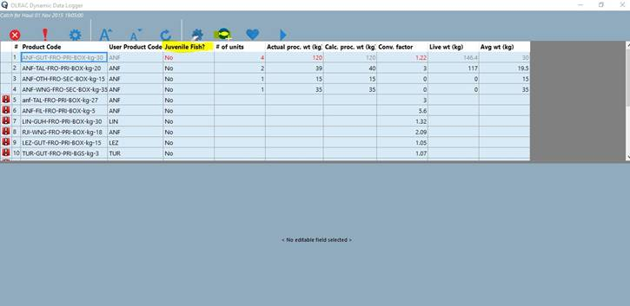

**Figure 5.**

**4.       Specifying Juvenile state on Discards**

•         If fishing on a tow by tow basis using non-fixed gear, discards can be recorded directly against the tow by pressing the “**Discard”** button see image below:-



**Figure 6.**

•         If fishing on a “tow by tow” basis using fixed/static gear, discards are recorded against the haul , see below:-



**Figure 7.**

•         If fishing using “by gear” basis, the discards are recorded against the “daily activity by gear”, the discard information is recorded as per previous above by pressing the “**Discard**” button. The discard node with information will be below the daily activity by gear node as shown below yellow highlighted:-



**Figure 8.**

•         When the skipper presses the “**Discard**” button in all the three cases above , the fields editor will open and he can enter the required information as shown below:-



**Figure 9.**

•         One of the fields shown on the image above is “**Discarded catch**” and this allows the user to also specify if the discarded fish was Juvenile or not as shown in the image below:-

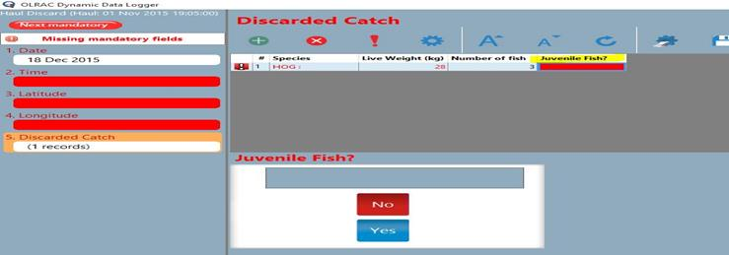

**Figure 10.**