



National Health and Social Care Standards for Scotland

What your healthcare and support should be like if you live in Scotland

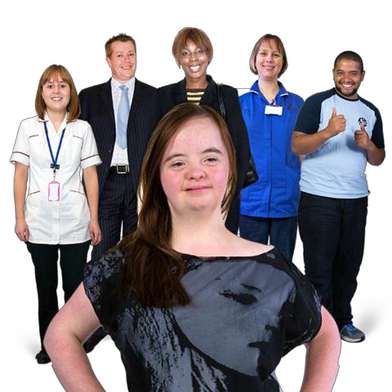

Please tell us what you think


Who we are


We are the government in Scotland.



We want to know what people think of the new National Health
and Social Care Standards for Scotland.

What this booklet is about
What are the new National Health
and Social Care Standards?


In this booklet we will call them standards
for short.

The standards are a bit like rules.

They say what people’s healthcare
and support should be like.

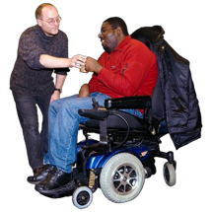
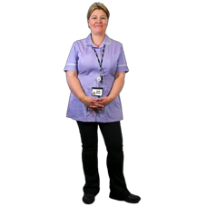
Healthcare is care you get from people like doctors and nurses.

Support is when you get help from staff to do things like:

- live at home

- look after yourself


- go out and do things

The standards should help
everyone in Scotland get good healthcare and support.

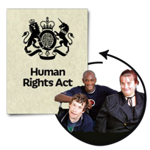

The standards should help make sure people get their human rights.

These are rights that everyone has. Like the right to be treated fairly.

The standards will also help
health and support people know what to do.
How did we make the new
standards?

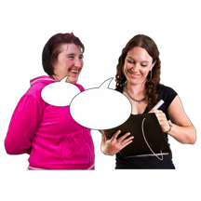



People told us that the old standards needed to change.

So we asked lots of people to help us make some new standards.

First we made some Principles
to go with the standards.

The Principles are 5 things
that should happen when you get healthcare and support.

They say that:

  - People should treat you with respect

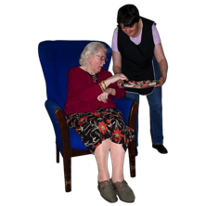
  - People should be nice and caring to you

  - You should be able to take part in things

  - You should have the right support at the right time
  - You should get support to feel happy and well
What happens now?

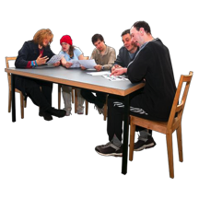
The new standards in this booklet are not final yet.

We will look at what everyone says about them first.


Then we will make the final standards.

The new standards will start to happen from Spring 2017.


Now you can find out what
the new standards say at the moment.

We want to know what you think of them.

There are some questions for you to answer after each standard and at the end.

You can find out how to tell us what you think on page 31.
The new National Health
and Social Care Standards

Standard 1. I get good care and support that is right for me

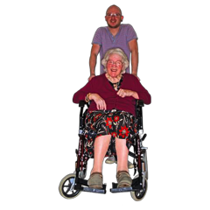

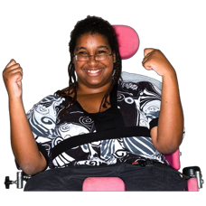
Some examples of what should happen:

- I am always treated fairly. No one treats me badly

- Staff give me care in a way
that makes me feel good and safe. It feels right for me.

- Staff help me do the best I can. They believe I can do things
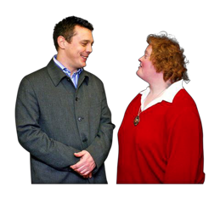
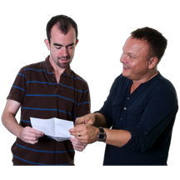
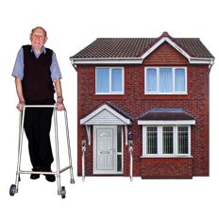
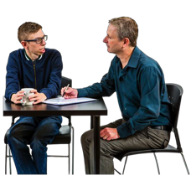


- Staff listen to me because I know what I want and need

- I have a big say in the care and support I get, to make sure it is right for me

- If I can’t get the support I want, staff tell me why

They help me find other support

- I can live in my own home if possible

- I can get things to help me look after myself. Like computers or other things that help me look after my health


- Staff help me get the healthcare I need


- I get support to make good choices that make me healthy, happy and safe

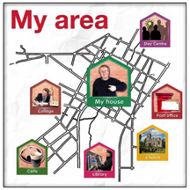
- I get support to be part of my local area and join in with things


If I am under 16 years old

- I can learn and play with other children as well


Question


Do you agree with this standard? Yes A bit No

Standard 2. I have a big say in my care and support

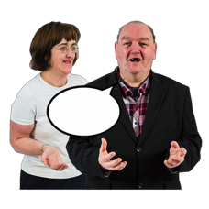
Some examples of what should happen:

- Staff give me information and advice in a way that is easy for me

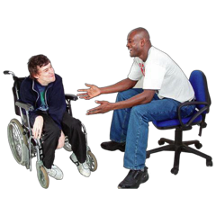
I can get support to speak up from someone called an advocate if I need it

- I can tell people what I want in a way that feels right for me

People do not try to rush me


- I can choose who gives me care and support and what it will be like if possible

If possible I can visit the care and support place first to see what it is like

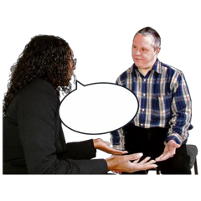
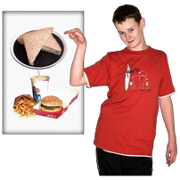
- Staff ask other people who know me well what I want if I find it hard to say

- I can choose what I want to do, like how to spend my money,
what to wear and what to do each day


- Staff help me do new things
if I want to. They help me know if things may be safe or unsafe

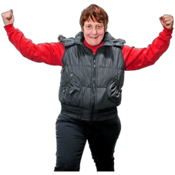
- I get support to do things that make me happy and more confident

Question

Do you agree with this standard? Yes A bit No

Standard 3. I feel good about the
people who support and care for me

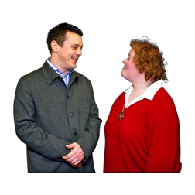
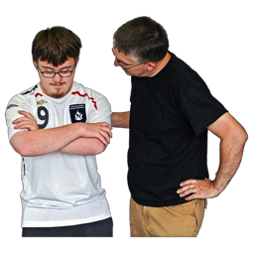

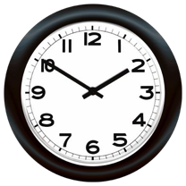
Some examples of what should happen:

- Staff talk to me. They get to know me and what I want

- Staff are kind and caring to me

- Staff have the right skills and training to support me

- Staff have enough time to spend with me

- I can get help quickly if I need it

- Staff help me feel safe in the area where I live

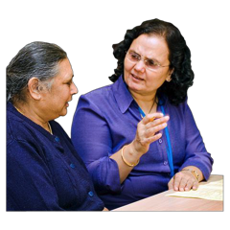
- Staff talk to me to find out things
and ask me questions about what I want

Question

Do you agree with this standard? Yes A bit No

Standard 4. I feel good about
the organisation I get care and support from





Some examples of what should happen:

- The organisation says sorry if something goes wrong

They try to make things better

- I can have a say in how to make
the care and support better for everyone

- I can say if I am unhappy about something

I will be treated fairly if this happens

- I feel that the organisation is good and works well

Question

Do you agree with this standard? Yes A bit No


Standard 5. This standard is about the building that you may get care and support in
For example, you may live in a care home or go to a day centre

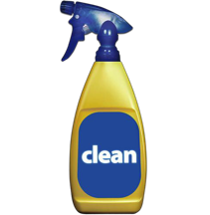

Some examples of what should happen:

  - The building is clean, nice and safe

  - Staff tell me if there are cameras
in the building and how I can still be private



The cameras are called CCTV cameras

  - If I get care all hours of the day I can use a TV, radio, phone and the internet

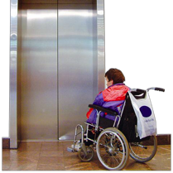
  - It is easy for me to get into
the parts of the building I need to use

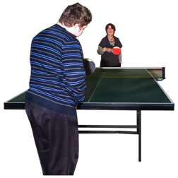
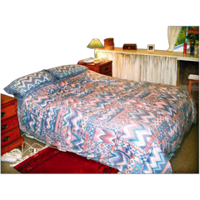

  - I can take part in things to do, in the building and outside it

  - If I am an adult or child I can share my room with someone I know well or who looks after me if I want to

Staff help me decide about this

  - My pet can live with me in my care home if possible

Question

Do you agree with this standard? Yes A bit No

Standards 6 and 7 are
extra standards for some people.

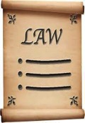

Standard 6. This standard is about
when the law says people can make some choices for you
For example, the law may say you have to
stay in hospital for a while if you have
a big mental health problem.

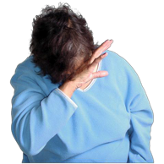
Some examples of what should happen:

- Staff help me know what my rights are to do with my behaviour
and what will happen

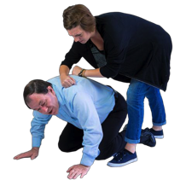
- Staff do not hold my body down to stop me unless they have to

This only happens for a short time if it does happen

Staff have proper training to do this

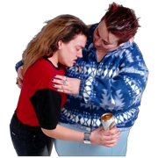
- Staff will only search my body or things if they really need to

They will tell me why if this happens

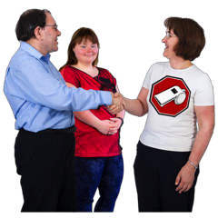
- Staff give me and other people good support with our behaviour

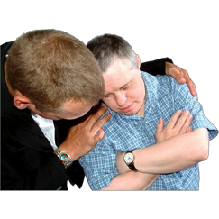
- The support I get helps to stop me hurting myself or other people

Question

Do you agree with this standard? Yes A bit No
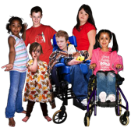
Standard 7. This standard is for
children and young people
who are under 16 and need support
For example, you may live in a children’s home or with foster carers.


Some examples of what should happen:

- I get support to feel better about myself and my life

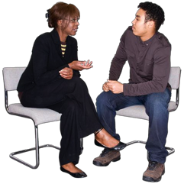
- Staff help me understand decisions that people make about me
even if I am not happy with them

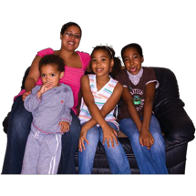
- I can live with other people in my family and my brothers and sisters
if I want to and it is safe

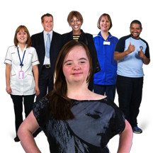
  - People who make decisions about me know me and what I want

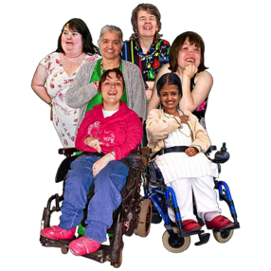
They can make good decisions about me
•

I get support to stay in touch with
family or people who are important to me and still be safe


  - I get support to do the best I can at school, college and work


  - I get support to do my own things in a safe way

  - If I leave home and go missing
people do everything they can to find me and make sure I am safe

Question

Do you agree with this standard? Yes A bit No
Questions

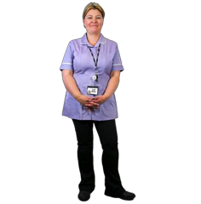
There are some more questions starting below. Please answer them if you can.

Question 1

Do you think the new standards are right for both healthcare and support?

Yes A bit No

Question 2

Do you think the new standards are right for what people who get healthcare
and support need?

Yes A bit No


Question 3

Do you think these new standards
will help make healthcare and support better?

Yes A bit No



Is there anything else you want to tell us about the standards? Like anything
that should change or is missing? Or anything we need to think about?
Question 4

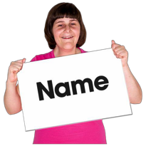
What should the new standards be called?

National Care Standards

National Health and Social Care Standards

National Healthcare and Social Care Standards

National Care and Health Standards

National Care and Support Standards Something else. Please tell us what


About you


Are you answering these questions as:

One person An organisation

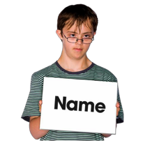
Your name.


Or the name of the organisation if you are part of an organisation
Address and postcode



Email


Phone number



Can we write about what you tell us in a report or on our website?

Yes. And you can use my name
Yes. But I don’t want you to use my name No I don’t want you to write about
what I said


Can we get in touch with you again if we want to know more about what you tell us?

Yes No


The Date

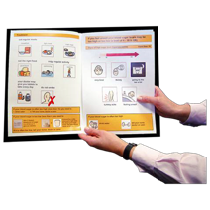

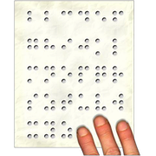
We will tell people about the final standards in different ways.

Is one of these ways best for you?

Easy read. This is easy words and pictures like this booklet

Large writing (Large Print) CD (audio)
Braille

Another language Please tell us which one



How would you like to look at the final standards?

On a computer Paper copy Both
How to tell us what you think of the new National Health and Social Care standards



Please tell us by 22 January 2017.

You can tell us by writing to:

National Care Standards Review Scottish Government
Area 2-ER
St. Andrews House Regent Road Edinburgh
EHI 3DG

By email to:
NationalCareStandards@gov.scot


By phone to:

0131 244 3546

Thank you!




© Crown copyright 2016
This publication is licensed under the terms of the Open Government Licence v3.0 except where otherwise stated. To view this licence, visit nationalarchives.gov.uk/doc/open- government-licence/version/3 or write to the Information Policy Team, The National Archives, Kew, London TW9 4DU, or email: psi@nationalarchives.gsi.gov.uk.

Where we have identified any third party copyright information you will need to obtain permission from the copyright holders concerned.
This publication is available at www.gov.scot

Any enquiries regarding this publication should be sent to us at The Scottish Government
St Andrew’s House Edinburgh
EH1 3DG
ISBN: 978-1-78652-598-7 (web only)
Published by The Scottish Government, November 2016
Produced for The Scottish Government by APS Group Scotland, 21 Tennant Street, Edinburgh EH6 5NA PPDAS83341 (11/16)

w w w . g o v . s c o t

